Editing PDF Files

Because of the way they are constructed it is almost always easier to edit the original document and remake the PDF from that rather than try and edit a PDF file. Unfortunately this is not always possible but there are ways to edit PDF files in Adobe Acrobat (not the free Adobe Reader).
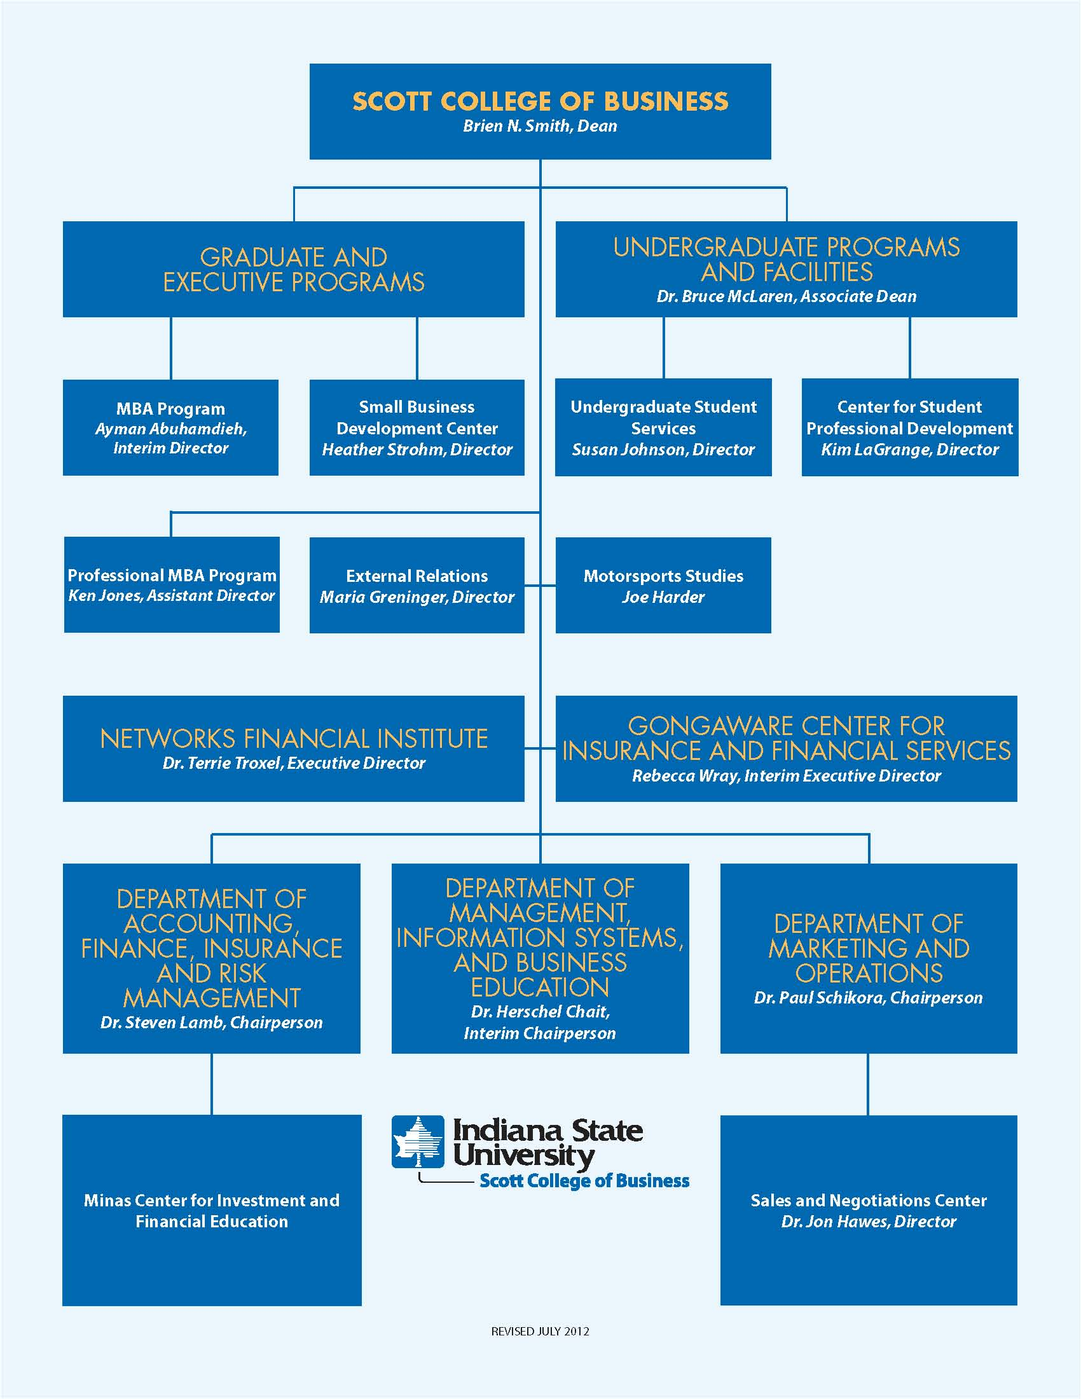
The whole of the original document
The original text is on the left, the updated text is on the right.

Converting to Another Format
One way to try and alter the text is to convert the file to an easily editable format such as a Microsoft Word document. This is done from the File > Save As… menu in Adobe Acrobat. This sometimes works very well. The file can be edited then resaved as a PDF file. It does not always work and in this case changing the PDF file to a Doc file loses nearly of the formatting…
PDF saved as a Microsoft Word document
This is not going to work so another way must be found. Adobe Acrobat has several tools that can be of use and so…

Touchup Text Tool
The touchup text tool is under advanced editing in the tools menu…

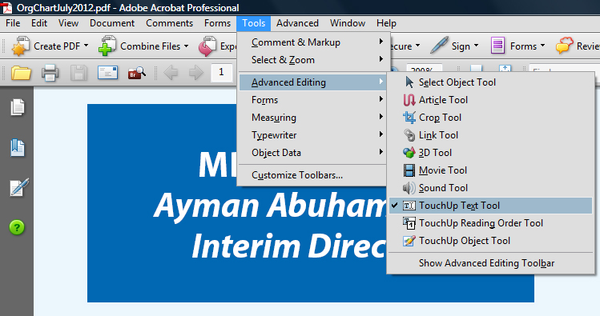
The Touchup Text Tool
This sometimes works very well but often you’ll get this message…
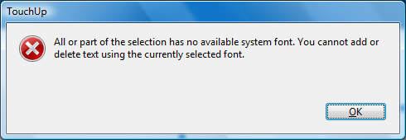
Font not found error message
This may happen even if you think you have all the correct font files installed. If this happens then you need to either find and install the font that was used to create the text or change the font used to one that is already installed. Adobe Acrobat allows you to do both.
Highlight the text you want to change, then right click and choose Properties from the menu that appears…
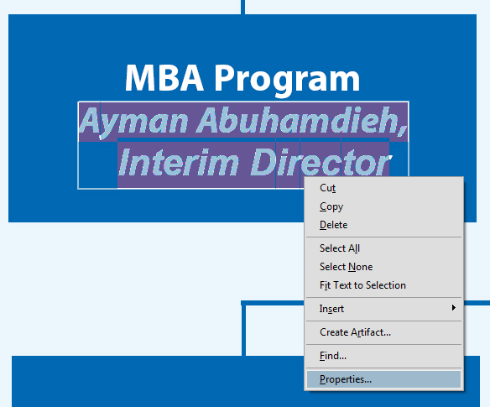
Opening the Properties dialog
This brings up a dialog box that shows the font that was used for the original text and gives you a chance to change it to something that is installed…
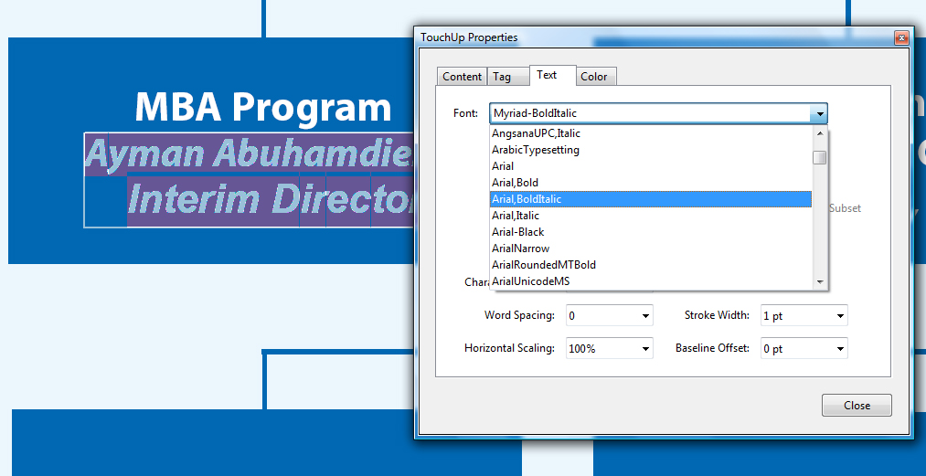
Changing the font
For this part of the exercise we just want to remove the text, so choose any font, close the dialog box and delete the text entirely.
For the other part of the exercise, to alter the text you need to use your judgment as to the best way to proceed as there is no text formatting such as center, left or right align in the text touchup tool. Adobe Acrobat is not a word processor but by using simple spacing a reasonable result can be obtained.
The finished Text Touchup Tool edit

Typewriter Tool
The Typewriter tool is fairly basic and to get the most out of it you should have Adobe Acrobat 9 as some features are not available in older versions.
To use the Typewriter go to Tools > Typewriter and display the Typewriter Toolbar…
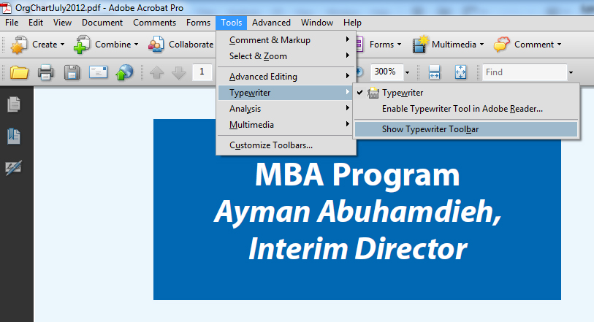
Opening the Typewriter Tool
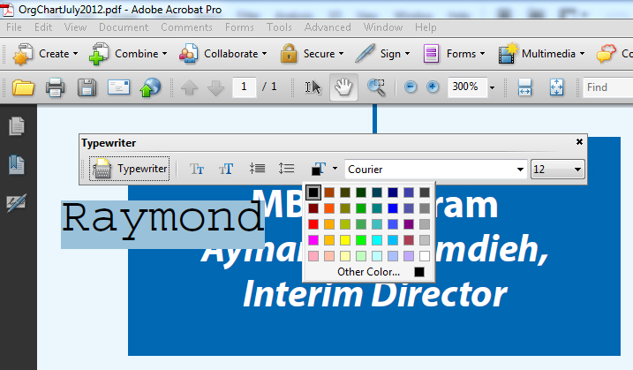
The Typewriter Tool in Adobe Acrobat 9
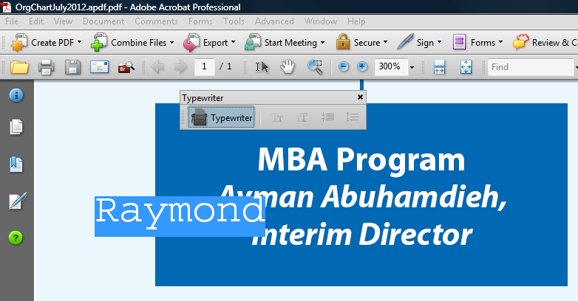
The Typewriter Tool in Adobe Acrobat 8
Adobe Acrobat 8 does not allow you to change either the font or color but Adobe Acrobat 9 does. In both versions the background of the text is transparent meaning it cannot be used to cover up existing text. It is only shown in blue in the above images because the text has to be selected in order to use the typewriter Toolbar.
In this particular instance the typewriter tool isn’t of much use to us, but it is useful to remember that it is there and has its own particular uses.

Text Box Tool
The Text Box Tool in Adobe Acrobat is meant for producing printer markups and corrections but it is very useful for quasi text editing. It is accessed through the Review and Comment > Comment and Markup Tools menu.
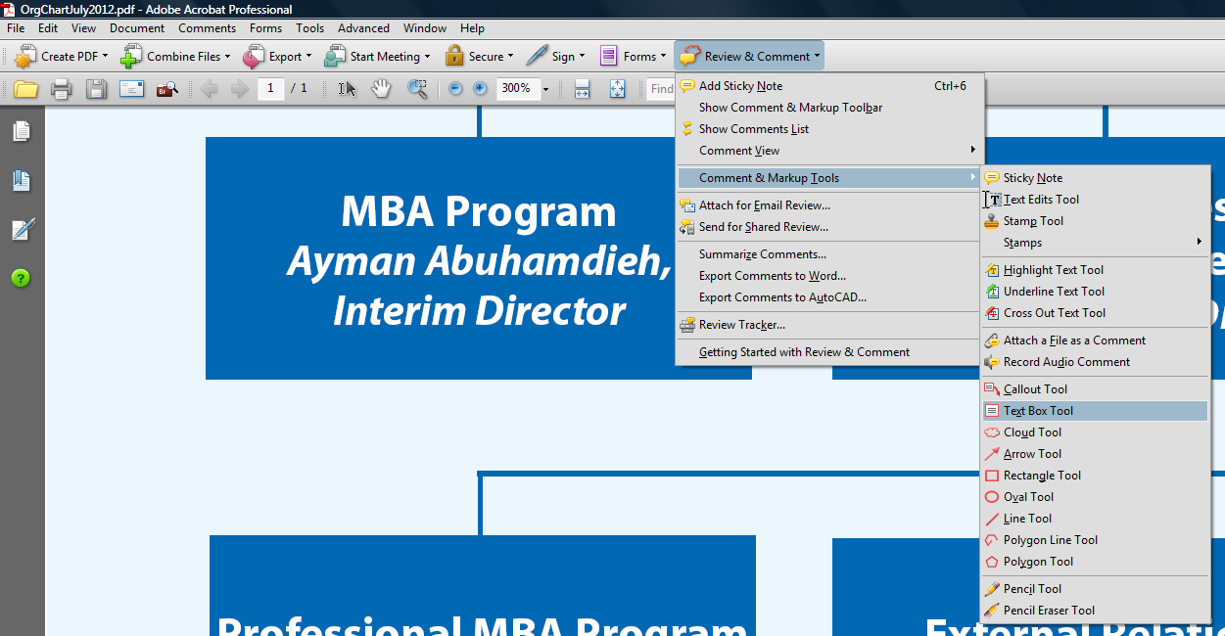
Opening the Text Box Tool
The standard text box contains red text on a white background with a red border
The standard text box
The text box is highly configurable by highlighting the entire txt box so that the boundaries are highlighted and either pressing Ctrl + E or by right clicking and choosing Properties from the menu. The dialog boxes that open are different but they have the same options.
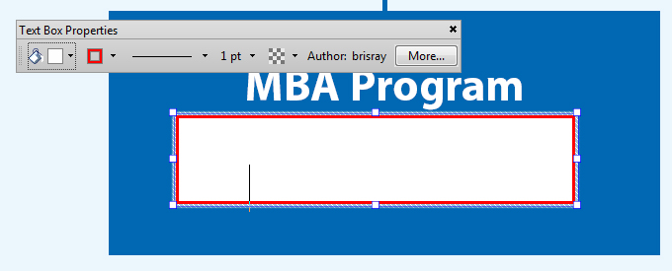
Text Box menu by using Ctrl + E
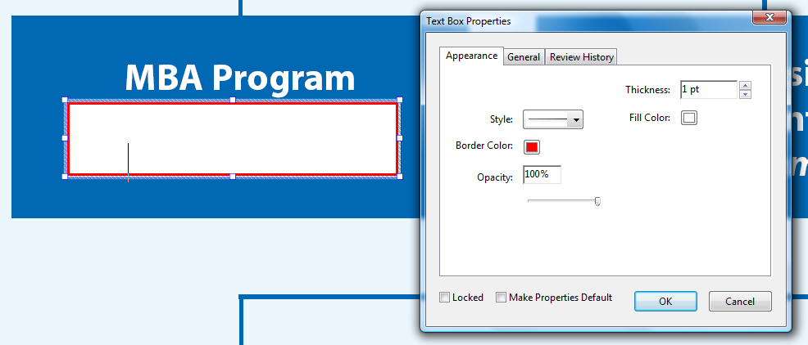
Text Box menu by right clicking and using Properties menu
These dialog boxes allow the border to be resized or even disabled and controls the fill color of the box. For this part of the exercise we just need to cover up the old text. We can start by removing the border…
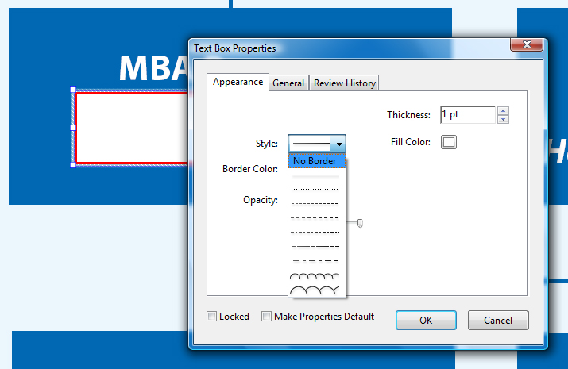
Removing the text box border
Next we need to fill the box with the correct color to match the background. Clicking on the Fill Color box opens a basic color chooser…
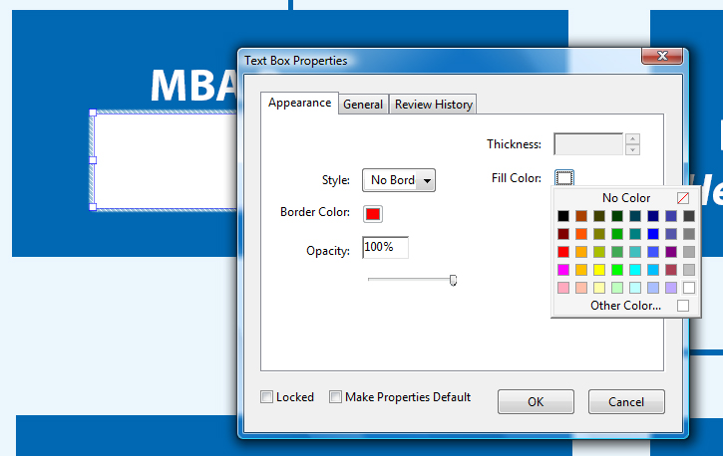
Clicking on Other Color… opens a more advanced color chooser…
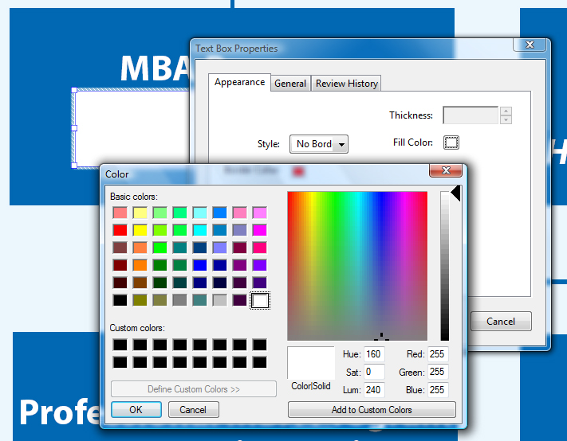
Adobe Acrobat does not include a color picker so for an accurate color match if one cannot be made manually then another tool is needed. There are several available but if you have it the one in Adobe Photoshop can be used.
Open a new empty image in Adobe Photoshop and position it so that both Adobe Photoshop and Adobe Acrobat are open together…
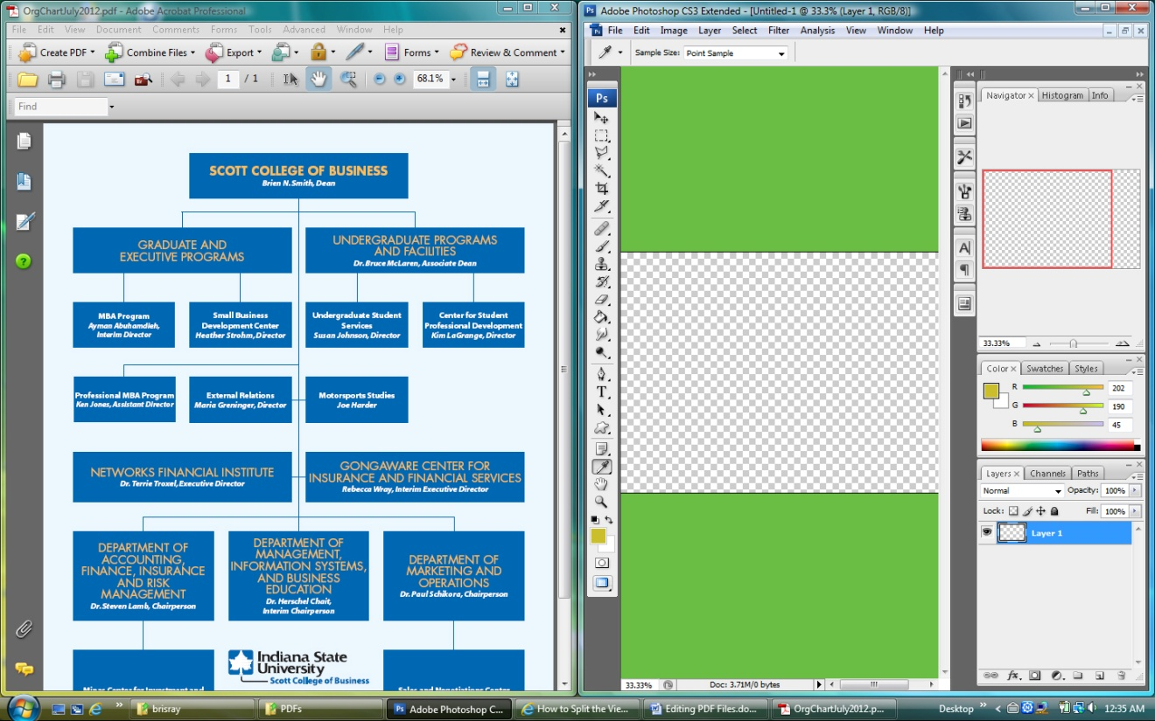
Adobe Acrobat and Photoshop open together
Select the Color Picker in Photoshop and place it over the empty image. Press the left mouse button and you can now drag the Color Picker out of Photoshop and into any other other application. In Photoshop’s color swatch make a note of the RGB color values that are chosen and enter those values into Adobe Acrobat’s Text Box color value.
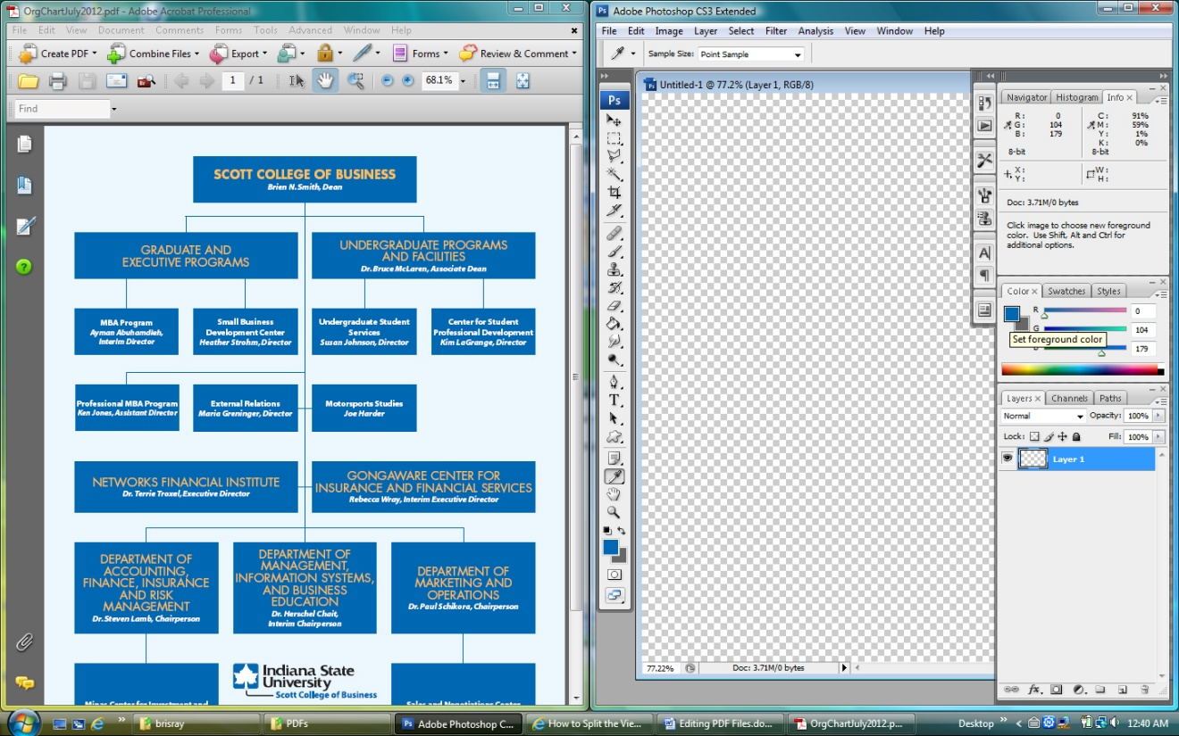
The values in this case are R=0, G=104 and B=179.
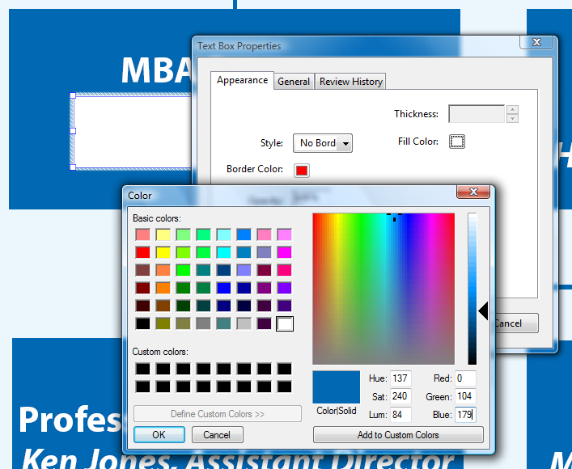
Click on OK to get out of the dialog boxes and the text box is now the same color as the background…
But why go through all this trouble if the Text Touchup Tool can do this? The reason is that the Text Box Tool has more text options available to center text and give different text styles – it’s a mini word processor.
Type the text into the text box, highlight it and press Ctrl + E to bring up the text dialog box. From here the text can be manipulated a little like Microsoft Word…
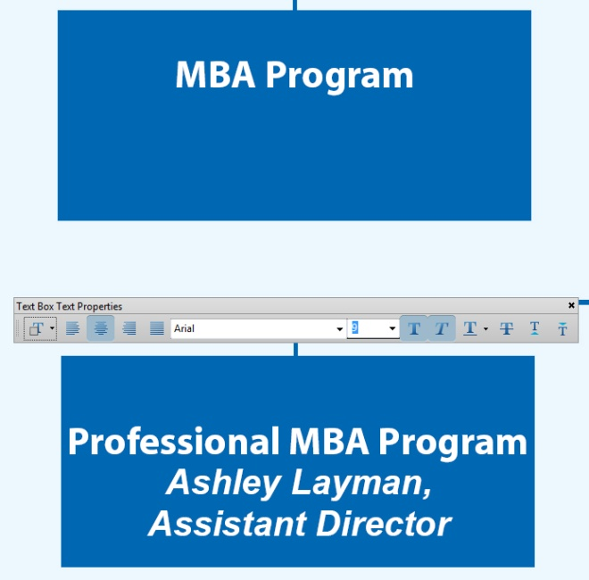
Adobe Acrobat’s Text Box Text Toolbar
We are not finished yet. The Text Box tool is part of Adobe Acrobat’s printer markup and correction tools. This means that these comments are movable when viewed in Adobe Reader; also, because these are non-printable, if the document is printed then the new corrections will not be printed.
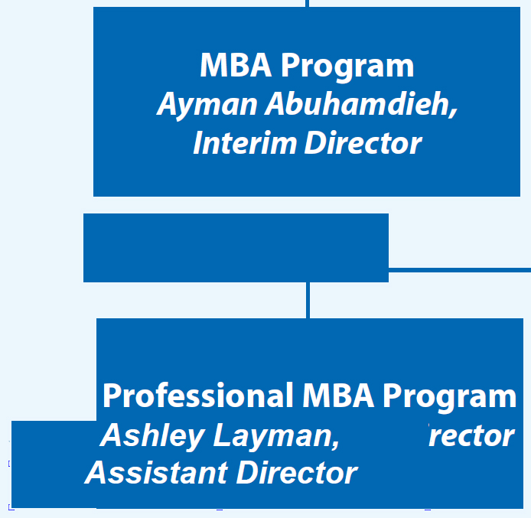
How the text boxes can be moved in Adobe Reader
To stop both of the above behavior it is not enough to simple save the PDF file, it has to be “flattened”. That is, the comments and text boxes have to be made part of the original text. This is done by printing the PDF file to a new PDF file. This is done using the File > Print menu in Adobe Acrobat. Instead of choosing a physical printer, choose to print to a PDF file.
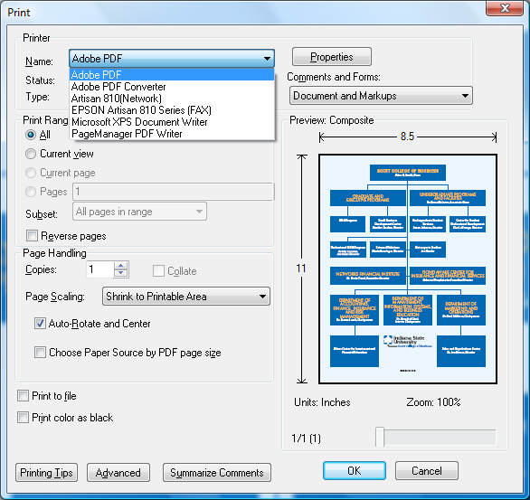
Printing to a PDF File
Flattening a PDF file in this way is called “refrying”. The file can now be opened by others in Adobe Reader without them being able to move the text boxes and other effects. It also means that if you need to re-edit the file in Adobe Acrobat then the steps must be repeated as the original edits that were made are now part of the document and cannot be separated.
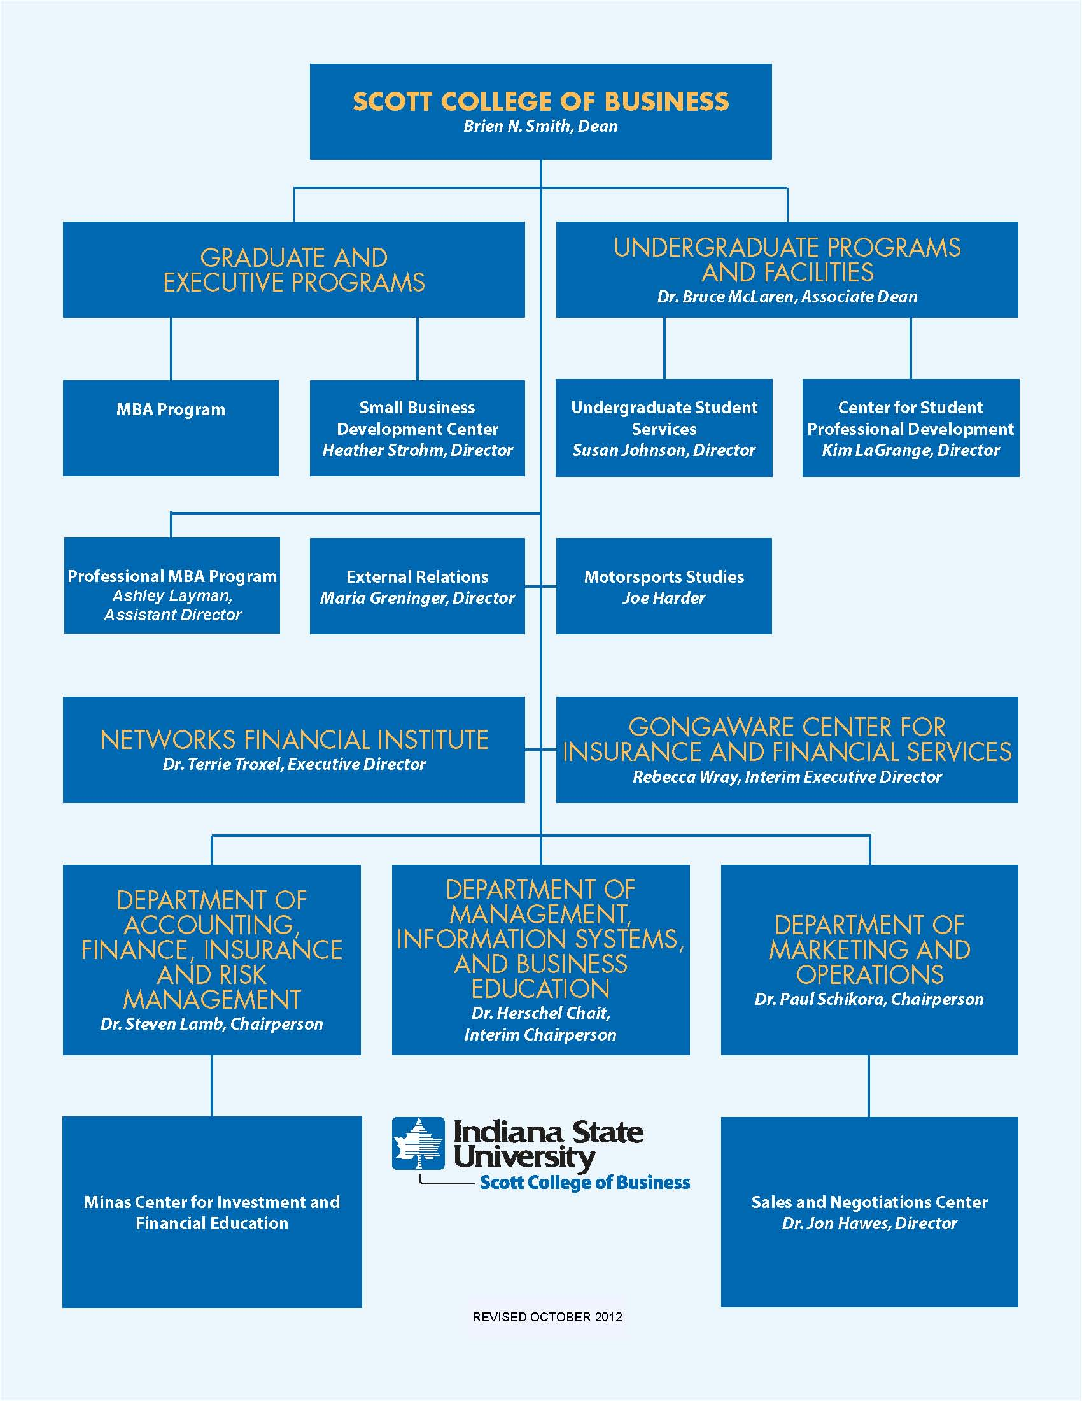
The complete edited document

Ray Thomas
October 2012

