SSRN Website:
Adding a New Paper

Adding a new publication to SSRN’s website is not difficult but there are a number of steps to complete the operation. If they are done incorrectly then the information may not appear on the site as expected, if at all.
Remember you are editing a “live” site on a production server and you need to be careful when editing information on the site.
Martha Henn will provide most of the information you need to complete the online form needed to upload the file. Other information can be found in the PDF that she will attach to the email for uploading. This is especially true of the JEL (Journal of Economic Literature) search terms and numbers which are usually at the bottom of the first page of the PDF. It is usually best to copy Martha’s email to Notepad and copy and paste the information from that. This is because Notepad will remove any formatting that is in the email.
If you need the login information for the website then contact Joe Zachery.

1) Open the SSRN website at http://www.ssrn.com/ in your web browser and enter your username and password.
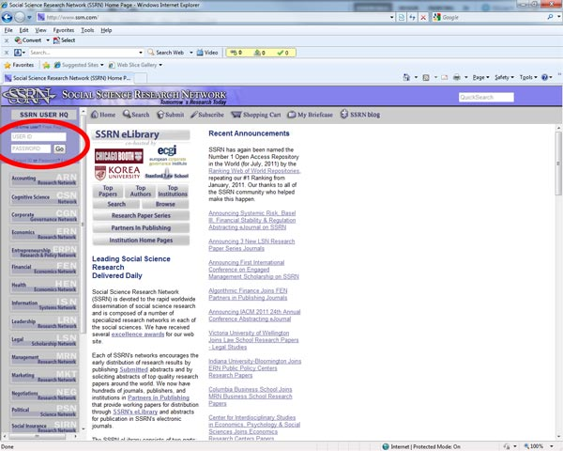
2) From the screen that appears, click on “My Papers”.
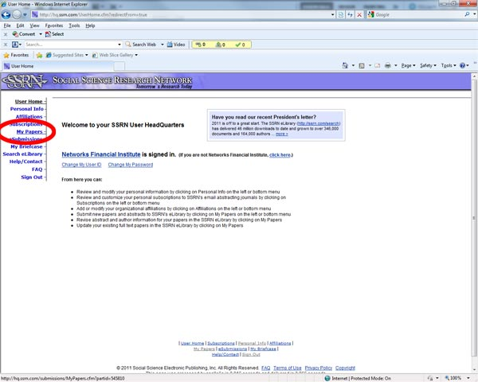
3) From the screen that appears, click on “Start New Submission.
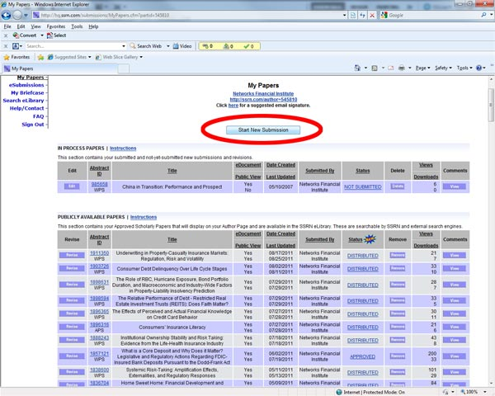
4) When the copyright dialog box opens, click on “Continue”
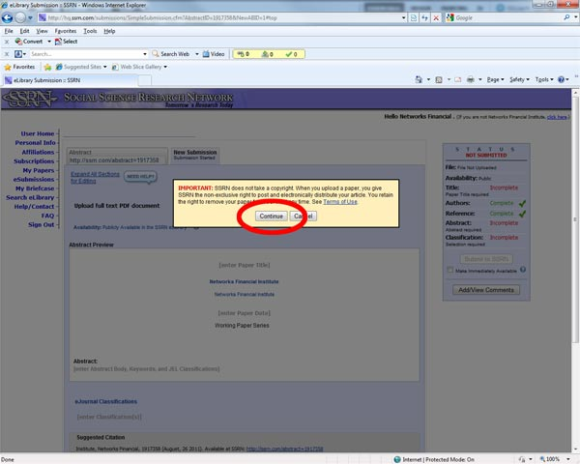
5) Most of the form is relatively intuitive to complete. One part that is not is the Paper Author section. Type the author’s surname into the search box and press enter.
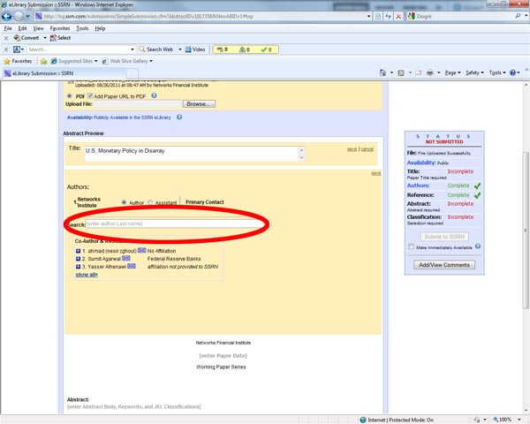
6) The author may appear in the list that appears. If it does, then select it.
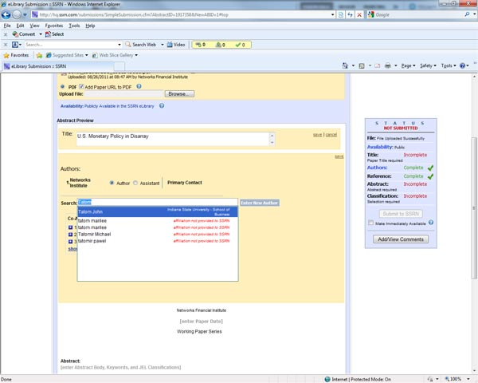
7) If it does not, then click on “Show All”.
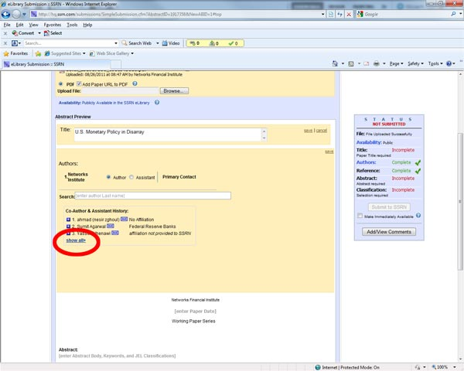
8) Sometimes the full list does not appear. This usually happens when using Internet Explorer and can be fixed by using Compatibility Mode by clicking on the broken page icon in Internet Explorer.
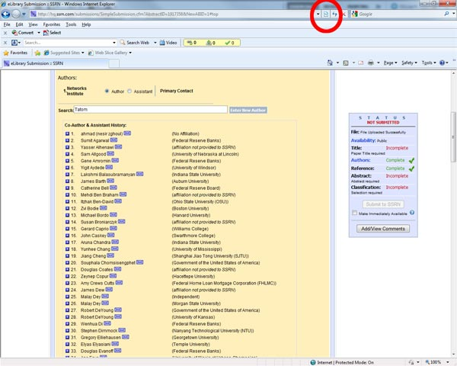
9) If the author does not appear in the list then you will be given an opportunity to create a new author. You will need to know the author’s affiliation (if any) and email address.
10) The lead author of the paper should be made the Primary contact and Networks should be listed as an Assistant.
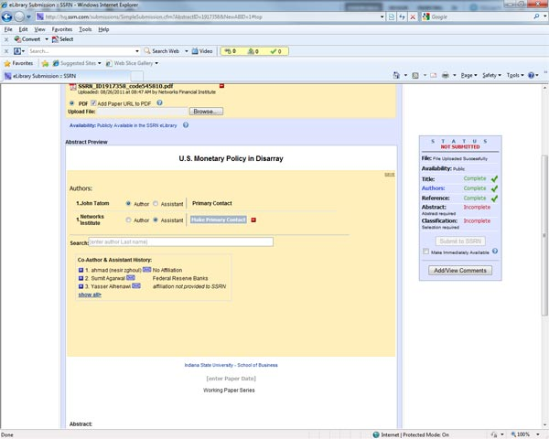

11) Nearly all the papers we submit to SSRN have also been accepted by NFI and this should be stated in the References section of the form. The usual way of writing this is Networks Financial Institute [Working Paper or Policy Brief] No. [Our publication number]. For example…
Networks Financial Institute Working Paper No. 2011-WP-21
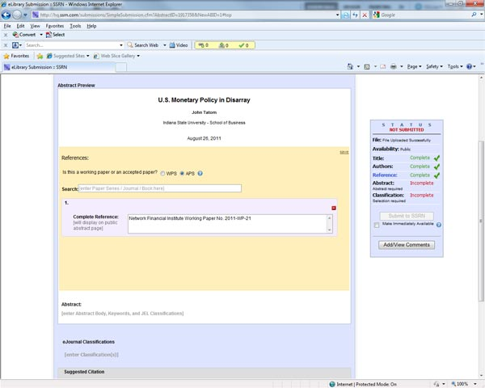

12) In the Abstract section the form any JEL keywords and classifications should be entered. These are usually found on the first page of the PDF paper.
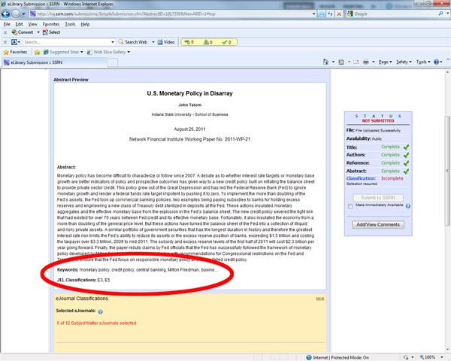
13) In the eJournals Classification section of the form let SSRN select the eJournal classification.
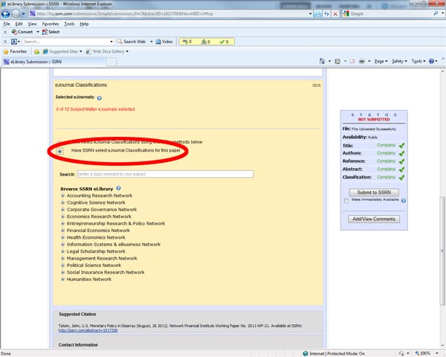
14) As sections of the form are entered and saved the sections on the right will turn green and once completed the form is ready to be submitted. If the paper is to be made available immediately then the checkbox for this should be checked.
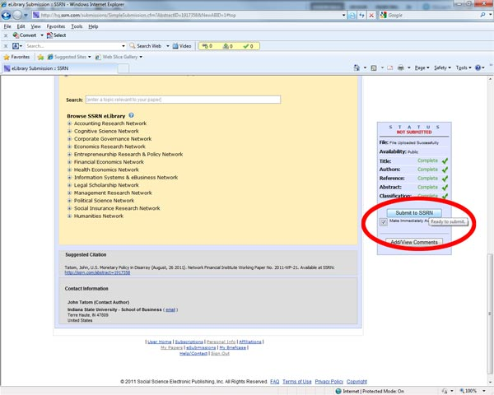
15) A dialog box will appear. If you are satisfied with the paper and the form then check the checkbox giving SSRN the right to publish it electronically and click the Submit button.
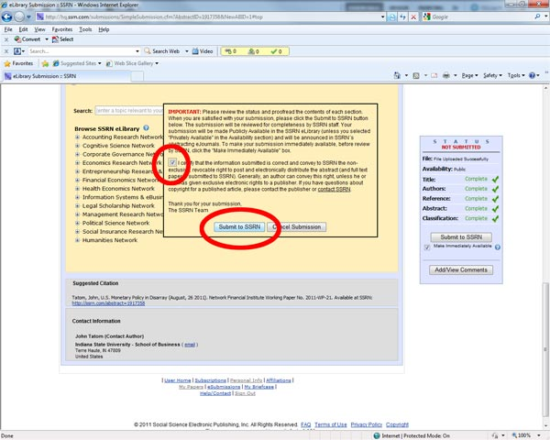
16) On the confirmation page that appears, click on “Go To My Papers”
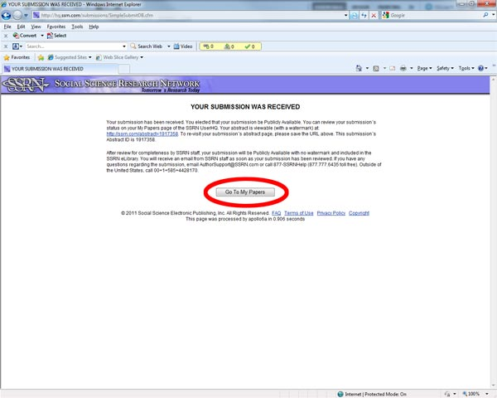
17) A listing of the papers will appear that includes the new submission. This submission should be in the section headed “In Process”. Click on the “Abstract ID” of the new submission.
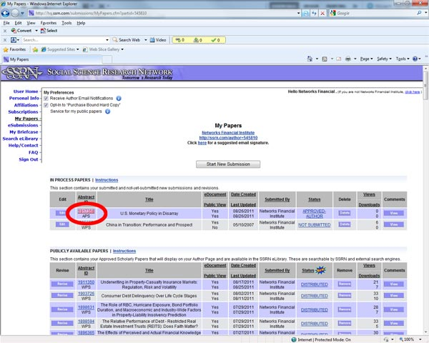
18) The paper’s submission details can then be inspected and by clicking on “One Click Download” the paper itself can be inspected.
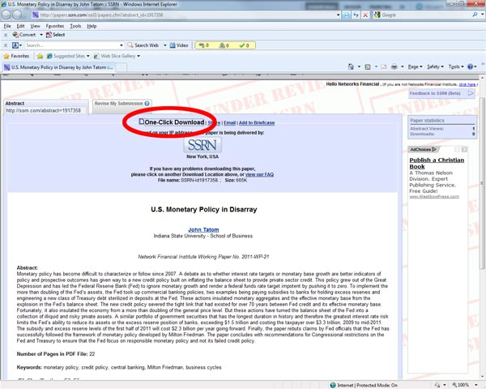
19) Sign out of the website by returning to the listing page and clicking on “Sign Out”.
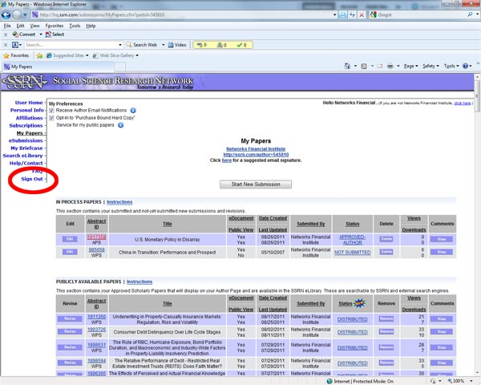
Ray Thomas
August 2011

