NFI Website:
Adding a New Paper

Adding a new publication to NFI’s website is not difficult but there are a number of steps to complete the operation. If they are done incorrectly then the information may not appear on the site as expected, if at all.
Remember you are editing a “live” site on a production server and you need to be careful when editing information on the site.
Martha Henn will provide most of the information you need to complete the online form needed to upload the file. Other information can be found in the PDF that she will attach to the email for uploading. It is usually best to copy Martha’s email to Notepad and copy and paste the information from that. This is because Notepad will remove any formatting that is in the email.
If you need the login information for the website then contact Joe Zachery.

1) Open the NFI website at http://isunetworks.org/ in your web browser.

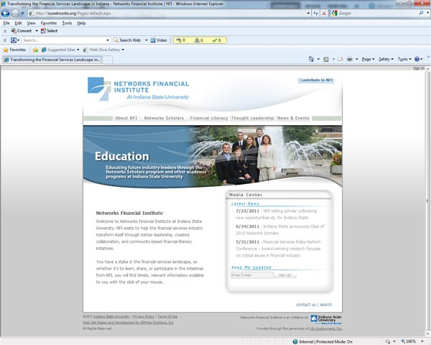
2) Click on the “Sign In” text in the top right of the window. A dialog box asking for your username and password will appear.
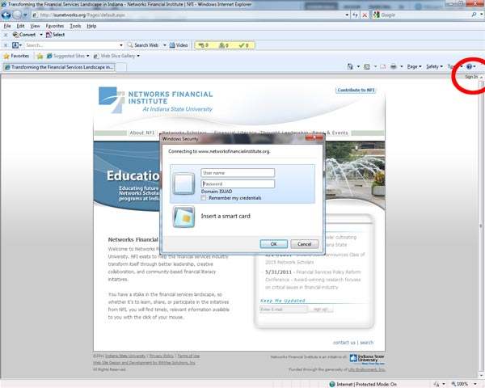
3) When the new menus appear, click on “Site Actions” in the top right of the window. Then click on “view All Site Content”
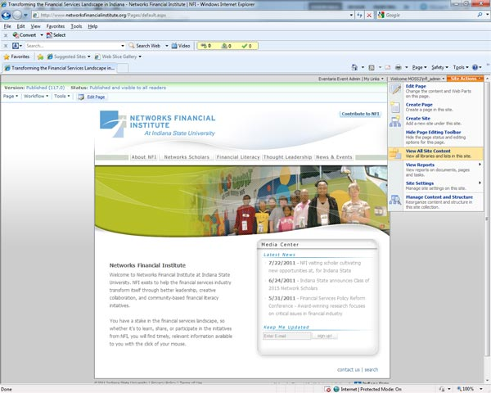
4) When the document list appears, scroll down to the section labeled “Lists” and click on “Publication Library”
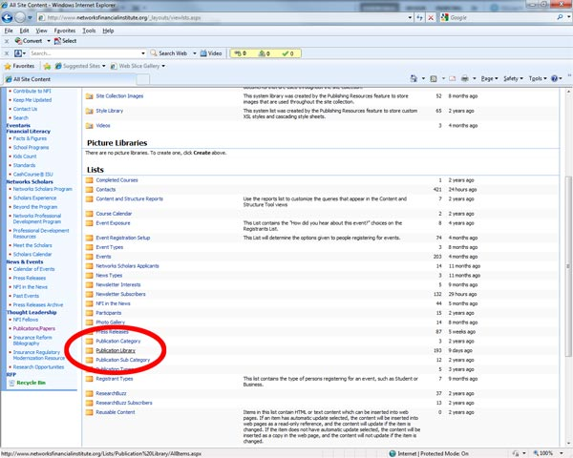
5) When the list of publications opens choose “New” from the top left menu
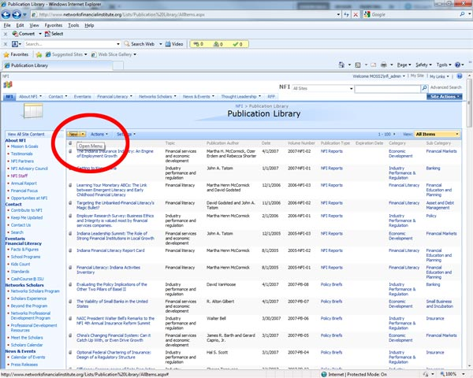
6) A form will open. Upload the paper in PDF format to the server using the “Attach File” button. Once the information has been entered then clicking on “OK” will upload the information and add it to the site’s database. If a file is not attached or if any of the form fields are not correctly entered then the posting may not take place at all.
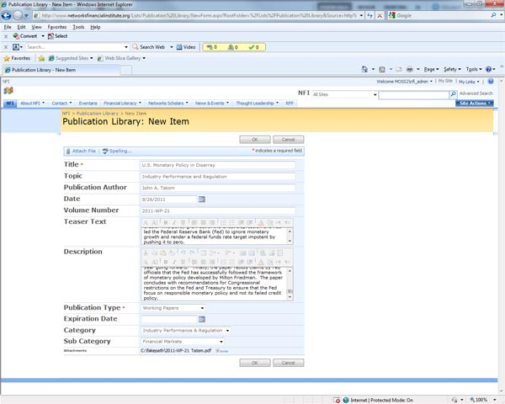
7) Open a new browser tab and go to http://isunetworks.org/thoughtleadership/publications/ and then the appropriate section (books, working papers, reports or policy briefs) to ensure the paper has been added
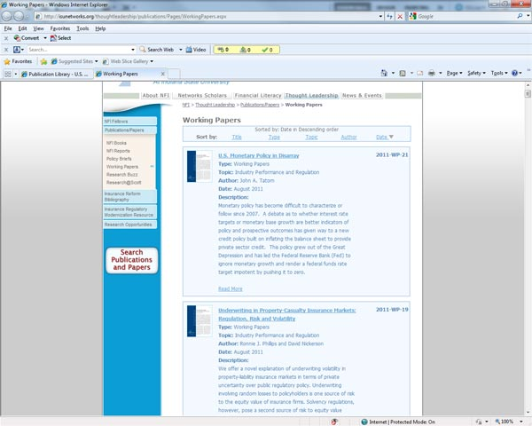
8) Go back to the original browser tab and either re-edit the library entry or sign out of the page. The columns in the library document list are sortable to help you find the entry you last edited.
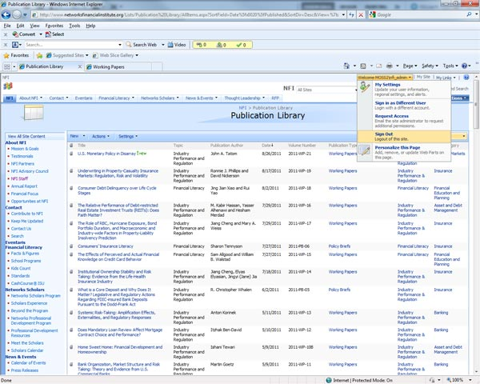

Ray Thomas
August 2011

