NFI Website:
Adding a New Paper

Adding a new event to NFI’s website and then registering it on Eventaris is not difficult but there are a number of steps to complete the operation. If they are done incorrectly then the information may not appear on the site as expected, if at all.
Remember you are editing a “live” site on a production server and you need to be careful when editing information on the site.
If you need the login information for the website and/or Eventaris then contact Ray Thomas.

1) Open the NFI website at http://isunetworks.org/ in your web browser.

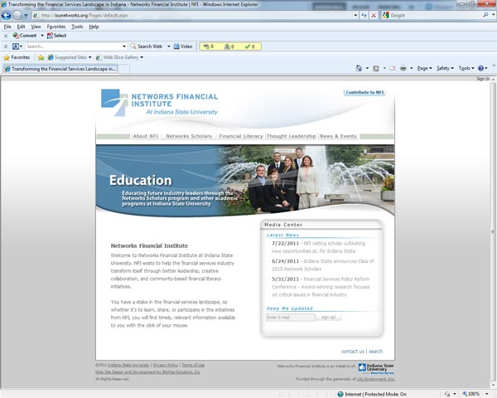
2) Click on the “Sign In” text in the top right of the window. A dialog box asking for your username and password will appear.
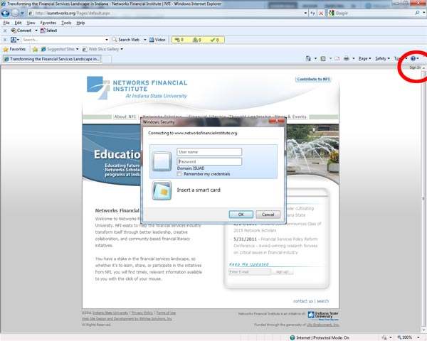
3) When the new menus appear, click on “Site Actions” in the top right of the window. Then click on “View All Site Content”
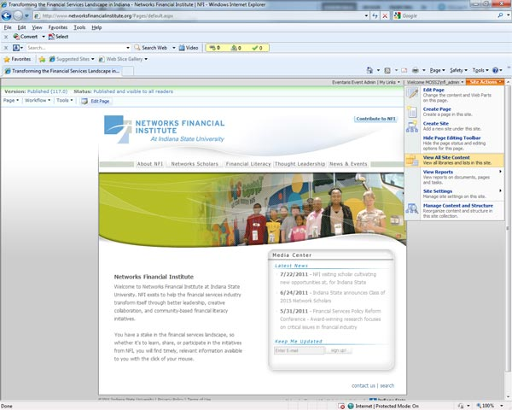
4) When the document list appears, scroll down to the section labeled “Lists” and click on “Events”
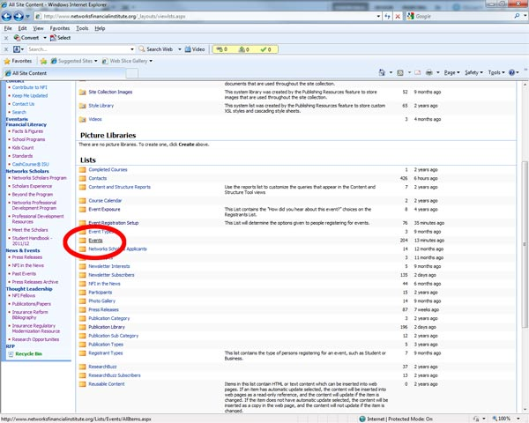
5) When the list of events opens, choose “New” from the top left menu
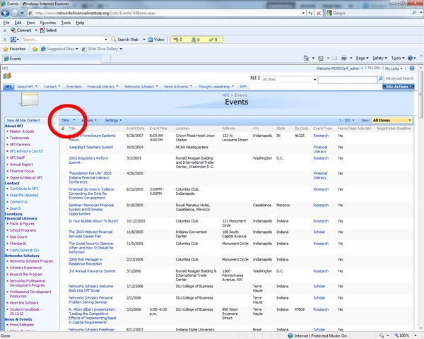
6) A form will open. Simply fill in the items as needed.
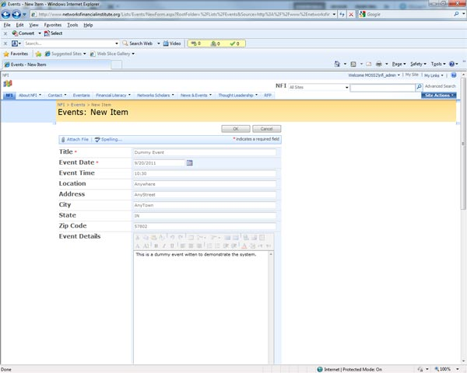
7) At the bottom of the form is a section entitled “Home Page Selection”. If this is checked then a link to the event will appear on the home page of the website.
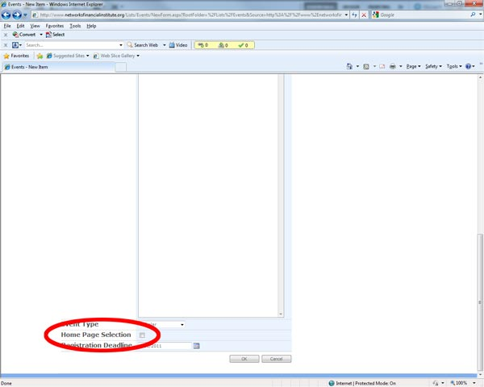
8) An event with the “Home Page Selection” checked.
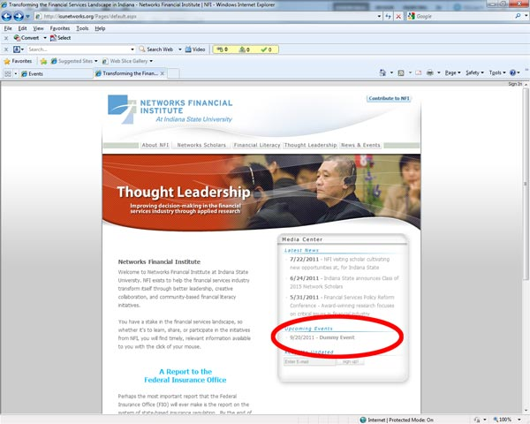
9) Also At the bottom of the form is a section entitled “Registration Deadline”. If this is left blank or the date entered is past then the registration form link will not appear on the event listing.
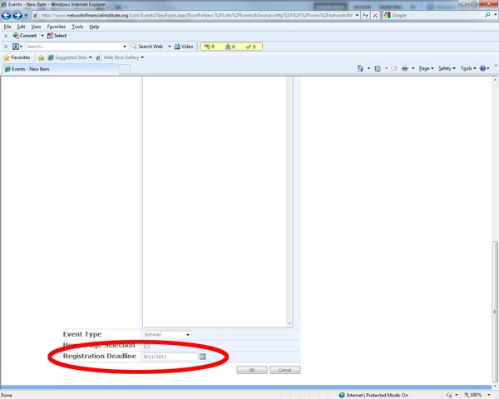
With and without the Registration Form
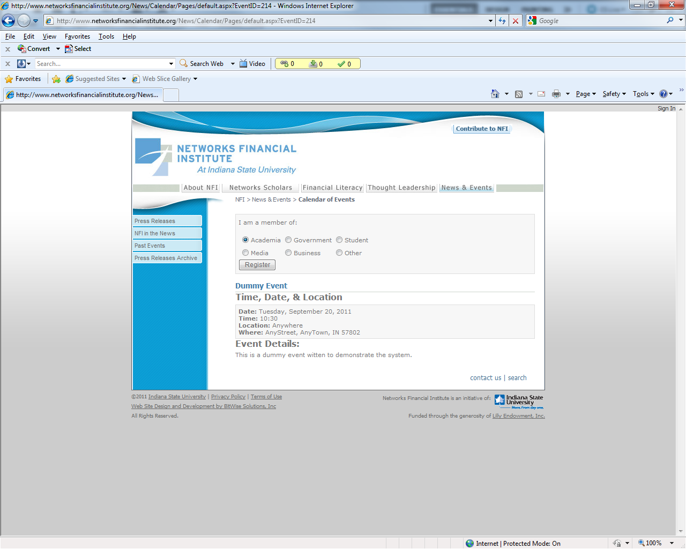
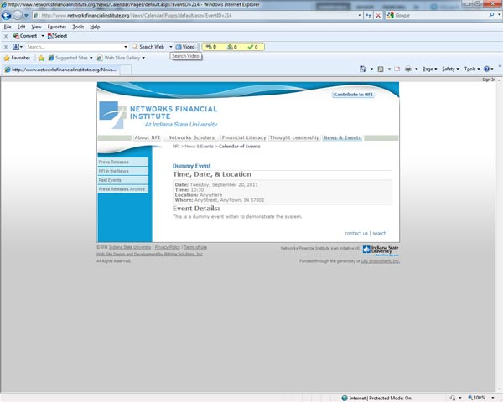
If anything needs to be edited on that page it must be done by opening the Event form as described above and editing it from there. Direct edits to the page itself cannot be easily done.
When the form was submitted it also appeared on the NFI webpage calendars. However the links to those calendars were suppressed on the website in September 2011. Because of this the only place the link appears is on the home page at http://isunetworks.org/
If the “Home Page Selection” checkbox on the form was left blank then the link will not appear anywhere on the website. In order to create a link to the event the Event ID must be found. The ID can be found when editing the page by looking at the URL in the browser address bar. Which should start with http://www.networksfinancialinstitute.org/Lists/Events/EditForm.aspx?ID=214 where 214 is the Event ID. When looking at the list of the events then when the mouse cursor is placed over the event then the Event ID can be found by looking at the bottom left of the status bar in the browser. One the Event ID has been found it can be added to this URL…
http://www.networksfinancialinstitute.org/News/Calendar/Pages/default.aspx?EventID=
In our example the entire URL would be
http://www.networksfinancialinstitute.org/News/Calendar/Pages/default.aspx?EventID=214
If the event registration form is NOT required then nothing further needs to be done. If it is. Then there are more steps…

10) Go back to the Lists view and click on “Event Registration Setup”
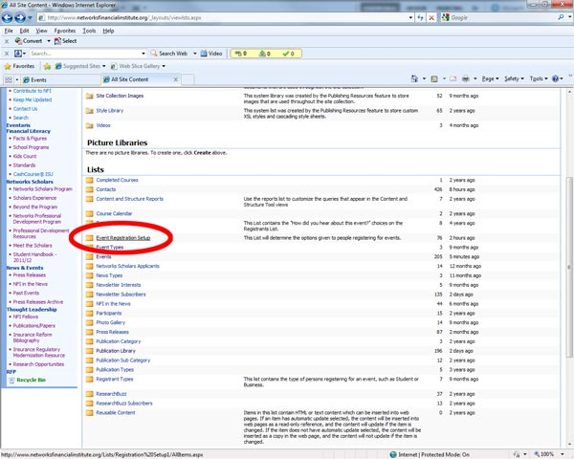
11) When the list of event registrations opens, choose “New” from the top left menu
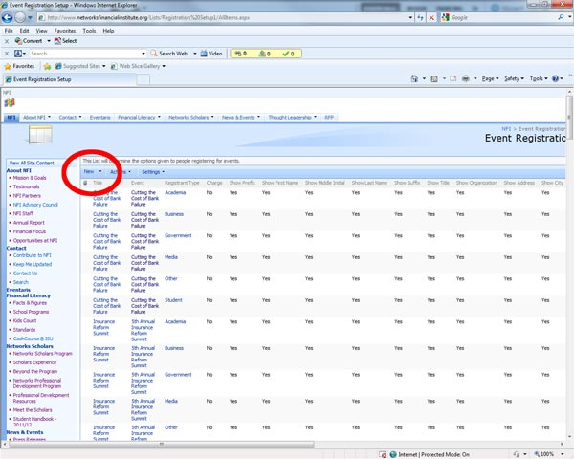
12) A form will open. Simply fill in the items as needed.
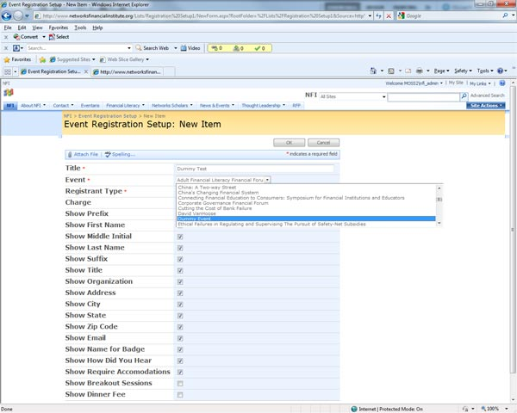
This step must be repeated for each registrant type if the information to be shown is different.
13) Open Eventaris from the Site Content List
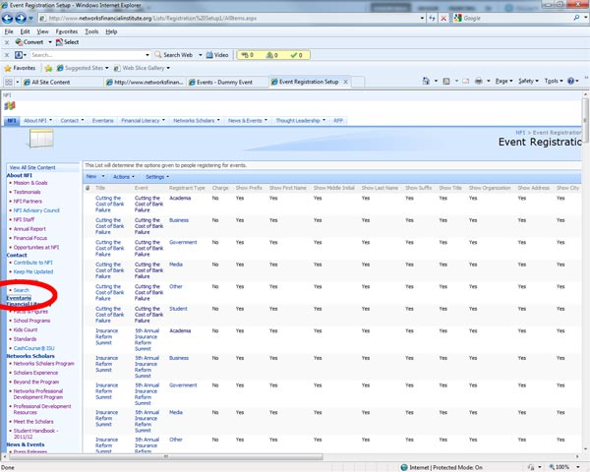
14) When the list of Eventaris items opens, click on “Add MOSS Event to Eventaris”. MOSS stands for Microsoft Office SharePoint Server.
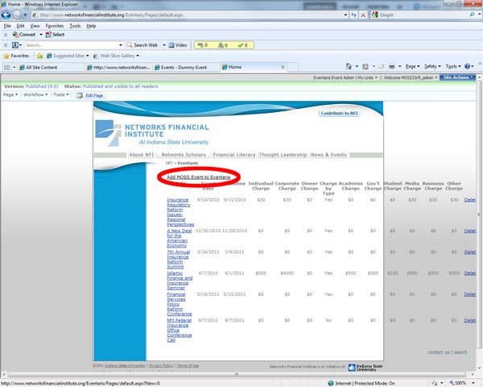
15) Fill in the form that appears and then press the Submit button at the bottom
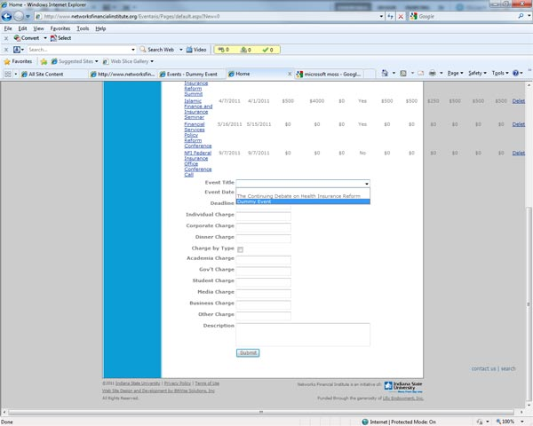
The event is now set up and registration setup inside Eventaris.
16) Sign out of the website
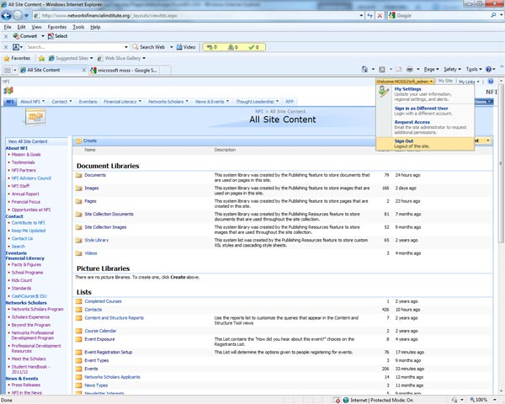
17) Open the URL to the event that was just created and click on the Register button
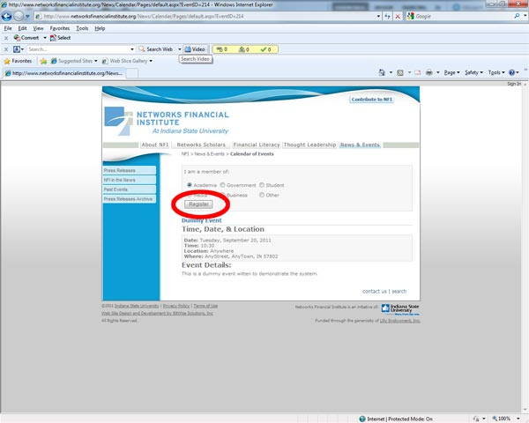
18) If all went well then the Eventaris Registration Form will open
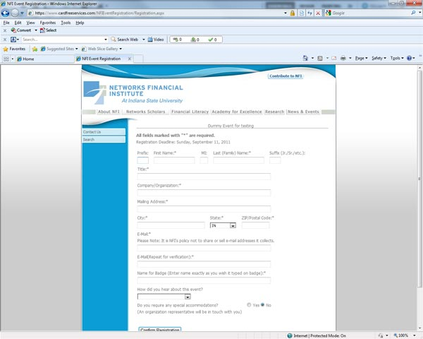
Currently, the Eventaris registrations are sent to Elaine McVay. If this needs to change then Bitwise should be contacted. Their email address is support@bitwisesolutions.com

Eventaris
19) Open the Eventaris website at http://www.eventaris.com/ and click on the “Existing customers login here”” text in the top right of the window. A dialog box asking for your username and password will appear.
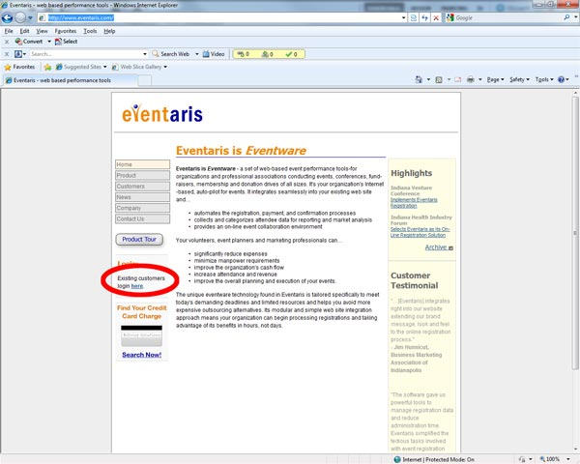
20) Eventaris login screen
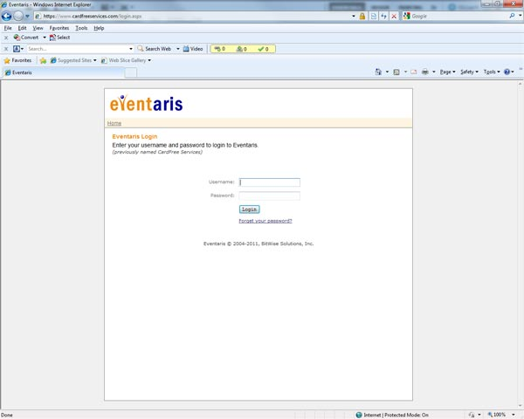
21) After logging in, various screens show the number of people registered for each event. Administrators can also register people directly.
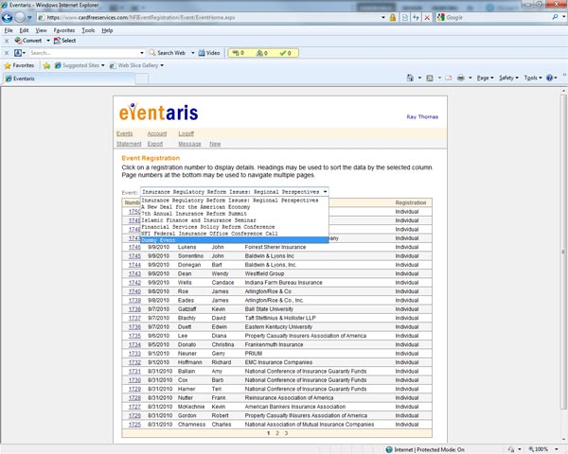

Ray Thomas
September 2011
Updated January 2012

