Sending Multiple Files via Email
Working with Zipped Files

ISUs email policy is set to be able to send attachments of up to 150Mb to on-campus addresses. To off-campus addresses the limit is 10Mb.
Sometimes it may be required that multiple files or even an entire folder is sent to someone. This document shows how use Windows built-in compression capabilities to be able to do this.
Depending on the file types a zipped compressed folder can be just 1/10 the size of an uncompressed folder. Note that some files, especially images and videos, are already highly compressed and will not compress much more, if at all.
Creating a zip folder from a folder
From My Computer navigate to the files you want to attach to your email.
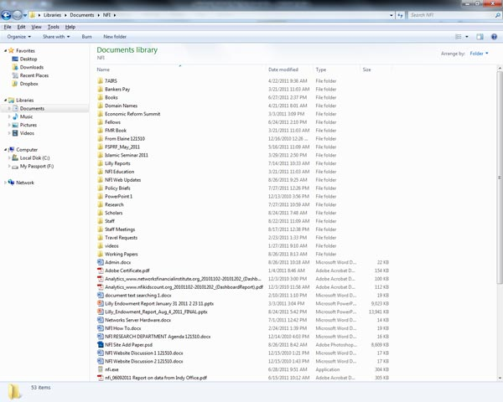
You can create a new folder and copy the files you want to email into that folder. Now you can right click on the folder and choose “Send to” then “Compressed (zipped) folder”

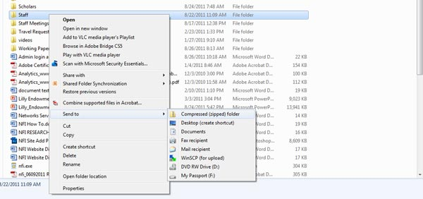
Doing this will create a new file named whatever the folder name was, but with a zip extension. The new file will appear with this icon…
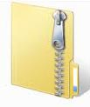
The file can be opened just the same as any other file.
Creating a zip folder from a collection of files
Select the files you want to zip…
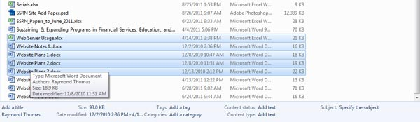
Right click on them and choose “Send to” then “Compressed (zipped) folder”
A new folder will be produced. The file name will be the same as the first file name you selected but with a zip extension. Just as with any other folder or file you can rename this as wanted.
Adding files to a zip folder
Once created you can copy and paste or drag and drop files into a zip folder
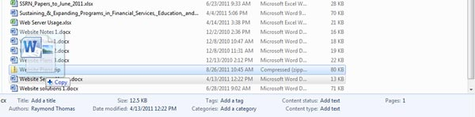
When you drag and drop, the file you are using is not moved into the zip file but copied and compressed. Your original files will not be altered in any way by using them with zip files.
Adding a zip file to emails
Once the zip file has been created it can be added to an email in the same way as any other file.
Decompressing a zip file
Windows uses a zip file just the same as any directory but extracting the files may sometimes be necessary. You can do this by right clicking on the zip file and choosing “Extract All” from the menu.
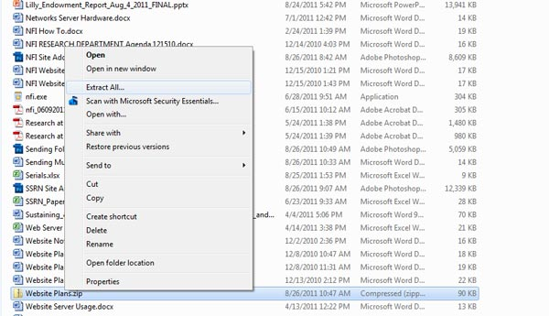
This will open a dialog box allowing you to extract and save all the files
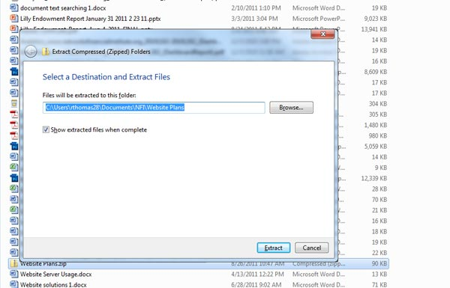

The files can be saved individually by opening the zip file and choosing which files to use. The files can be copy and pasted or dragged and dropped to their new location.
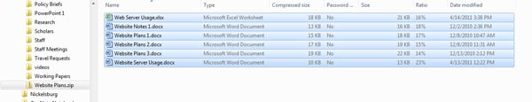

Other Options
Windows copes very well with zip files but sometimes you may receive compressed files in other formats such as RAR or ARJ. Windows cannot natively cope with these files but a free program that can is 7-Zip - http://www.7-zip.org/
Using larger files
Sometimes even a zip folder can be too big and exceed the capabilities of the email client. In this case you can create several smaller zip files using one of the methods above or use some other method of giving the recipient the files.
Online sharing
Online sharing of files is now very common and easy to use. David, for example, uses MobileME – http://mobileme.com. Many students use Google Docs – http://docs.google.com. I regularly get files from different places using Dropbox – http://dropbox.com
Here’s a list of some common online sharing sites and their capabilities
Google Docs - http://docs.google.com - 1Gb of free space - 1Mb to 20Mb individual file size limit depending on type
Dropbox - http://dropbox.com - 2Gb of free space - 300Mb individual file size limit
SkyDrive - http://skydrive.com - 25Gb of free space - 50Mb individual file size limit
Adrive - http://adrive.com - 50Gb of free space - 2Gb individual file size limit
Megaupload - http://www.megaupload.com - 200Gb of space - 1Gb individual file size limit
Mediafire - http://www.mediafire.com - unlimited free space? - 200Mb individual file size limit

Ray Thomas
August 2011

