Using Task Scheduler

Windows has an inbuilt utility to run programs on a schedule. This is called Task Scheduler and can be found Start > All Programs > Accessories > System Tools
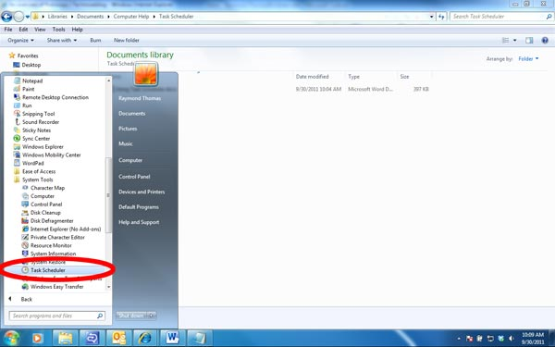
The program is designed to run a program automatically when one or more conditions are met. This could be when the computer starts, when someone logs on, at a particular time or when an event is triggered by the operating system.
This guide is simply to show some of the options available and how to set up a simple task using the inbuilt wizard.
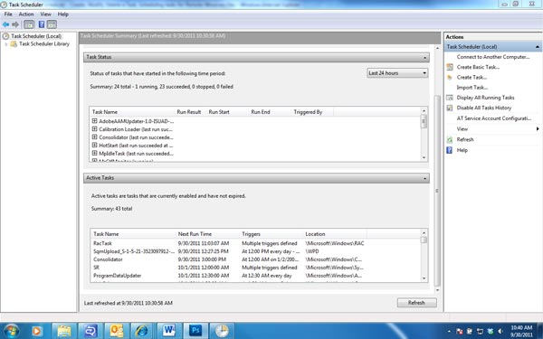
Warning
Nearly all the housekeeping tasks that Windows performs are kept in the Task Scheduler. Be careful not to disturb tasks unless you know what you are doing.
Creating a New Folder for Your Tasks
To help separate your tasks from the system tasks it’s best to make a new folder and keep your tasks in that. It provides better security in that you are less likely to stop or delete a system task and makes your tasks easier to find among the hundreds of system tasks.

1) Click on the Task Scheduler Library folder on the top left of the screen to open the folder list
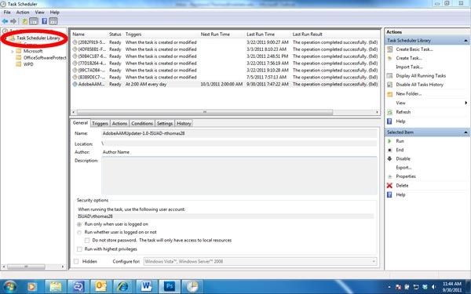
2) Create a new folder by either clicking on the “New Folder…” menu item on the right or by right clicking on the Task Scheduler Library folder list and choosing “New Folder…” from the menu or by clicking on the Action menu at the top of the window and choosing “New Folder…” from that. You can name the new folder whatever you like.
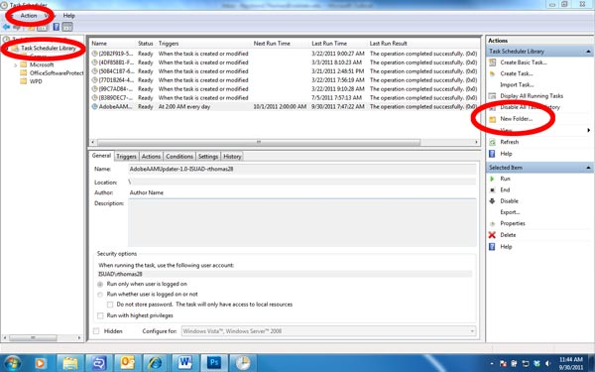
Creating a Task Using the Wizard
In this example all that is going to happen is that we are going to open Notepad once a day at 11am. This is a trivial, but the steps are exactly the same if you’re running a backup program or any other type of program. In fact, if you use Windows Backup then that program keeps its scheduled tasks in Task Scheduler.
1) Ensure that the folder that contains YOUR scheduled tasks is highlighted
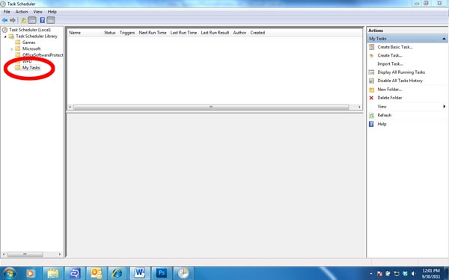
2) Open the New Task wizard by right clicking on your folder and choosing “Create Basic Task…” or clicking on the top Action menu and choosing “Create Basic Task or by clicking on “Crete New Task..” from the menu on the right
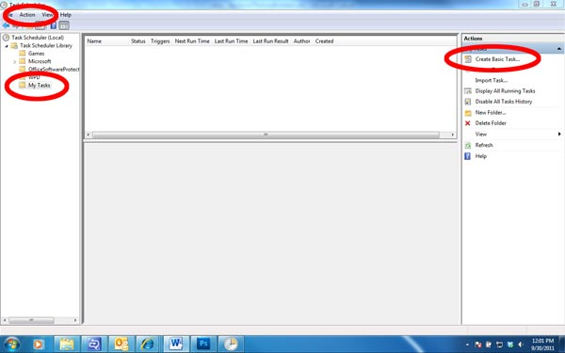
3) In the dialog box that opens, type a name for the task and a brief description, then click Next
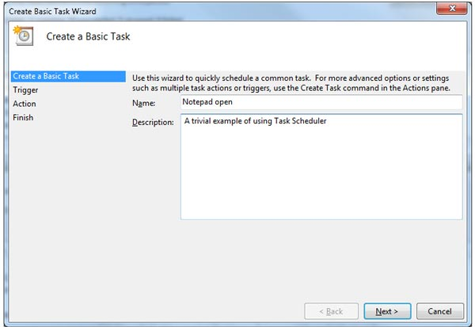
4) Choose the trigger that starts the program. What you choose in this screen determines what you see in the next screen when you click Next
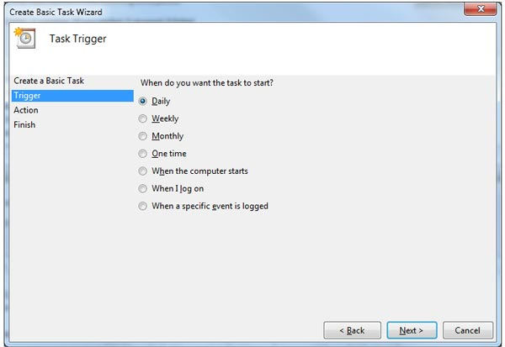
5) This screen lets you determine the specifics of the trigger. Click Next when you have finished
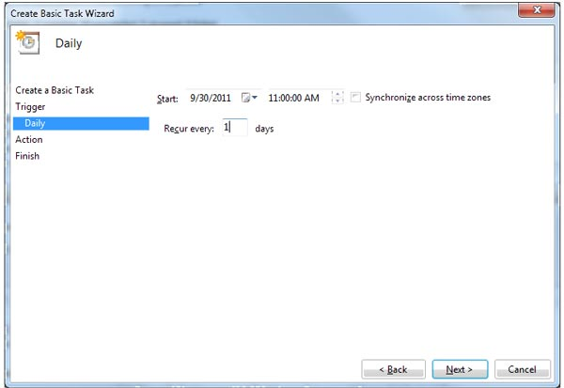
6) This screen determines what action you want to take. Again, what you choose in this screen determines what you see in the next screen when you click Next
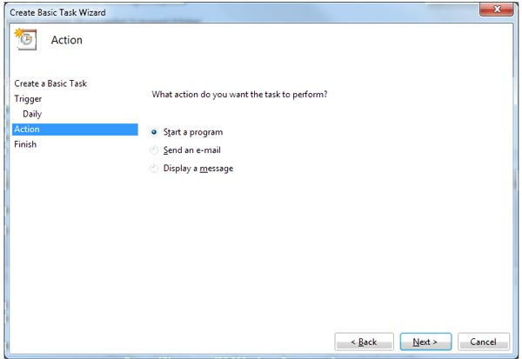
7) This screen lets you determine the specifics of the action. Click Next when you have finished
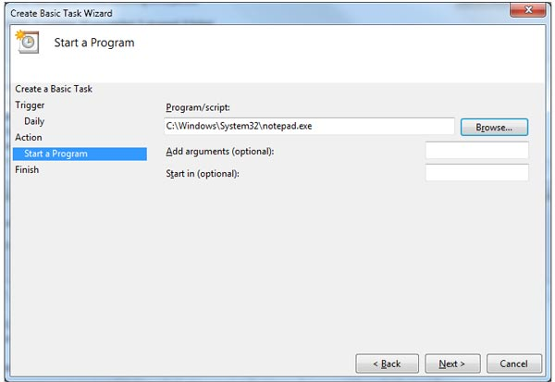
8) This time a summary dialog appears
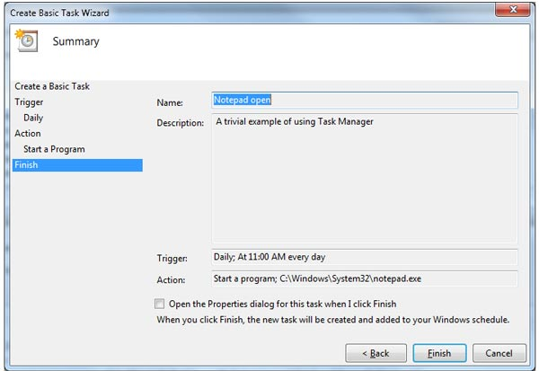
You now have several choices
- Back – Allows you to re-edit any aspect of the task
- Finish – Adds the task to the Task Scheduler
- Cancel – Closes the wizard without saving the task
- Check the “Open the Properties dialog for this task when I click finish” then click on finish. What happens in this case is that an advanced editor opens with more options for your task.
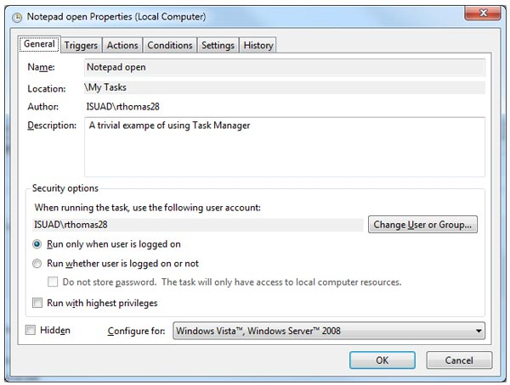
The Advanced Task Editor in Task Scheduler
9) When “Finish” is clicked the new task will appear in the main Task Scheduler window
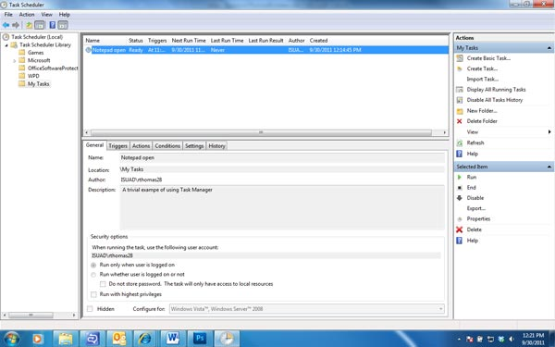
Manipulating a Task
Tasks can be viewed, edited, run, stopped, disabled and deleted. All of these functions can be accessed through the Action menu when the task is highlighted. This can be accessed by using the Action pane on the right, the Action menu item in the top menu or by right clicking on the task.
The Properties menu item gives the opportunity to both view and edit the task.
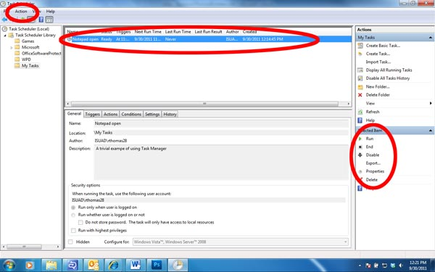

Ray Thomas
September 2011

