

Indiana State University
College of Business
&
College of Technology
Website Documentation
April 2011
Contents
Documentation Changes 4
Overview 5
Introduction 5
Standards 5
Directory Structure 6
Naming Conventions 7
Templates 7
Anatomy of a Template 8
Template Section Dimensions 9
Menus / Server Side Includes 9
JavaScript 12
JavaScript: The Slideshow Function 13
JavaScript: The Alphabetical Button Function 15
JavaScript: Breadcrumbs Menu 17
JavaScript: Sortable Tables 19
JavaScript: Showing and Hiding Part of a Page 20
JavaScript: Query String 22
JavaScript: Random Images 24
PHP 25
PHP: Query String 25
PHP vs JavaScript 26
Form Elements / Control Elements 26
Control Element: Drop-Down Lists 26
Forms 29
Qualtrics 29
Google Docs 29
Images 30
Image Maps 31
Video 33
RSS Feeds 36
Search Engine Optimization 37
Website Traffic and Analysis 39
Adding and Editing Website Files 39
Introduction 39
Warnings 39
Editors 40
Working With Directories 40
Working With Files 41
Creating a New Page 41
Copying an Existing Page 41
Editing an Existing Page 41
Administrative Tools 43
Global Replace Find & Replace 43
Site Reports 44
Broken Links 44
Other Software 44
Useful Resources 45
Sortable Tables Help 46

Documentation Changes

As this document is now rather long the table below highlights the major changes that have occurred between editions of this help file.
January 2009
Original documentation for COB website only
February 2011 (v2)
Documentation for both COB and COT websites
Sortable Tables section added
Query String section added
Random Images section added
PHP section added
Video section added
RSS Feeds section added
Search engine Optimization section added
Website Traffic and analysis section added
April 2011 (v3)
Forms section added
Note added to video section about which versions of JW Player are watermarked
Note added about using MP4 files added to video section
Ethics website note added to Introduction

Overview

Introduction
The College of Business website was updated between November 2008 and January 2009. The site went “live” on Thursday, January 8, 2009. The College of Technology website was updated between November 2010 and January 2011.
The COB Professional MBA website, part of the COB website, was created in January 2011. The Ethics website, http://indstate.edu/ethics, was changed to the new templates in March 2011.
Ray Thomas, currently web developer for Networks Financial Institute at the College of Business, helped in some part with these sites and is the author of this document.
As the sites were created using the same technology and techniques this document describes the structure of the above sites and technical information for their maintenance.
It is outside the scope of this document to provide detailed information on HTML, web technology or scripting languages but it does explain their use as it pertains to the Indiana State University COB/COT websites.

Standards
The standard used is xhtml1 strict as defined at http://www.w3.org/TR/xhtml1/ and any additions and modifications should adhere to this standard. Writing the web pages to a standard and testing the site ensures that the web site is viewable in all standard web browsers.
The pages must also adhere to the university’s web and graphics standards. These can be found at http://indstate.edu/webguide/index.htm. For help or clarification on any point there are a list of contacts at http://indstate.edu/webguide/support.htm and http://indstate.edu/commar/web_staff.htm.

Directory Structure
As with any file system, individual directories on the server were created for each section.
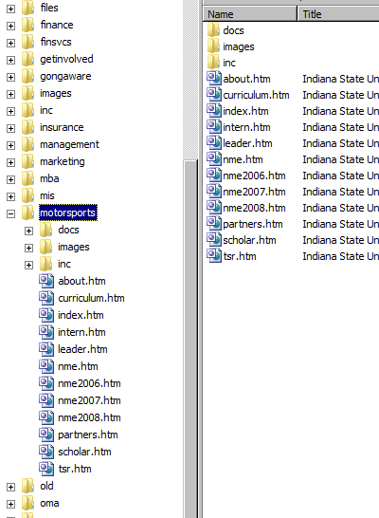
View of the file system (COB)
The main directory should contain subdirectories for the various degree programs or sections of the website, such as faculty. Directory names should be short but descriptive of what they contain, for example docs, images, videos and so on.
The main directory may contain special directories named css, inc, js, templates and so on. These contain the CSS (cascading style sheets), server side include, JavaScript and template files for the entire site. Where applicable, the degree program or other site section directories may also contain directories with these names, these should be specific to that particular section.
Care needs to be taken when editing the files in these directories as these contain information that is used on multiple pages within the web sites.

Naming Conventions
Files used for the website should be descriptive, not too long, all lower case and must not contain spaces. Examples are curriculum.htm and alumni.htm.
Most web sites were developed on Linux or Unix based web servers and unlike Windows based computers these are case sensitive. For example, on a Linux based computer the files notepad.txt, NotePad.txt and notepad.TXT can all exist in the same directory. This is impossible on a Windows based computer. Hence, the naming convention for web sites is to make all file names lower case.
Spaces in web site file names also create some problems on computers. This is because of the way they are displayed in the browser address bar. Spaces are replaced by the code %20, so a file named my file.htm will be displayed as my%20file.htm which can create some confusion for some users.
The naming convention is to name the first page seen in a web site directory index.htm. This is because of the way that web servers work. On the COB/COT web sites it is possible to go to any directory and not specify a file name to display. This is because the server software automatically displays any file named index.htm it finds in that directory. For example, going to
http://indstate.edu/business/about/
will automatically show
http://indstate.edu/business/about/index.htm

Templates
The individual pages are template based to provide a consistent look throughout the site and for ease of use. The templates are kept in the templates directories. These files must not be altered in any way without authorization. When they are used they should be copied, not moved, to their new location and renamed.

Anatomy of a Template
The template, and consequently the pages on the COB/COT websites can be thought have as having various sections

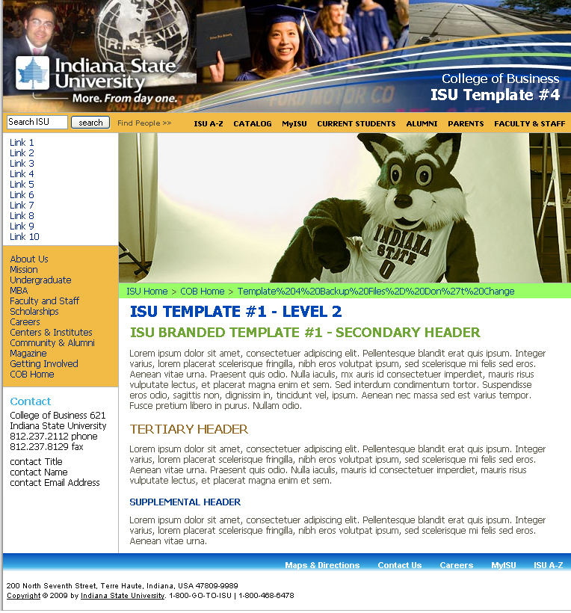
Heading Section
Main menu
Contact Info
ISU Menu
ISU footer
Content area
“Local” menu
Section image
Breadcrumbs
Anatomy of an ISU COB/COT webpage
When editing the page the ISU menu ribbon, COB/COT main menu and ISU footer must not be altered.
The Heading section needs only limited editing.
The “Local” menu, section image, content area and contact information can be edited as circumstances demand.
The ProMBA pages of the College of Business website have an extra section in accordance with the printed materials that were produced for it. This is displayed under the breadcrumbs ribbon.

Template Section Dimensions
The length of the template is not important the various sections of the template automatically expand in height to accommodate the content. What is important however is the width of the various sections as this determines the maximum width of an “unwrappable“ piece of text i.e. a piece of continuous text, such as a URL, or image that can be placed inside each section.
The section widths can be found by examining the CSS files. These dimensions must not be exceeded by any image or long “unwrappable” text, placed inside them because the entire layout of the page will change giving unpredictable results in most browsers.

Menus / Server Side Includes
The menus and contact information on the left hand side are added to the pages as Server Side Includes (SSIs). What this means is that before being presented to the browser the page is first processed by the server and through the use of these SSIs these items are added from separate files.
The main College of Business main menu is kept in /inc and is named cobnav.htm. The College of Technology website’s main include file is named technav.htm. These files must not be edited without authorization as it is used on every page on the website.
Using the #include statement there are two methods of adding these SSIs to the pages, virtual or file. The virtual keyword signifies that the path designated is relative to the website root whilst the file keyword shows the path is relative to the web page. For example
<!--#include virtual="/inc/isuglobal_tmp4.htm"-->
<!--#include file="inc/contact.htm"-->
Due to a quirk in the way that SSI’s are managed they should be edited in Notepad rather than the SharePoint editor. The editor adds extra blank lines to the include when it is displayed on the webpage.
To edit these files in Notepad right click on the file in the inc directory and choose Open With > Notepad.

Before and after editing in a HTML editor
If this happen then you need to open the include file and copy all of the visible text, apart from the very first character, into Notepad. Type in the missing character and save it to your desktop; copy the saved file back to the website and overwrite the original file.
The include files are usually short pieces of HTML and easily editable. For example, the Accounting program navigation menu looks like this…
<ul>
<li><a href="careers.htm">Careers</a></li>
<li><a href="intern.htm">Internships</a></li>
<li><a href="curriculum.htm">Curriculum</a></li>
<li><a href="/business/accounting/forensic.htm">Forensic Accounting</a></li>
<li><a href="../facstaff/index.htm#Accounting">Faculty</a></li>
<li><a href="/business/scholarships/byprogram.htm">Scholarships</a></li>
<li><a href="st_orgs.htm">Student Organizations</a></li>
<li><a href="/business/about/councils/accounting.htm">Advisory Board</a></li>
<li><a href="alumni.htm">Alumni</a></li>
<li><a href="../brochures/accounting.pdf">Brochure (PDF)</a></li>
<li><a href="/business/magazine/news.htm#accounting">In the News</a></li>
<li><a href="./">Accounting Home</a></li>
<li><a href="../programs">Undergraduate Home</a></li>
<li><a href="../">COB Home</a></li>
</ul>
This is simple a list of links and can be easily edited with little HTML knowledge. The part in the a href tag is simply the page to link to and the other text is the text that appears for the link.
There are a couple of pieces of code that are remnants of old DOS days…
../ means “the directory above this one (the parent directory)
./ means “this directory”
To add an include file to a page it is necessary to add the following code to the webpage where the include file is to be placed…
<!--#include virtual="path/filename"-->
<!--#include file="path/filename"-->
For example…
<!--#include virtual="/inc/cobnav.htm"-->
<!--#include file="inc/contact.htm"-->
The virtual keyword signifies that the path designated is relative to the website root whilst the file keyword shows the path is relative to the web page.
There is one odd effect of using includes. The space allocated for the width of the include is fixed. “Unwrappable text” is text that contains no spaces where it can be wrapped and images wider than the include area (154 pixels) may cause the entire content area to drop below the last of the navigation areas.
If PHP is used then the format of the include statement in the file changes. The format used must be in the form…
<? include("inc/technav.htm"); ?>

JavaScript

The website also makes use of JavaScript. JavaScript is a client side processing programming language often used for dynamic effects on a web page. It is used on several pages of the COB/COT sites for this purpose.
Any JavaScript used on the pages should be thoroughly tested in various browsers and submitted to the Communications and Marketing Web Staff - http://indstate.edu/commar/web_staff.htm - for checking.
Where possible the JavaScript functions should be written to a .js file and put in the inc or js folder of a particular section. Three changes need to be made to the HTML page that uses the JavaScript. A line of code needs to be added to the HTML file the function is used so that the calling page knows where the function is.
For example, suppose a JavaScript file of functions with the name mycode.js is placed in the inc directory, the following line of code needs to be added to the head section of the HTML code.
<script type="text/javascript" language="javascript" src="inc/mycode.js"></script>
In order for the functions inside the .js file to be loaded when the page loads the function must be called from the HTML file. This is usually done by altering the <body> tag of the page to read <body onload=”myfunction()”>
Calling a particular JavaScript function can also be done by using the following code
<script language="text/javascript" type="text/javascript">
Name_of_function();
</script>
And placing it on the page where the code is to be executed.
There is a global JavaScript file named isucobjs.js in the main inc directory on the COB website. For the COT website the file is named isucot.js in the js directory. Where possible JavaScript functions that are to be used in multiple pages in multiple areas of the site should be placed in this file.

JavaScript: The Slideshow Function
Several pages on the website such as http://indstate.edu/business/gongaware/ and http://indstate.edu/business/motorsports/ have a JavaScript based slideshow.
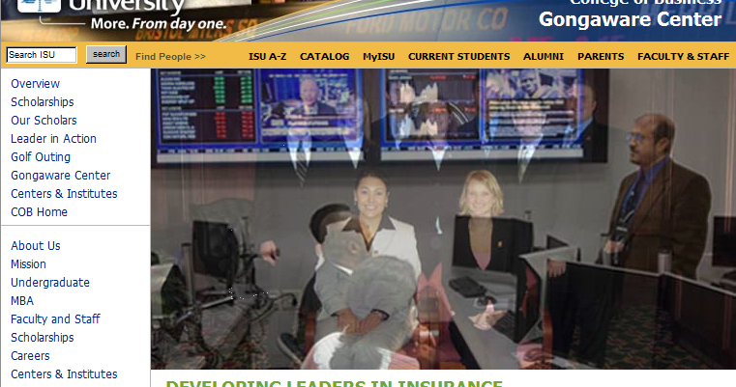
JavaScript slideshow transition
http://indstate.edu/business/gongaware/
The code inside the slideshow.js file is this…
var slideShowSpeed = 3500
var crossFadeDuration = 2
var Pic = new Array() // don't touch this
// to add more images, just continue
// the pattern, adding to the array below
Pic[0] = 'images/homeimage1.jpg'
Pic[1] = 'images/homeimage2.jpg'
Pic[2] = 'images/homeimage3.jpg'
Pic[3] = 'images/homeimage4.jpg'
// =======================================
// do not edit anything below this line
// =======================================
var t
var j = 0
var p = Pic.length
var preLoad = new Array()
for (i = 0; i < p; i++){
preLoad[i] = new Image()
preLoad[i].src = Pic[i]
}
function runSlideShow(){
if (document.all){
document.images.SlideShow.style.filter="blendTrans(duration=2)"
document.images.SlideShow.style.filter="blendTrans(duration=crossFade Duration)"
document.images.SlideShow.filters.blendTrans.Apply()
}
document.images.SlideShow.src = preLoad[j].src
if (document.all){
document.images.SlideShow.filters.blendTrans.Play()
}
j = Math.round(Math.random()*(p-1));
if (j > (p-1)) j=0
t = setTimeout('runSlideShow()', slideShowSpeed)
What this code does is set up an array containing the images and to preload these into the visitor’s computer memory. The code then randomly displays the images. The variable slideShowSpeed determines how long each image is to be displayed for and the variable crossFadeDuration determines how long the fade effect from one image to the next should last for.
The HTML of the page that uses the slideshow has the following code added…
In the head section
<script type="text/javascript" language="javascript" src="inc/slideshow.js"></script>
The <body> tag has been edited to read
<body onLoad="runSlideShow()">
And where the sideshow is to appear the following code added
<!-- Your picture MUST be exactly 605x312 in terms of width and height -->
<img src="images/homeimage1.jpg" name='SlideShow' width="605" height="312" alt="" />
In order for the image to fill the width of the content area then the images must be 605 pixels wide. The exact height does not matter and can vary from slideshow to slideshow but all the images used in any particular slide show must be exactly the same size otherwise they will not display with the correct aspect ratio.
The image name, height and width measurement should be changed to suit your particular images, but should remain consistent for all images.
Copy the file slideshow.js from any inc directory that includes it, for example, /magazine/inc or /scholarships/inc to the inc directory of the section in which you want it to appear.
Open the file in Notepad and edit the lines that look like…
Pic[0] = 'images/homeimage0.jpg'
Pic[1] = 'images/homeimage1.jpg'
Pic[2] = 'images/homeimage2.jpg'
Pic[3] = 'images/homeimage3.jpg'
You can add or reduce the number of images shown in the slideshow by editing the number of entries in this array.

JavaScript: The Alphabetical Button Function
Several pages on the website such as http://indstate.edu/business/facstaff/alpha.htm, http://indstate.edu/business/scholarships/alpha.htm and http://technology.indstate.edu/directory/ have JavaScript based alphabetical buttons.
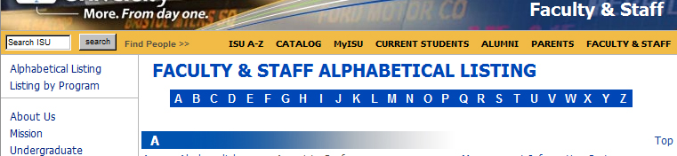
JavaScript buttons
http://indstate.edu/business/facstaff/alpha.htm
In this instance the JavaScript function that draws the button images is not in a separate .js file but embedded in the HTML page itself. Where the buttons are to be displayed the following code is used…
<script language="javascript" type="text/javascript">
{
var count;
var strs;
/* 65 = ASCII value for A, 90 = ASCII value for Z */
for (count = 65; count<=90; count++){
strs = count.toString();
values = '&#' + strs;
document.write('<input type="button" value=" ' + values + ' " style="font-weight:bold; width:20px; border-style:none; background-color:#0047b6; color:white"; onclick=document.location.href="#' + values + '">');
}
}
</script>
Computers do not understand letters, all they can deal with is numbers. Because of this, each key on the keyboard has a numeric code, known as an ASCII (American Standard Code for Information Interchange) code assigned to it. Keys that can have multiple outputs such as the “a” or “A” key have several of these codes assigned. Because the codes are numeric they can be easily manipulated in computer programs. For the capital letters A to Z the ASCII codes are 65 to 90.
The JavaScript code simply uses a loop to produce a button that is given a style to make them appear flat and then assigned a letter in order from A to Z. As well as displaying this letter it is also embedded inside the button as a value.
Throughout the HTML page are anchor tags, or placemarkers, of the form <a name="C"></a>. When a button is clicked on, the value of the button is matched to the anchor tag, A to A, B to B and so on, and the page scrolls down to that particular section.
These anchor tags you need create on the page yourself. If there is no anchor tag for a corresponding letter button then nothing will happen when the button is clicked on.
Although they do not look like normal HTML buttons the appearance has been altered using standard CSS styling codes.

JavaScript: Breadcrumbs Menu
All of the pages have a JavaScript based “breadcrumbs” menu.
The JavaScript breadcrumbs menu
The code for this menu is contained in the breadcrumbs function in the main /inc/isucobjs.js file. The function is this…
function breadcrumbs(){
var path = location.pathname;
var bitsarray = path.split("/"); //Split the path and put it into an array
var x=0;
var i=0;
var j=0;
var output = "&nbsp; <a href=\""; //Start building the output string
//If the directory is a program then need to flag to put a link to the program directory...
var progflag = 0;
x = bitsarray.length-2;
switch(bitsarray[x]){
case "accounting": progflag = 1; break;
case "beit": progflag = 1; break;
case "busadm": progflag = 1; break;
case "finance": progflag = 1; break;
case "finsvcs": progflag = 1; break;
case "insurance": progflag = 1; break;
case "management": progflag = 1; break;
case "marketing": progflag = 1; break;
case "mis": progflag = 1; break;
case "motorsports": progflag = 1; break;
case "oma": progflag = 1; break;
}
for (i=1;i<bitsarray.length;i++){
output = output + "../";
}
output = output + "\">ISU Home</a>";
for (i=1;i<bitsarray.length-1;i++){ //Work on each element in the array
switch(bitsarray[i]){ //and change it to a more readable form
case "beit": bitsarray[i] = bitsarray[i].toUpperCase(); break; case "busadm": bitsarray[i] = "Business Administration"; break;
case "business": bitsarray[i] = "COB Home"; break;
case "cec": bitsarray[i] = "Career Experience Center"; break;
case "facstaff": bitsarray[i] = "Faculty &amp; Staff"; break;
case "finsvcs": bitsarray[i] = "Financial Services"; break;
case "getinvolved": bitsarray[i] = "Get Involved"; break;
case "mba": bitsarray[i] = bitsarray[i].toUpperCase(); break;
case "mis": bitsarray[i] = bitsarray[i].toUpperCase(); break;
case "oma": bitsarray[i] = bitsarray[i].toUpperCase(); break;
case "spring2008": bitsarray[i] = "Spring 2008"; break;
default: bitsarray[i] = bitsarray[i].substr(0,1).toUpperCase() + bitsarray[i].substr(1);
}
output = output + " > <a href=\"";
x = bitsarray.length - 2;
if (i < x){
x=bitsarray.length-i-1;
for (j=1;j<x;j++){ //Work through each directory path to the page
output = output + "../";
}
}
//If the directory is a program then need to put a link to the program directory before the final directory...
if (progflag==1 && i==bitsarray.length-2){
output = output + "../programs\">Undergraduate</a> > <a href=\"../programs/information.htm\">Programs</a> > <a href=\"";
}
output = output + "./\">" + bitsarray[i] + "</a>";
}
document.write("<div style='background-color: #99ff66; padding: 3px;'>");
document.write(output + "</div>");
}
What this code does is look at the URL of the page using location.pathname and splits it into the bitsarray array. Each element in the array is then processed.
The first thing to be done is to set a flag for the programs. This is because the actual directory structure does not always follow the logical layout of the site. To make the breadcrumbs menu more readable to the user instead of seeing, for example ISU Home > COB Home > Accounting the user sees ISU Home > COB Home > Undergraduate > Programs > Accounting.
An output string, output, is set up and as the various elements of bitsarray are processed this string is appended to. Again, because the directory names are not always in a form easily recognized by the user some tidying is done in the case statement.
bitsarray[i] = bitsarray[i].toUpperCase();
Upper cases the entire string, so that beit becomes BEIT.
case "business": bitsarray[i] = "COB Home"; break;
Completely changes the text, in this case “business” becomes “COB Home”
The default action of this case statement is to proper case the text so that “gongaware” becomes “Gongaware”.
There is one slightly confusing part of the syntax used in the code and that is the use of \”. This is because of the way that JavaScript uses quotes as a delimiter. Where quotes need to be used, as in <a href=”xxxxxx…. then an escape character “\” has to be used to tell the scripting engine that the character after the backslash is to be treated as text and not a string delimiter.
The breadcrumbs menu appears on nearly all pages of the COB/COT websites. The actual JavaScript code is kept in the main inc directory in the file isucobjs.js in a function named breadcrumbs.
Be very careful when editing this code as it is used on every page of the website. Make a copy of the file before changing any code and ensure the new code works before deleting or overwriting the original.

JavaScript: Sortable Tables
Some tables in the websites, for example - http://technology.indstate.edu/consortphd/facstaff/index.htm are sortable by clicking on the table headers. The original code for this was written by Stuart Langridge and comes from his website http://www.kryogenix.org/code/browser/sorttable/
The JavaScript for this is kept in the JS directory of the COT website and should not need any editing. Should the original website be no longer available the documentation for this has been added at the end of this document.

JavaScript: Showing and Hiding Part of a Page
It is sometimes useful to hide or show part of a webpage at will and this can be achieved using a mixture of JavaScript and CSS. An example of this can be found on the FAQ page of the ProMBA website - http://indstate.edu/business/promba/faq.htm

Showing and hiding webpage elements
http://indstate.edu/business/promba/faq.htm
Clicking on one of the question links shows the information associated with that particular question

Showing and hiding webpage elements
http://indstate.edu/business/promba/faq.htm
The code to do this is in the main JavaScript file and is…
function showhide(mydiv){
/* Show or hide a page element - useful for FAQs */
if(document.getElementById(mydiv).style.display == "none") {
document.getElementById(mydiv).style.display = "block"; }
else { document.getElementById(mydiv).style.display = "none"; }
}
All this does is test, using an ID, to see if a block of code is hidden. If it is then it shows it, if it isn’t then it hides it.
An example of the code calling this function is
<p><a href="javascript:showhide('laptopreq')">Question?</a></p>
<div id="laptopreq" style="display:none;">
<p>reply reply reply</p>
</div>
There are two CSS properties that can show or hide webpage elements, these are display and visibility. Display will remove the element from the webpage so the flow and layout are seamless whilst visibility will leave the space that would have been occupied by the element intact – an empty space will appear where that element should have been displayed.
The attributes most used with the display property are “none”, “block” or “inline” for the visibility property the attributes are “visible” or “hidden”.
A more sophisticated version of this code was used on the COT Degree Program page - http://technology.indstate.edu/degrees/bydept.htm
The individual divs that make up the various sections of page are inside a div. When the page is loaded JavaScript is used to check if the URL contains a query string. If it does not then the entire page is loaded.
If it does then the query string is extracted and only the Div with the matching ID to the query string is displayed. A button is also shown that will reload the page without a query string to show all of the page’s contents.
This behavior can be shown by first of all visiting http://technology.indstate.edu/degrees/bydept.htm and then clicking on one of the Degree Programs, for example Aviation Technology, in the second section. If you then click on the “Degree Programs” link at the top left of the page that appears you will be taken back to http://technology.indstate.edu/degrees/bydept.htm but this time only the Aviation degree programs will show. Take a look at the browser address bar; the actual URL displayed is http://technology.indstate.edu/degrees/bydept.htm#AVT&dept=AVT
The JavaScript for the page has read the URL and used the query string to only display the div with the ID AVT.
The code to do this is in the JavaScript functions, function querystr() which checks if a query string is present; function getqs(dept) which reads the query string and function reloadpage() which reloads the page with no query string.

JavaScript: Query String
A query string is a form of URL that contains that contains data to be passed to web applications. This takes the form of http://server/path/program?query_string where the query string contains one or more name and value.
function querystr(){
/* Parse the URL query string
This is a simple search for "="
If found then call another function to get the querystring and hide everything apart from that on the page */
var deptarray = document.location.href.split("=");
if (deptarray.length > 1){
getqs(deptarray[1]);
}
}
function getqs(dept){
// Get an array of all DIV elements inside the DIV "hideall" and then hide them
// Show any DIVs that match the querystring dept.
var mylist=document.getElementById("hideall");
var listitems=mylist.getElementsByTagName("div");
for (i=0; i<listitems.length; i++){
listitems[i].style.display = "none";
if (listitems[i].id.toLowerCase() == dept.toLowerCase()){
listitems[i].style.display="block";
}
}
document.write("<p class='ctr'><button type='button' onclick='javascript:reloadpage()'>Show All</button></p>");
}
function reloadpage(){
// Reload the entire page without any querystring
var pagearray=document.location.href.split("#");
document.location=pagearray[0];
}
The query string method is used on the pages at http://technology.indstate.edu/degrees/bydept.htm and then clicking on one of the Degree Programs, for example Aviation Technology, in the second section. If you then click on the “Degree Programs” link at the top left of the page that appears you will be taken back to http://technology.indstate.edu/degrees/bydept.htm but this time only the Aviation degree programs will show. Take a look at the browser address bar; the actual URL displayed is http://technology.indstate.edu/degrees/bydept.htm#AVT&dept=AVT
It is also used at http://technology.indstate.edu/videos.htm but in this case when a video link is clicked on the onclick event property calls a JavaScript function, passing to it the name of the video to play and the name of the image to show.
<tr>
<td class="ctr"><a href="#" onclick="showvids('COT opening day.flv','day_one_web.jpg');">
<img alt="COT Opening Day" src="videos/day_onesml.jpg" width="30" height="60" class="noborder"/></a>
</td>
<td><a href="#" onclick="showvids('COT opening day.flv','day_one_web.jpg');">Opening Day for First Year Students</a>
</td>
</tr>
The function is in the main JavaScript file and is…
function showvids(vid,pic){
// Get the video and image and open a new window to show them
var newurl = "showvid.php?vidfile=" + vid + "&picfile=" + pic;
window.open(newurl, 'popup', 'width=500,height=350');
}
What this does is create a query string and open a new window at showvid.php. PHP is not used much on the COB/COT sites but the server does support it. The PHP code to read the query string in showvid.php is…
<?php
$self = $_SERVER["PHP_SELF"];
if($_SERVER["QUERY_STRING"]) {
$vidfile="http://technology.indstate.edu/videos/" . $vidfile;
$picfile="http://technology.indstate.edu/videos/" . $picfile;
} else {
$vidfile="http://technology.indstate.edu/videos/COT opening day.flv";
}
?>
The remaining code on the page is the normal video code to display the JW Player.

JavaScript: Random Images
Nearly all the pages of the COT website show a random image from a set of images. The easiest way to implement this is to create a series of images, all the same size and with the same filename apart from a numeric suffix, for example mymg0.jpg, myimg1.jpg, myimg2.jpg and so on, and place them all in a single directory. The JavaScript to display any one of these images is…
function rndmpict(){
/* Choose a random picture for the right hand column
The images should be 180 pixels wide and named picX.jpg
where X are consecutive numbers starting from 0
As images are added, increase the variable "numpics" to match the number of images available */
var numpics = 42;
var rndmnmbr = Math.floor(Math.random() * numpics);
document.write('<p class="ctr"><img src="/images/pic' + rndmnmbr + '.jpg" alt="College of Technology" class="noborder "/></p>');
}
It is also possible, by passing a variable to the JavaScript function to display an image from a set of images which is different for a particular set of pages…
function rhspict(dept){
/* Choose a random picture for the right hand column depending of the dept chosen
The images should be 180 pixels wide and named xpicy.jpg
where x are the depts and y consecutive nuumbers starting from 0
As images are added, increase the variable "xpics" to match the number of images available
genpics are general images and can be used anywhere */
/* Generate a number 0 or 1. If 0 then use a general picture else use a dept picture */
if (dept.toLowerCase() != "gen"){
rndmnmbr = Math.floor(Math.random() * 2);
if (rndmnmbr == 0){
dept = "gen";
}
}
switch(dept.toLowerCase()){
case "aet" :
numpics = "9";
break;
case "aetm" :
numpics = "18";
break;
case "avt" :
numpics = "25";
break;
}
var rndmnmbr = Math.floor(Math.random() * numpics);
document.write('<p class="ctr"><img src="/images/rhimages/' + dept + 'pic' + rndmnmbr + '.jpg" alt="College of Technology" class="noborder "/></p>');
}
Care should be taken that when adding images that the variable for the number of images is also updated.

PHP

PHP is not used much on the COB/COT webpages even though the server supports it. For most purposes JavaScript fits our needs as well as, and sometimes better than, PHP. One place that PHP is used is in reading RSS feeds. This is discussed elsewhere.
If PHP is used then the file containing the PHP code must have the PHP file extension .php so the server recognizes that the page contains code that needs to be processed before it is served.
The format of the include statement in the file must be changed. The format used must be in the form…
<? include("inc/technav.htm"); ?>

PHP: Query String
One place PHP is used is in the query string handling on showvid.php accessed from the links on http://technology.indstate.edu/videos.htm. JavaScript is used to create the query string from the onclick event handler but the PHP on showvid.php reads it. The code to do this is…
<?php
$self = $_SERVER["PHP_SELF"];
if($_SERVER["QUERY_STRING"]) {
$vidfile="http://technology.indstate.edu/videos/" . $vidfile;
$picfile="http://technology.indstate.edu/videos/" . $picfile;
} else {
$vidfile="http://technology.indstate.edu/videos/COT opening day.flv";
}
?>
The rest of the code on the page simply displays the video.

PHP vs JavaScript

Both client side scripting like JavaScript and server side scripting like PHP have their uses. JavaScript is useful where the webpage elements are already on the page, so using PHP, which needs to access the server, may be slower. PHP is useful in situations where the page is fresh from the server and especially in database applications which the COB/COT sites do not use.

Form Elements / Control Elements

As their name implies, form elements or control elements, such as check boxes, radio buttons, buttons etc., were originally developed for use in HTML forms.
The COB/COT websites makes little use of forms but does use control elements such as buttons and drop-down lists. The use of JavaScript coded buttons has been previously described.

Control Element: Drop-Down Lists
Drop-down lists are not particularly hard to code and provide a useful, space-saving way of hiding menu items until the page visitor decides to activate them.
Although normally embedded in the HTML page itself because the server supports SSIs the code used is placed inside a separate HTML file named dropdown.htm and placed in the inc folder and called by using <!--#include file="inc/dropdown.htm"--> at the place in the page where the drop-down list is to appear in the main HTML page.
Several pages on the websites such as http://indstate.edu/business/motorsports/news.htm and http://indstate.edu/business/facstaff/ and http://technology.indstate.edu/index.php make use of drop-down lists.
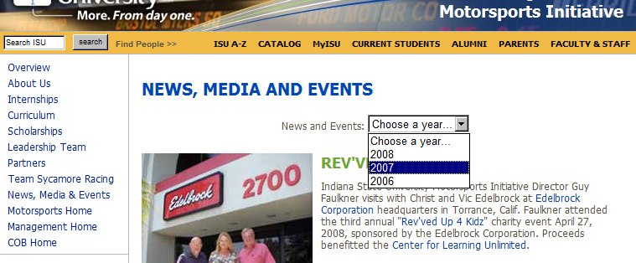
Drop-down list
http://indstate.edu/business/motorsports/news.htm

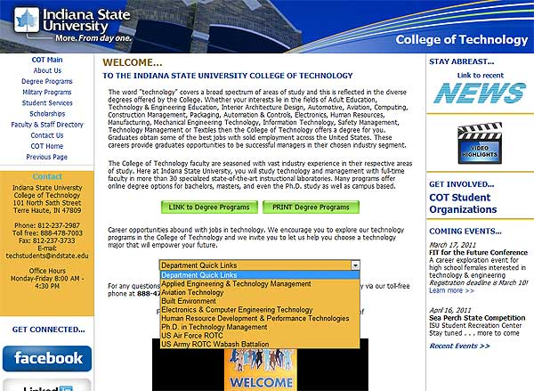
Dropdown list with added style
http://technology.indstate.edu/
The code used to produce this drop-down list is…
<form name="jump">
<p align="center">
News and Events: <select name="drop"
onChange="location=document.jump.drop.options[document.jump.drop.selectedI ndex].value;">
<option>Choose a year...</option>
<option value="nme2008.htm">2008</option>
<option value="nme2007.htm">2007</option>
<option value="nme2006.htm">2006</option>
</select>
</p>
</form>
In this form of code, the onChange event is triggered when a new choice from the menu is selected. Each option in the menu is assigned a value of a name of a HTML page and when the onChange event is triggered the visitor is taken to that page.
Styles can also be added to dropdown list. This is done by adding a style to the Select statement, for example
<select name="drop" style="background-color:#f1bb46;" onChange="location=document.jump.drop.options[document.jump.drop.selectedIndex].value;">
The main working parts of the code are the lines that read…
<option value="nme2008.htm">2008</option>
These can be changed to suit your purpose. Change nme2008.htm to point to the page that you want and change 2008 to whatever text you want to appear in the list. To go to an anchor tag on the current page then simple change nme2008.htm to #anchor_name – such as #marker where the user will be taken to the anchor tag <a name="marker"></a> on your page.

Forms

The COB / COT websites make little use of forms on the site pages. The simplest way of doing this is using a mailto form…
<form method="post" action=mailto:yourname@yoursite.com?subject=from web page enctype="text/plain">
<input type=text name=your_comments>
<input type=submit value="Submit Your Comments">
</form>
Unfortunately and for a variety of reasons mailto forms do not always work properly. These forms no longer work correctly in IE 6 and above; it may be that the visitor’s email client isn’t set up for web forms or a number of other reasons. Browsers that do use mailto forms, like Firefox, will automatically open the visitor’s email client, which is something they may not want you to do.
There are a couple of alternate solutions…

Qualtrics
In order to produce a Qualtrics form you will need to create an account. You can request a Qualtrics account by contacting the OIT Help Desk at 237-2910 or e-mail it-help@indstate.edu. Be prepared to supply your ISU ID (991 number) when making your request.
You can see a sample Qualtrics form and survey at Qualtrics’ website at http://www.qualtrics.com/sample-survey/. There is also a lot of help available on the site at http://www.qualtrics.com/university/. A Qualtrics form is used as a sign-up for the 2011 Octoberfest Golf Scramble on the COB pages at http://indstate.edu/business/insurance/golf/.

Google Docs
Also very useful is Google Docs. You need to have a Google account in order to use Google Docs and you can create a new form easily and is used by the COT to submit news items and request changed to the website - http://technology.indstate.edu/requestforms.htm

Images

There are three image formats in common usage on the web and which are displayed properly in all browsers. These are .jpg, .gif and .png. These are all bitmap files as vector (scalable) images are not yet widely supported. gif images are versatile in that they support transparencies and animation which jpg files do not. However gif files are limited to a palette of 256 colors which makes them unsuitable for photographic images. png files also support transparency.
Unnecessarily large image files will drastically increase the page loading time. To be used on web pages, images must be optimized. That is, the file size must be reduced whilst still giving acceptable image quality. In order to get the best quality from the finished image a good image editor is recommended.
There are several methods that are employed.
Web browsers automatically display images at 72dpi, and so the first step in reducing the file size is to reduce the dpi to 72dpi.
The image dimensions are an important factor and images should be resized to the same dimensions as they are going to appear on the website. This may seem obvious but images can be dimensioned within HTML code, although the algorithms used by the browser are not so good as those in a dedicated image editor.
jpg and png files can also be compressed. Many images can be compressed up to 80% or more with little noticeable difference to the quality.
The largest image that can be accommodated by the main content area has a width no greater than 605 pixels.

Image Maps

An image map is an image that has one or more distinct hyperlinked areas. This is different to a normal image link where the entire image is linked to a single destination.
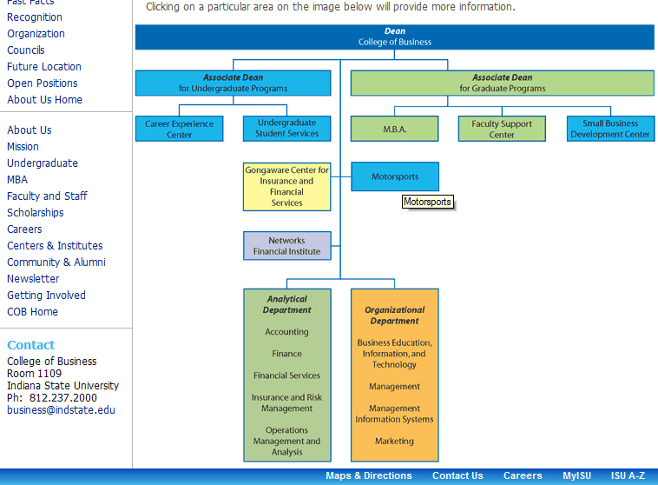
Each of the colored areas is hyperlinked to a separate page
http://indstate.edu/business/about/orgchart.htm
The code for this image map is…
<MAP NAME="orgmap">
<AREA HREF="welcome.htm" ALT="The Dean" TITLE="The Dean" SHAPE=RECT COORDS="3, 5, 602, 33">
<area href="../programs" alt="Undergraduate Programs" title="undergraduate programs" shape="rect" coords="3, 57, 229, 88">
<area href="../mba" alt="Graduate Programs" title="Graduate programs" shape="rect" coords="251, 57, 603, 86">
<area href="../CEC" alt="Career Experience Center" title="Career Experience Center" shape="rect" coords="3, 110, 105, 139">
<area href="../programs/students/usso.htm" alt="Undergraduate Student Services" title="Undergraduate Student Services" shape="rect" coords="127, 110, 229, 139">
<area href="../mba" alt="MBA" title="MBA" shape="rect" coords="251, 110, 353, 139">
<area href="../facstaff/adamsa.htm" alt="Faculty Support Center" title="Faculty Support Center" shape="rect" coords="375, 110, 477, 139">
<area href="http://www.westcentralindianasbdc.com/" alt="Small Business Development Center" title="Small Business Development Center" shape="rect" coords="500, 110, 602, 139">
<area href="../gongaware" alt="Gongaware Center" title="Gongaware Center" shape="rect" coords="127, 163, 229, 219">
<area href="../motorsports" alt="Motorsports" title="Motorsports" shape="rect" coords="251, 163, 353, 196">
<area href="../centers/networks.htm" alt="Networks" title="Networks" shape="rect" coords="127, 242, 229, 276">
<area href="../programs/information.htm" alt="Undergraduate Programs" title="Undergraduate Programs" shape="rect" coords="127, 308, 229, 345">
<area href="../accounting" alt="Accounting" title="Accounting" shape="rect" coords="127, 343, 229, 372">
<area href="../finance" alt="Finance" title="Finance" shape="rect" coords="127, 370, 229, 396">
<area href="../finsvcs" alt="Financial Services" title="Financial Services" shape="rect" coords="127, 394, 229, 423">
<area href="../insurance" alt="Insurance &amp; Risk Management" title="Insurance &amp; Risk Management" shape="rect" coords="127, 421, 229, 460">
<area href="../oma" alt="Operations Management &amp; Analysis" title="Operations Management &amp; Analysis" shape="rect" coords="127, 458, 229, 508">
<area href="../programs/information.htm" alt="Undergraduate Programs" title="Undergraduate Programs" shape="rect" coords="251, 308, 353, 359">
<area href="../beit" alt="Business Education, Information &amp; Technology" title="Business Education, Information &amp; Technology" shape="rect" coords="251, 357, 353, 408">
<area href="../management" alt="Management" title="Management" shape="rect" coords="251, 406, 353, 434">
<area href="../mis" alt="Management Information Systems" title="Management Information Systems" shape="rect" coords="251, 432, 353, 474">
<area href="../marketing" alt="Marketing" title="Marketing" shape="rect" coords="251, 472, 353, 508">
</MAP>
<img border="0" src="images/COBOrgChart.gif" width="605" height="513" USEMAP="#orgmap">
There are several programs that can produce the code semi-automatically, including some HTML editors.
Image maps are a method of making a part or parts of an image clickable. The organizational chart on http://indstate.edu/business/about/orgchart.htm is an image map. The can be easily created in both Microsoft SharePoint Designer and FrontPage.
Add an image to the web page and put the editor into design view using the tabs in the bottom left corner. Show the picture toolbar by right clicking on the image and choosing “Show Pictures Toolbar” from the menu that appears.
Using the tools on the right of the toolbar, highlighted in the image below, the editor will produce the code needed to produce the “hot spots”. You will be prompted for the page, email address or anchor you want the user to be taken to when they click on that particular “hot spot”.
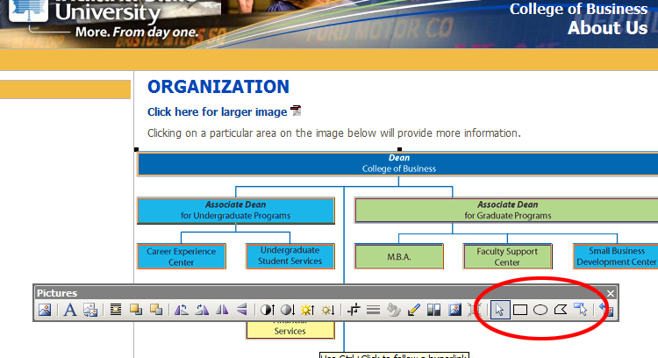
The picture toolbar showing the image map tools

Video

There are several methods of adding videos to webpages. Most rely on using whatever video player the visitor has installed on their computer. The HTML 5 standard hopes to standardize the code used but that may not be finalized for another 10 years or so.
The method chosen for the COB/COT websites is to embed a video player into the webpages to give a more consistent look and feel to the pages. The video player used is JW Player from http://www.longtailvideo.com/ . This player can be used in conjunction with SWFObject from http://code.google.com/p/swfobject/ to control how the player behaves.
At the time of writing the latest version of JW Player is 5.5. However, the versions from at least 4.5.230 were watermarked with the JW Player logo. The last version that we have available that is not watermarked and without paying is version 4.3.132.
JW Player can only handle FLV and MP4 video files. FLV files are pretty standard but MP4 files can be made using various codecs. JW Player needs MP4 files to be created using H264 standards. A common standard for MP4 files is MOV but these will not play in JW Player
Pages with video include http://technology.indstate.edu/, http://technology.indstate.edu/videos.htm, http://technology.indstate.edu/AVT/ and http://indstate.edu/business/promba/
The controlling file, swfobject.js should be placed in the main JavaScript directory for the site and linked on the page by using a normal JavaScript tag such as
<script type="text/javascript" src="/business/inc/swfobject.js"></script>
The video using controlled by placing the controlling JavaScript directly underneath that
<script type="text/javascript">
var flashvars = {};
flashvars.file = "http://indstate.edu/business/promba/videos/prombaintrov2.flv";
flashvars.image = "http://indstate.edu/business/promba/videos/prombavid.jpg";
flashvars.width = "190";
flashvars.height = "350";
flashvars.displayheight = "300";
flashvars.backcolor = "0x111111";
flashvars.frontcolor = "0xdddddd";
flashvars.lightcolor = "0x99cc00";
flashvars.playlist = "bottom";
flashvars.playlistsize = "0";
flashvars.buffersize = "30";
flashvars.icons = "false";
var params = {};
params.loop = "false";
params.quality = "best";
params.wmode = "transparent";
params.allowfullscreen = "true";
params.allowscriptaccess = "always";
var attributes = {};
swfobject.embedSWF("player.swf", "altvideo", "400", "240", "9", "expressInstall.swf", flashvars, params, attributes);
</script>
The image attribute is used to specify what image should be placed in the video player prior to the video running. Finally, where the video is to be displayed, the following code is used on the webpage…
<div style="margin-right:auto;margin-left:auto;text-align:center;">
<div id="altvideo">
</div>
</div>
<p>&nbsp;</p>
</div>
The page at http://technology.indstate.edu/AVT/ shows how video player looks with a simple XML playlist. The playlist is placed in the video subdirectory and looks like this…
<?xml version='1.0' encoding='utf-8'?>
<playlist version="1" xmlns="http://xspf.org/ns/0/">
<trackList>
<track>
<creator>Aviation</creator>
<title>APV1</title>
<location>http://technology.indstate.edu/AVT/videos/apv1.flv</location>
<image>http://technology.indstate.edu/AVT/videos/apv1pic.jpg</image>
</track>
<track>
<creator>Aviation</creator>
<title>APV2</title>
<location>http://technology.indstate.edu/AVT/videos/careers-in-aviation.flv</location>
<image>http://technology.indstate.edu/AVT/videos/careerpic.jpg</image>
</track>
<track>
<creator>Aviation</creator>
<title>APV3</title>
<location>http://technology.indstate.edu/AVT/videos/aviation.flv</location>
<image>http://technology.indstate.edu/AVT/videos/advpic.jpg</image>
</track>
</trackList>
</playlist>
When specifying the file paths to the images and videos for JW Player the full, absolute path URL should be used. Using relative URLs will result in some “file not found” errors.
For ease of use and consistency it has been found that videos should be converted to FLV format. The free utility Super Converter from http://www.erightsoft.com/SUPER.html

RSS Feeds
The page at http://technology.indstate.edu/news.php takes the newsfeed from the ISU page at http://www.indstate.edu/news/rss/home.php. In order to do this the RSS feed reader RSS2HTML is used from http://www.feedforall.com/. The zip file downloaded from the site includes files named FeedForAll_XMLParser.inc.php and rss2html.php. These should be placed in a separate directory, in the case of the COT site, tech-news-files. This directory should also contain the files to format the RSS output.
In the file that the RSS feed is to be displayed, for example http://technology.indstate.edu/news.php, the following lines are added…
<?php
$XMLFILE = "http://www.indstate.edu/news/rss/rsstechnology.xml";
$TEMPLATE = "http://technology.indstate.edu/tech-news-files/tech-feed-wlink.php";
include("tech-news-files/rss2html.php");
?>
$XMLFile is the RSS feed file, in this case it is rsstechnology.xml but it could be rssbusiness.xml.
$TEMPLATE is the template file to display the RSS feed. In this case it is tech-feed-wlink.php. This file contains the lines…
<!--<H1>~~~FeedTitle~~~</H1> -->
~~~BeginItemsRecord~~~
<p>
<b><a style="text-decoration:none;" href="~~~ItemLink~~~">~~~ItemTitle~~~</a></b><br>
~~~ItemDescription~~~
</p>
~~~EndItemsRecord~~~
Sometime not all the characters in the newsfeed display properly on the HTML page. For example,
Room and board increase is smallest since ‘99
when shown on the COT newsfeed page at http://technology.indstate.edu/news.php appeared as...
Room and board increase is smallest since â€˜99
In order to correct this behavior then the PHP str_replace method can be used either in FeedForAll_XMLParser.inc.php which replaces the string in the XML input file variable, $XMLString or in rss2html.php which replaces the string in the HTML output variable, $resultHTML
The PHP str_replace functions is
str_replace(substring_to_replace, substring_to_replace_with, string_to_look_in)
For example
$XMLString = str_replace(“a", "z", $XMLString)
For more information see http://php.net/manual/en/function.str-replace.php
In the COT news files, I’ve marked the changes I’ve made with my name and *** to make looking for them easier.

Search Engine Optimization

Due to abuse not many of the major search engines place too much emphasis on the meta tag “keywords” but it may still be used. Here’s an example from the head section of http://indstate.edu/business/promba/index.htm
<meta name="keywords" content="indiana, state, university, pro, professional, master, business, administration, mba, scott, college" />
The head section of the templates do contain the line
<meta name="robots" content="all" />
This means that the search engine crawlers will index the entire page, including links to other pages. This is the standard behavior of search engine crawlers. The robots directive can also be used in a separate robots.txt file. Full details of this file can be found at http://www.robotstxt.org/
The ProMBA directories in the COB website contain a sitemap.xml file in order to help search engine crawlers find every page in the directory. This file is a list of all pages in the form of an XML file…
<?xml version='1.0' encoding='UTF-8'?>
<urlset xmlns:xsi=http://www.w3.org/2001/XMLSchema-instance
xsi:schemaLocation=http://www.sitemaps.org/schemas/sitemap/0.9 http://www.sitemaps.org/schemas/sitemap/0.9/sitemap.xsd
xmlns="http://www.sitemaps.org/schemas/sitemap/0.9">
<url>
<loc>http://indstate.edu/business/promba/</loc>
<lastmod>2011-02-11</lastmod>
</url>
<url>
<loc>http://indstate.edu/business/promba/index.htm</loc>
<lastmod>2011-02-11</lastmod>
</url>
…..
…..
…...
<url>
<loc>http://indstate.edu/business/promba/schedule.htm</loc>
<lastmod>2011-02-11</lastmod>
</url>
<url>
<loc>http://indstate.edu/business/promba/students.htm</loc>
<lastmod>2011-02-11</lastmod>
</url>
</urlset>
A plain text file containing a list of all files to be indexed can also be used. Full details can be found at http://sitemaps.org/ which was produced by Google, Yahoo and Microsoft.
Sitemaps may be submitted directly to Google at https://www.google.com/webmasters/tools/

Website Traffic and Analysis

Aside from the raw server statistics one of the best website analytics engines is Google Analytics. This involves adding a snippet of code to every page that is to be included in the report. This can easily be done using the preferred editor, SharePoint Designer.
As with other Google products you need to have a Google account and be given administrator rights to the analytics pages.
Currently the only portion of the COB/COT websites to carry the Google Analytics code is the ProMBA section of the COB website. The Google Analytics administrators for this are currently Jeff Harper, Bruce Mclaren and myself, Ray Thomas.
The Google Analytics webpages can be found at http://www.google.com/analytics/. A link to this page will also appear when you log into your Google account.
A short video about what Google Analytics can do can be found at http://www.google.com/analytics/tour.html and an example report can be found at http://www.escapecreative.com/pdf/google-analytics-sample-report.pdf

Adding and Editing Website Files

Introduction
Adding and editing web files is not hard, however doing it properly and to W3C (World Wide Web Consortium - http://www.w3.org/) standards requires some patience and practice. This part of the documentation contains information that should help in updating and maintaining the Indiana State University COB/COT websites.

Warnings
Remember, you will be editing original files on a live web server. Ruining one of these files requires that a copy of it is retrieved from a backup which may take a little time, during which the file may either not display properly or at all to anyone visiting the COB/COT websites.

There is no recycle bin on web servers and once deleted it is not so easy to recover files that have been deleted as it is on other computers. For this reason it is best to move the file into a directory named “old” until it is positive that the file is no longer needed and can be safely deleted.
If you want to edit an already live file then work on a copy of the file and do not delete the original until you are sure that the copy displays properly in a variety of browsers.
Any scripts you add to the web pages must be tested in a variety of browsers and submitted to the Communications and Marketing Web Staff - http://indstate.edu/commar/web_staff.htm - for checking.
Do not edit the include files with a HTML editor. In order for these files to work hidden characters are added to the beginning of the files and these will create gaps in the text. The include files should only be edited in Notepad.

Editors
The preferred HTML editor for the COB/COT websites is Microsoft SharePoint Designer. This is an intelligent editor in that it can validate the HTML as it is being written. It can also, to a certain degree, warn of what effect moving a particular file will have on pages that use that file and rewrite the links on those pages. It is not however infallible and care should be taken when editing the web site files.
Other Microsoft products such as FrontPage 2003 or Visual Web Developer 2008 Express Edition should not be used to edit the HTML files.
Adobe DreamWeaver cannot be used to edit the COB/COT websites. This is because SharePoint uses different technology than DreamWeaver was designed for.
Do not use Microsoft Office or similar programs to edit or create files for use on the COB/COT websites. Although excellent programs for their primary purpose, this is not writing HTML files. The HTML produced by, for example, Microsoft Word, produces HTML and XHTML code that will allow the document to be reopened in that program for further editing. This makes the code incompatible with any recognized HTML or XHTML standard which makes the pages produced very difficult to re-edit properly afterwards.

Working With Directories
Remote directories can be accessed and manipulated in the editor in exactly the same way as directories on your own computer. Documents should be placed in the appropriate directories; image files in the images directory, code and include files in the inc directory and so on. If you feel that a new main directory section needs to be created then the inc directory should be created to hold that sections local navigation and contact HTML file. Other directories, such as images, docs etc. can be created as they are needed.
When creating a new section of the website it may be useful to copy the entire inc directory so as to provide a starting point to edit the navigation and contact HTML snippets.

Working With Files
As with the directories, files can also be manipulated on the web server as they would on any other computer. There two major exceptions.
- The web server does not have a recycle bin and once deleted files cannot be easily recovered. For this reason it is best to move the file into a directory named “old” until it is positive that the file is no longer needed and can be safely deleted.
- When a file is moved from within the editor then both Microsoft Office Designer and Microsoft FrontPage will automatically update the links to that file on pages that reference it. This is not true of all editors and although it is a design feature it may mean that old material may still be referenced by one or more web pages.

Creating a New Page
This is not recommended. The reason being new pages have to fit with the general look and feel of the entire site. This is not easy if the page is created from scratch and instead copying and editing an existing page or one of the templates is the best course of action.

Copying an Existing Page
This is the preferred method of creating a new page. The copied page may be an existing page or one of the templates. Once copied to its new location the page can then be edited.

Editing an Existing Page
Do not edit anything on the page other than those sections listed below or the entire webpage may become unusable.
There are several sections in a copied page that will need to be edited. The first of these is the page title. This is found near the top of the HTML file and the text looks like this…
<title>Indiana State University: College of Business: Accounting Program</title>
The only part of this that needs to be changed is the last part, in this case “Accounting Program”. Change this to whatever suits your needs.
The title tag is important because this is the text that is displayed in the browser’s title bar.
Internet Explorer’s Title Bar
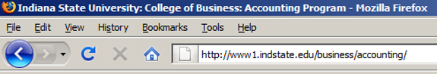
Mozilla Firefox’s Title Bar
The index.htm page of each section contains a standard image. This can be edited as required.
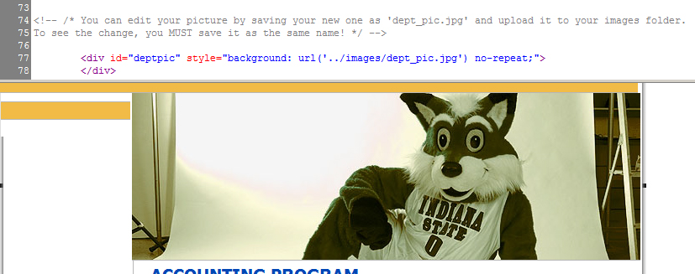
The standard image of an index.html page

This image is kept in the images directory of each section. If it is not required then the following HTML may be removed from the page…
<!-- /* You can edit your picture by saving your new one as 'dept_pic.jpg' and upload it to your images folder.
To see the change, you MUST save it as the same name! */ -->
<div id="deptpic" style="background: url('../images/dept_pic.jpg') no-repeat;">
</div>
Ensure that only the above text is edited otherwise the page may become unusable.
The only other part of the web page that can be freely edited is the part in the content div after the breadcrumbs navigation code and the end <div> of the content div.
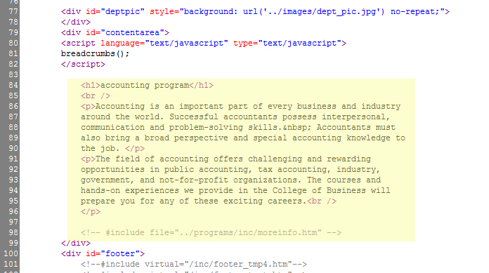
The content editable region
Do not edit anything on the page other than those sections listed above or the entire webpage may become unusable.
The largest image that can be accommodated in the main content area has a width of not greater than 605 pixels.

Administrative Tools

Global Replace Find & Replace
SharePoint Designer has the ability to make global changes across all pages in a SharePoint web using the find and replace editing function. It was used several times during the development of the site but care should be taken when using this feature. Remember: There is no undo once this function has been used. This means that if a mistake is made then either the global find and replace has to be used again or each page that was altered has to be individually re-edited.

Site Reports
SharePoint Designer and FrontPage both have the ability to create reports based on the currently viewed website. The way to access these reports is to use the “Reports” tab on the bottom left menu. There appear to be some doubts over the accuracy of some of these reports, especially the broken links, and individual items need to be checked before making changes to the links.

Broken Links
Although the site reports can be used to find broken links and other reports one tool that can be used to produce comprehensive reports about a web site is Xenu’s Link Sleuth available for free from http://home.snafu.de/tilman/xenulink.html. This software is reliable and very fast.

Other Software
SharePoint Designer is an excellent piece of software and should be sufficient for all tasks concerned with the upkeep and maintenance of the web site.
As most web sites use a lot of graphics then anyone updating the site should have access to a good graphics editor. There some very good editors around but the industry standard is still Adobe Photoshop - http://www.adobe.com/products/photoshop/compare/
A good audio / video converter is Super Converter available for free from http://www.erightsoft.com/SUPER.html
The COB/COT websites use an embedded video player. This is JW Player from http://www.longtailvideo.com/ and is used in conjunction with SWFObject from http://code.google.com/p/swfobject/
The RSS feed reader used is RSS2HTML from http://www.feedforall.com/

Useful Resources

Website standards are controlled by the World Wide Web Consortium (W3C). Their website is authoritative and can be found at http://www.w3.org/. The site also contains several validators which may be useful - http://www.w3.org/QA/Tools/
There are several good websites that offer general HTML, CSS and JavaScript help and advice among these are W3Schools - http://www.w3schools.com/ (not affiliated with W3C) and the Web Design Group - http://htmlhelp.com/
Both Yahoo and Google have an assortment of tools that may be of use to the COB/COT websites.
Yahoo - http://developer.yahoo.com/yui/
Google – After you create a Google account your current active Google tools can be found at https://www.google.com/accounts/ManageAccount, other useful Google URLs are http://www.google.com/intl/en/options/ and https://www.google.com/webmasters/tools

Sortable Tables Help

Stuart Langridge created the sortable tables code several years ago and very generously made it available for everyone to use. This help file was taken from his website at http://www.kryogenix.org/code/browser/sorttable/ and is reproduced here as an aid to maintaining the COB/COT websites.
sorttable: Make all your tables sortable
While the web design community gradually moves away from using tables to lay out the structure of a page, tables really do have a vital use, their original use; they're for laying out tabular data. For instance, imagine a table of employees.
Name | Salary | Extension | Start date | Start date (American)
Bloggs, Fred | $12000.00 | 1353 | 18/08/2003 | 08/18/2003
Turvey, Kevin | $191200.00 | 2342 | 02/05/1979 | 05/02/1979
Mbogo, Arnold | $32010.12 | 2755 | 09/08/1998 | 08/09/1998
Shakespeare, Bill | $122000.00 | 3211 | 12/11/1961 | 11/12/1961
Shakespeare, Hamnet | $9000 | 9005 | 01/01/2002 | 01/01/2002
Fitz, Marvin | $3300 | 5554 | 22/05/1995 | 05/22/1995

Pretty simple. But if you saw that table in a client-side application, you'd expect to be able to click on the headers and have the table sort, would you not? I know it always annoys me when you can't. A fair few web applications do allow this; most of them, which are pulling this data by submitting a SQL query to a relational database (an environment eminently suited to tabular data) implement this by resubmitting the whole page with something like ordercolumn=4 in the URL, and then adding an ORDER BY clause to their SQL query to return the data from the DB ordered by the specified column.
Resubmit the page? Just to sort data we already have? I'm sure we can do better than that.
Name | Salary | Extension | Start date | Start date (American)
Bloggs, Fred | $12000.00 | 1353 | 18/08/2003 | 08/18/2003
Turvey, Kevin | $191200.00 | 2342 | 02/05/1979 | 05/02/1979
Mbogo, Arnold | $32010.12 | 2755 | 09/08/1998 | 08/09/1998
Shakespeare, Bill | $122000.00 | 3211 | 12/11/1961 | 11/12/1961
Shakespeare, Hamnet | $9000 | 9005 | 01/01/2002 | 01/01/2002
Fitz, Marvin | $3300 | 5554 | 22/05/1995 | 05/22/1995

As you can see, the above table now has clickable headers that sort the table by the clicked column. Note how the numeric and date columns all sort properly, too, rather than sorting alphanumerically.
This is not a new trick, sorting a table using the DOM. However, this mini-library has two nice attributes; the first is, unsurprisingly, that it follows my principles of unobtrusive DHTML, as you'll see below. The second is that, as mentioned above, it knows how to sort a variety of different data types, and it works them out for itself -- you don't have to tell it.
Now, how to use it. To make a table of your choice sortable, there are three steps:
1.Download the Javascript library
2.Include the Javascript library, by putting a link to it in the HEAD of your page, like so:
<script src="sorttable.js"></script>
3.Mark your table as a sortable one by giving it a class of "sortable":
<table class="sortable">Note that the library's JavaScript file is called sorttable (two Ts), but the class you add to the table is sortable (one T).
And that's all you need. Your table will now have column sorting available by clicking the headers. For niceness, you might want to add the following styles to your stylesheet, or make up some of your own based on this:
/* Sortable tables */
table.sortable thead {
background-color:#eee;
color:#666666;
font-weight: bold;
cursor: default;
}
This is version 2 of sorttable, released April 2007. If you're using the old version, you may find it useful to update; v2 has numerous new features and should be completely backwards compatible.
Advanced usage
You probably don't need the bits here. Sorttable is designed to require no configuration, no fiddling around. Just take it and use it. If you need it to do more than it does by default, then come back here and read this part.
Totals rows
If you have a "totals" row at the bottom of your table that you want to stay at the bottom of your table (and not get sorted), then add it to a <tfoot> section in your table (which is what you should be doing anyway, according to the HTML spec). So, your table should look like this:
<table class="sortable">
<thead>
<tr><th>Person</th><th>Monthly pay</th></tr>
</thead>
<tbody>
<tr><td>Jan Molby</td><td>£12,000</td></tr>
<tr><td>Steve Nicol</td><td>£8,500</td></tr>
<tr><td>Steve McMahon</td><td>£9,200</td></tr>
<tr><td>John Barnes</td><td>£15,300</td></tr>
</tbody>
<tfoot>
<tr><td>TOTAL</td><td>£45,000</td></tr>
</tfoot>
</table>
Note how sorting the table leaves the TOTAL row at the bottom.
Person  | Monthly pay
Jan Molby | £12,000
John Barnes | £15,300
Steve McMahon | £9,200
Steve Nicol | £8,500
TOTAL | £45,000

Using custom sort keys
You may have some data which does go in an order but isn't identified by sorttable. The way to fix this problem is to use custom sort keys. Take, for example, a column of spelled out numbers. Ordinarily, sorttable wouldn't work here; it will treat the spelled-out numbers as strings, and so would sort the numbers in alphabetical order, i.e., five, four, one, three, two. To get around this, you can specify on a cell in your table a sorttable_customkey attribute, and sorttable will use the contents of that attribute instead of the text in the cell itself when sorting the table. So, for example, your table might look like this:
<table class="sortable">
<tr><th>Number (spelled)</th><th>Person</th></tr>
<tr><td sorttable_customkey="2">two</td><td>Jan</td></tr>
<tr><td sorttable_customkey="3">three</td><td>Bruce</td></tr>
<tr><td sorttable_customkey="1">one</td><td>Steve</td></tr>
</table>
Note that clicking on the "Number (spelled)" column in the table below sorts it in the correct one, two, three order.
Number (spelled) | Person
two | Jan
three | Bruce
one | Steve

You can fix practically any problem you have with sorttable's automatic column typing by specifying custom sort keys.
Manually specifying a column's type
Sorttable works out the type of your columns in order to work out how to sort them (numbers sort differently than letters, for example). Occasionally, it might get it wrong. If so, you can explicitly specify a type for a column, which will override sorttable's assessment. To specify a type, add a class of sorttable_columntype to the header row of that column. Available column types are numeric, alpha, ddmm, and mmdd. The latter two are for dates, but are not likely to be useful because if sorttable fails to automatically identify a date then the sort won't work anyway.
So, for example, if you have a "part number" column which you want to be treated as if it were numeric, then you might do your table like this:
<table class="sortable">
<tr>
<th class="sorttable_numeric">Part number</th><th>Part name</th>
</tr>
<tr>
<td>111-A5</td><td>Three-eighths Gripley</td>
</tr>
<tr>
<td>31337-H4X0R</td><td>Computer system intrusion toolkit</td>
</tr>
</table>
Remember: you probably do not need to do this. It is unlikely that you'll need to "force" sorttable to recognize a column type. You may also want to investigate using custom sortkeys, above, as a better way of achieving your goals.
Using custom date formats
One common question with sorttable is how to make it handle custom date formats. Sorttable will have a try at understanding dates in whatever format you add them in, but it sometimes needs help. The way to do this is with custom sort keys, as mentioned above. If you have table cells like this:
<td>February 11th 2008, 1.19pm</td>
change them by adding a custom sort key in YYYYMMDDHHMMSS format:
<td sorttable_customkey="20080211131900">February 11th 2008, 1:19pm</td>
The YYYYMMDDHHMMSS format for the date in the custom key will sort properly, and sorttable will use the information in the custom key rather than the information in the table cell itself.
Stable sorting
Sorttable, by default, does an unstable sort. This means that it does not maintain the order of rows where those rows have the same key in the sorted column. Wikipedia has more on stable sorting. If this is a problem, and you need the sort to be stable, you can do it by making a tiny edit to sorttable.js. Edit the file and find the lines:
/* If you want a stable sort, uncomment the following line */
//sorttable.shaker_sort(row_array, this.sorttable_sortfunction);
/* and comment out this one */
row_array.sort(this.sorttable_sortfunction);and change them so the shaker_sort line is uncommented instead:
sorttable.shaker_sort(row_array, this.sorttable_sortfunction);
//row_array.sort(this.sorttable_sortfunction);
The sort will now be stable. However, it will be considerably slower (the stable sorting can take eight times as long as the unstable sort), which is why it isn't enabled by default.
Making some columns unsortable
If you'd like some column headers to not be clickable, meaning that your users won't be able to resort the table by those columns, then add class="sorttable_nosort" to the <th> column header. Observe how the "number of legs" column here isn't sortable.
Name | Team | Number of legs
Molby, Jan | Liverpool | 2
Hughes, Mark | Manchester Utd | 2
Nicol, Steve | Liverpool | 2
Ardiles, Ossie | Tottenham Hotspur | 2
Charlie Nicholas | Arsenal | 2

Sorting the table when the page is loaded
Lots of people ask, "how do I make sorttable sort the table the first time the page is loaded?" The answer is: you don't. Sorttable is about changing the HTML that is served from your server without a page refresh. When the page is first served from the server, you have to incur the wait for it to be served anyway. So, if you want the table sorted when a page is first displayed, serve the table in sorted order. Tables often come out of a database; get the data from the database in a sorted order with an ORDER BY clause in your SQL. Any solution which involves you running sorttable as soon as the page loads (i.e., without user input) is a wrong solution.
Sort in descending order first
Making sorttable sort your columns in descending order first rather than ascending order requires editing sorttable.js. Find the line:
row_array.sort(this.sorttable_sortfunction);and after it, add a new line:
row_array.reverse();Sort case-insensitively
Making sorttable sort your columns case-insensitively (so uppercase and lowercase letters sort together) requires editing sorttable.js. Find the lines:
sort_alpha: function(a,b) {
if (a[0]==b[0]) return 0;
if (a[0]<b[0]) return -1;
return 1;
}
and change them for
sort_alpha: function(a,b) {
if (a[0].toLowerCase()==b[0].toLowerCase()) return 0;
if (a[0].toLowerCase()<b[0].toLowerCase()) return -1;
return 1;
}
Changes from sorttable v1
Sorttable has changed quite a lot in this new version 2. Please read the release announcement for more details of what's changed and who is to be thanked. If for some reason you need the original version 1 of sorttable you can download it from sorttable_v1.js along with the original instructions.
Licencing
Sorttable, like all my DOM scripts, is under the X11 licence, which basically means you can do what you want with it, including using it at work, in a commercial setting or product, or in open source projects (including those that are GPL licenced). If you're not sure, or you have other questions, please contact me for details.
Can I give you money for sorttable? I really like it
You don't have to. I believe in Free Software; writing this and seeing people use it is its own reward. Of course, if you're determined to give me money then I'm not going to stop you. You can send money to my PayPal account with the button below.
I've found a problem in sorttable. How can I tell you about it?
Firstly, thanks for using sorttable; sorry it's not doing quite what you want! You can see the list of issues with sorttable, both fixed ones and ones still outstanding, in the sorttable bug tracker. It's quite possible that someone's already reported the issue you've discovered. If a bug hasn't been fixed yet, you can "subscribe" to it in the bug tracker, and when it changes you'll get an email telling you I've done something. If your bug isn't there, do please contact me and tell me about it, and I'll add it to the list to be fixed.
But I need my problem with sorttable fixed! Can I pay you to fix it?
Yes. Sorttable gets worked on in my spare time, between paid work, which means that development might not be as fast as you like. If you really want something fixed, you can jump it up my priority list by waving money at me. Best thing to do is to contact me and we can talk about rates and so on.
Stuart Langridge, November 2003, April 2007

April 29, 2011
Ray Thomas
Web Developer
Networks Financial Institute
Scott College of business
800 Sycamore Street, #411A
Terre Haute, Indiana 47809
raymond.thomas@indstate.edu
812-237-2158 | Fax 812-237-2939

