Some Network Connection Help

If you have a router with wireless it should look a bit like this…
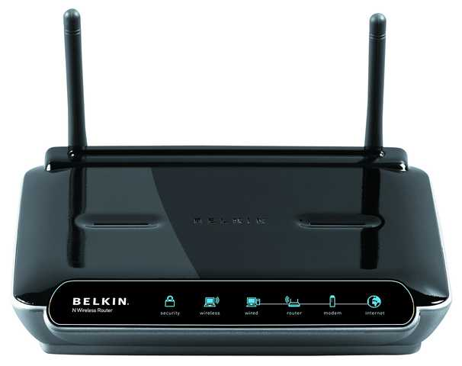

And the back of it should look something like this…
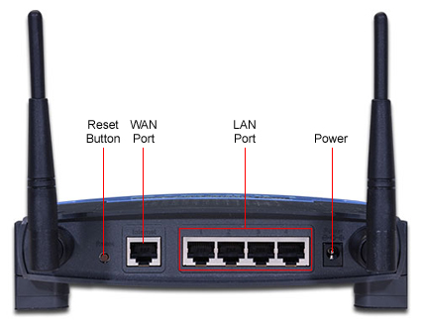

You should be able to connect any computer with a suitable port using a cable to the LAN Ports on the back of the router.
Nearly all modern laptops come with wireless capability, but not all desktop computers do. If a desktop does not have wireless capability then you can install a wireless card. They look a little like this…
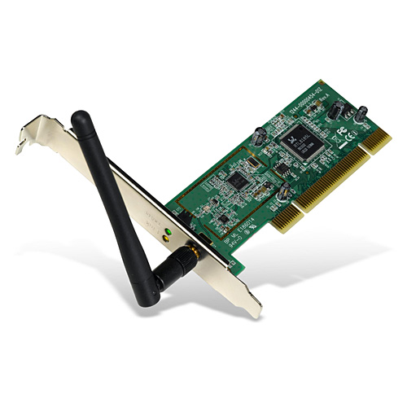
Installing one means opening up your computer case, but a much easier method, which can be used on either a laptop or desktop is to use a USB Wireless Adapter, which looks a bit like this…
Most of the one’s like this can also be used by pulling the top part off and plugging that directly into the computer…
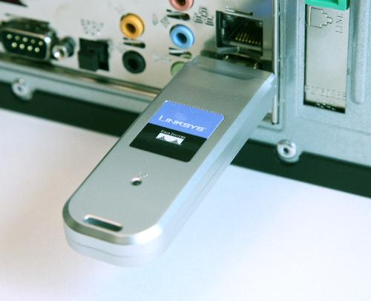

Some types do not come with a stand are more like the picture above when you buy them. Most will come with a CD to install the hardware.
Once you’ve got the device installed you have to find the wireless network for it to connect to. In the bottom right of your screen should be a small wireless network connection icon. Double click on that to show which wireless networks are available and connect to your router.

