Using Robocopy

The files on our desktops and laptops are not backed up by ISU and we are individually responsible for keeping copies of our files so that if something nasty happens to our computers then we do not lose any files.
We should all have an external drive and there are various ways of keeping copies of files on those drives. Windows has various utilities to help do this. There is Windows Backup that can be found in Start > Maintenance > Backup and Restore and Sync which can be found in Start > Accessories > Sync Center or you can simple use Windows Explorer to copy and paste or drag and drop files.
Windows also has a very powerful command line utility called Robocopy
Robocopy is based on the old Copy and XCopy commands, is much more powerful than either and is designed to copy entire directory trees from one location to another. This document is to try and help you use it to copy your user profile files from your computer to the external disk drive.
Because of the way it is written and the fact it has no GUI (graphical user interface), Robocopy is very fast and can copy thousands of files in seconds.
It is ideally suited for making quick backups because by default, it will only copy files that do not exist or are newer than those in the destination directory.
Opening a Command Prompt
Robocopy has no GUI and so has to be used from the command prompt. If you’re not used to them then command prompts can be somewhat daunting to use. To open one click on the Start button and in the Search area type
cmd
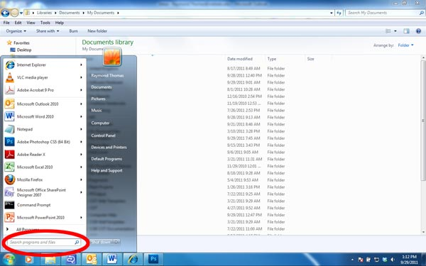
Once you press Enter a command prompt will appear
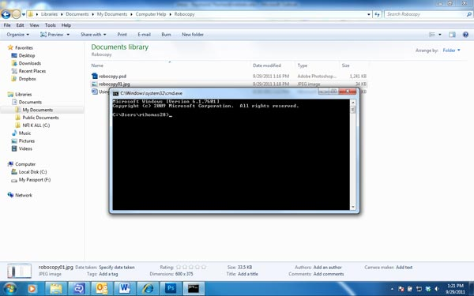

If you now type
robocopy
at this command prompt then some information will appear for Robocopy’s basic use. Because not all the information that Robocopy needs to run has been entered then no files have yet been copied.
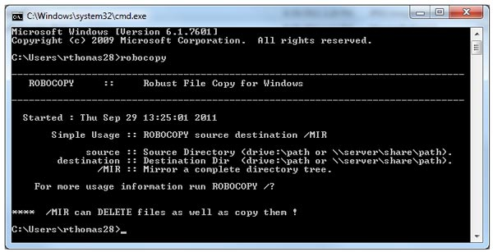
Command Prompt Window
The command prompt window is very special and does not behave like other Windows windows. There is no mouse interaction and the copy and paste commands (Ctrl + C and Ctrl + V) does not work in it. Instead, clicking on the top left corner at the little C:\ icon brings up a menu for the command prompts copy and paste commands.
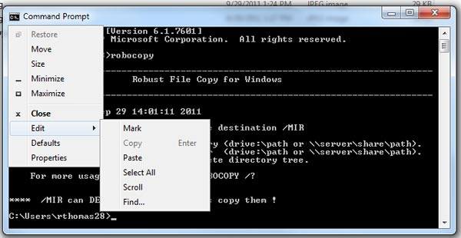
This menu may be of help copying the directories to want to copy from and to into the command prompt window.
If you are using Windows Explorer the navigation bar at the top shows you what directory you are in
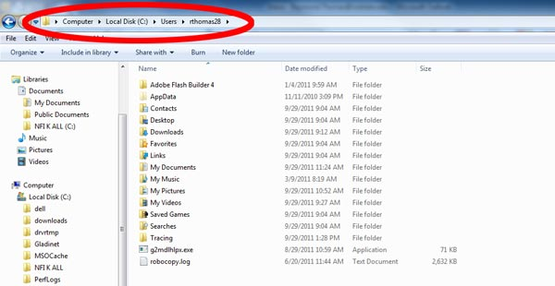
Clicking on the address bar changes the display that is more useful for the computer to use
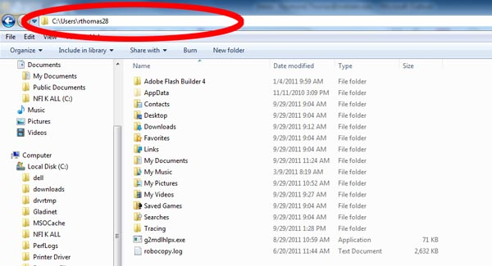
This can now be copied by highlighting it and then using the Ctrl + C command, but to paste it into the Command Prompt window you have to use the prompt window menu as outlined above as the Ctrl + V paste command does not work.
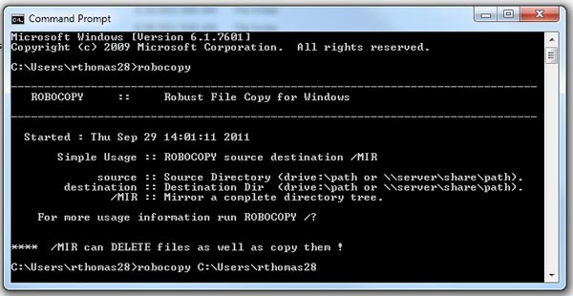

Wildcards
Many Windows accept wildcards. These are symbols that represent alpha-numeric characters or groups of alpha-numeric characters. The two most common are ? and *
? means replace any single character. For example, c?mp can mean anything from camp, cbmp to cymb, cxmp and c0mp to c9mp
* means replace a group of alpha-numeric characters. For example comp* can mean anything beginning with comp, such as computer, comptroller, compliance and so on.
Delimiters
In a command prompt window a space is a delimiter. That is, when the command is processed, a space means a separate part of a command or a new command altogether. This creates problems when using file and directory names that have spaces in them.
To a command prompt window command the directory c:\users\rthomas\my documents does not exist. As soon as the space in “my documents” is encountered then the processor starts looking for a new command or switch.
To get around this directory and file paths with spaces in them are always put in double quotes. In this example c:\users\rthomas\my documents has to be written “c:\users\rthomas\my documents”
Switches
At the very least Robocopy needs source and destination directories to copy files from and to.
The behavior of Robocopy can also be changed using command line switches. There is a full list of these at http://technet.microsoft.com/en-us/library/cc733145(WS.10).aspx
What to Copy
I would suggest the very least you need to copy are the files in My Desktop, Documents, Music, Pictures and Videos. Personally I prefer to copy my entire profile files which include all of the above as well as the Favorites and Contacts folders amongst others.
Where to Copy the Files
The files can be copied to another directory on the computer’s hard drive. There is a problem with this though because if the computer doesn’t start or the hard drive becomes corrupted then you cannot get to the copy of the files you made. So, a far better solution is to copy the files to an external drive.
My external drive is usually marked as the F: drive by Windows so I usually have the backup files all put into a directory I made on it called Ray but you can call this main directory what you like such as backup.
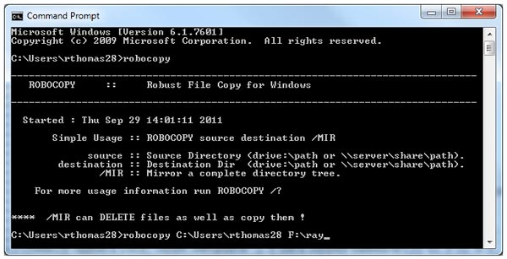
Using the Switches
Unfortunately, this is not all you need to do. The user profile directories contain a lot of hidden system files; it also contains a lot of temporary and backup files that some programs create that do not need to be copied. Robocopy also cannot copy files that are open in other programs.
When using this command on my computer then the full command line looks like this
robocopy c:\Users\rthomas f:\ray /e /XA:STH /r:0 /XF *.bak *.bkp *.tmp /XD temp* appdata /LOG:"c:\users\rthomas\My Documents\robocopy_local_backup.log"
Here’s what each part does…
Robocopy – the name of the program to run
c:\Users\rthomas – the directory I want to copy the files from
f:\ray – the directory I want to copy the files to
/e – copy the entire directory and all the directories it contains. This is needed otherwise Robocopy will only copy the topmost directory. In this case c:\Users\rthomas but not C:\Users\rthomas\Documents or C:\Users\rthomas\Pictures
/XA:STH – do NOT copy system, temporary or hidden files
/r:0 – if there is an error then carry on to the next file. By default, if there is an error then Robocopy will wait 30 seconds then try again. By default, Robocopy will try to copy a file 1 million times before it gives up and moves to the next file. This is controlled by the /w switch which is not used here.
/XF *.bak *.bkp *.tmp – do not copy files that have a bak or bkp extension. These are usually backup files created by certain programs and are not needed. Do not copy files that have a tmp extension – these are usually temporary files
/XD temp* appdata - do not copy directories that begin with temp. This will also include directories named temporary. Appdata is a directory that contains a lot of information about the software on your computer and which you probably do not need to backup.
/LOG:"c:\users\rthomas\My Documents\robocopy_local_backup.log" – create a log file. In this case the log file will be kept at
c:\users\rthomas\My Documents\robocopy_local_backup.log
The log file records exactly what Robocopy did when it was running.
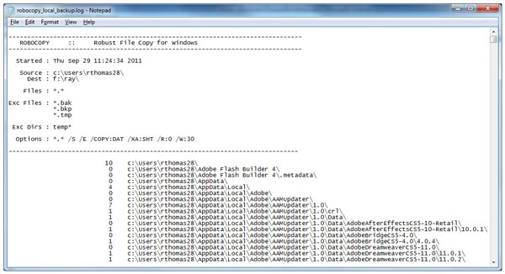
The beginning and end of a Robocopy log file
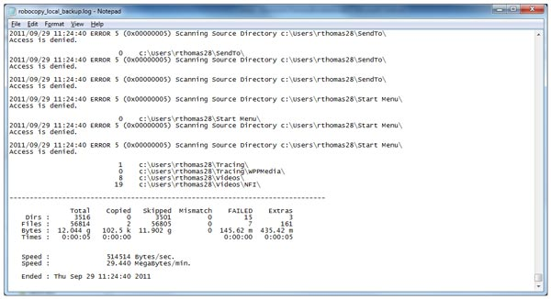
Log Files
In the log file you’ll see numbers next to the directory listing, this is just the number of files in the directory. You may also see a single word next to the file or directory listing. These may be confusing
Lonely – the file exists in the source but not in the destination. You should get very few of these, if any.
Tweaked – The file exists in both the source and destination directories but the file attributes are different
Same - The file exists in both the source and destination directories and are exactly alike
Newer - The file exists in both the source and destination directories, the file wasn’t copied because the one in the destination directory is newer
Older - The file exists in both the source and destination directories, the file in the source directory is newer. You shouldn’t see this very often
Extra – There are files in the destination directory that do not exist in the source directory – they may have been deleted or moved since the last backup
Mismatched – For some reason a file in the source directory is reported as a directory in the destination directory. You should rarely see this

The First Time
The first time a command like this is run Robocopy, although fast, may take a long time to complete. For example, my profile directories contain 71,600 files in 3,700 directories and take up 19.5Gb of space. Running Robocopy on this directory structure the first time took it 8 minutes to copy all the files.
By default, Robocopy only copies files that are newer or do not exist in the destination directories so the second and subsequent runs of the program are very much quicker and take only seconds to complete.
When Robocopy is running you will see a command prompt. This will automatically close when it is finished. The first time you run Robocopy to make a backup of your files the prompt may stay on the screen for quite a while. You can minimize the prompt but do not close it. Closing the prompt window will automatically stop Robocopy.
Batch Files or I Can’t Remember All of This
There’s no need to. Once you have got Robocopy working how you want it to then you can create a batch file for it and simply click on the batch file, the same as you would any other program to run it.
A batch file is simply a set of commands in a plain text file. They can contain any valid Windows commands and can be run as any other Windows program.
Copy this
robocopy c:\Users\rthomas f:\ray /e /XA:STH /r:0 /XF *.bak *.bkp *.tmp /XD temp* appdata /LOG:"c:\users\rthomas\My Documents\robocopy_local_backup.log"
to a new Notepad file and edit the parts in red to your own preferences. Then save the file. You can call the file whatever you like but it MUST end in .bat
You will have to use the “Save as Type” dropdown in the File > Save As menu to change it to “All Files” otherwise Notepad will try and save the file with a .txt extension.
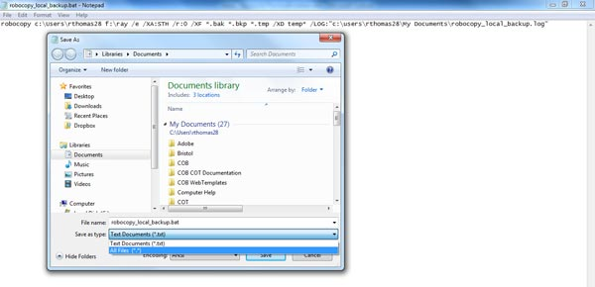
You can also save it where you like, on your desktop, in my documents, my programs or wherever. To run it simply double click on it or get it to autorun using the Task Scheduler.
Running Automatically
You can force Robocopy to run on your computer all the time in the background checking for changes by using in the /mon:n switch. n is the number of file changes that are allowed before Robocopy automatically runs again. There is also /mot:n n in this case is a time minutes after /mon:n has been detected.
A simple example, you run robocopy with /mon:10 /mot:5
This means that once you’ve updated 10 files Robocopy will wait a further 5 minutes before starting to work.
Windows has another handy utility called the Task Scheduler. One thing it can do is automatically run programs automatically to a schedule or when a certain condition is met. This makes it ideal for running the newly created backup batch file automatically.
Conclusion
Robocopy is not pretty but it is very reliable, powerful and fast. Setting it up looks confusing but is worth spending a little time with.
Ray Thomas
September 2011

