2010 Sympodiums
Equipment
The equipment consists of
Spectrum Sympodium
Sympodium power and communications module
Middle Atlantic 115v Rackmount Power Strip – Model PD-91R5
Extron MediaLink Switcher – Model MLS 304MA
Extron VGA & Audio Switcher – Model VSW 2VGA A
Netgear 5 Port 10/100mps Fast Ethernet Switch – Model FS105 v2
Interwrite Panel
Cyber Acoustics Amplified Speaker System – Model CA-3550
Computer
DocCam - Samsung Digital Presenter SDP-950
Cables
As well as the above the following cables are needed. Some of these cable are included with the equipment, some have to be installed separately
Ethernet
25’ – from ethernet switch slot 1 to the wall
3’/4’ – from ethernet switch slot 5 to computer
3’/4’ – from ethernet switch slot 4 to laptop
VGA
25’ – from Medialink to wall
4’/6’ – male/male from VGA Switch input 1 to monitor (included with Interwrite)
4’/6’ – from Medialink input 2 to DocCam
3’/4’ – male/male from VGA switch input 2 to laptop – this can use VGA/audio cable
3’/4’ – male/male from VGA switch output to Medialink input 1 – this can use VGA/audio cable
3’/4’ – male/male from Interwrite to computer
Audio
3’/4’ – speakers to Medialink line out (included with spreakers). This also needs a female pigtail made at the Medialink end of the cable. The pigtail is made by using the audio cable splitter included with the speakers and using the connector from the Medialink
3’/4’ - VGA switch input 2 to laptop – this can use VGA/audio cable
3’/4’ – VGA switch input 1 to computer (included with speakers)
3’/4’ – VGA switch output to Medialink input 1 – this can use VGA/audio cable
USB
3’/4’ – square to oblong male (included with interwrite) from Interwrite to computer
3’/4’ – oblong male/oblong female from computer to top of Sympodium
Tools
Not many tools are required to fit the equipment and cables
Philips screwdriver – to fit the Sympodium power module, rackmount power strip and the Extron MediaLink Switcher
Knife – mostly to open the boxes and packaging!
Wire strippers – to make the pigtails
Small flat screwdriver – for making the pigtails. This is usually included in the Extron MediaLink Switcher kit
Velcro – to attach the VGA Switcher and Ethernet Port to the side of the Sympodium
Cable ties

Pigtails
Two pigtails need to be made. One is for the VGA switcher and is simply a jumper to turn on autoswitching, the other is for the Medialink to enable the speakers to use the line out.
VGA Switcher autoswitch jumper
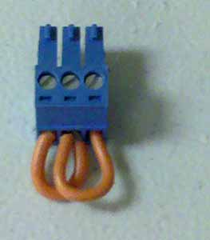
VGA Switcher autoswitch jumper
The jumper simply consists of two small loops of wire connecting pins 1 and 3 to 2
Audio connector
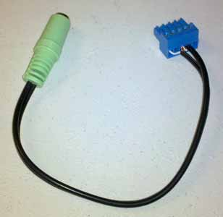
Audio connector
The audio splitter that is included with the speakers is cut at the left / right terminals. The outer insulation is removed from the wires for a length of around 12mm (1/2”). The metal shielding is pulled back and the inner insulation cut to about 5mm. With the connector (included with the Extron Medialink) screw side up the white wire is inserted into pin 1, both shielding wires into pin 3 and the red wire into pin 4.
The connector can now be inserted in the line out of the Extron Medialink and the speaker jack inserted into the female pigtail.
Assembly
When running cable to the top of the Sympodium, be aware that the DocCam drawer needs to open and close and so the cable should be routed down the back of the symposium in the channels provided.
Most of the equipment can be mounted in any order but it was found convenient to do it in this order…
Fit Middle Atlantic 115v Rackmount Power Strip to top of rails inside the Sympodium
Fit Extron MediaLink Switcher just below the power strip.
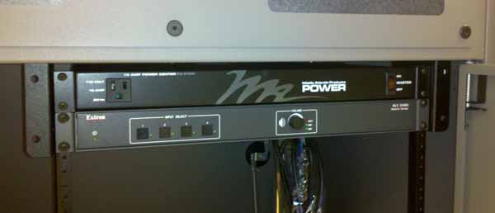
The fitted Rackmount Power Strip and Extron MediaLink Switcher
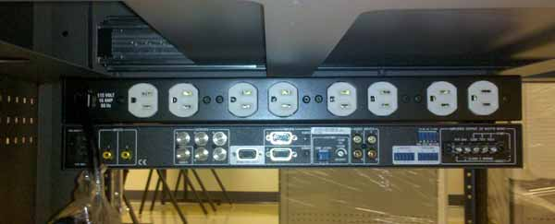
The fitted Rackmount Power Strip and Extron MediaLink Switcher
Because of the various sized and shaped power plugs used by the equipment it was found best to use the sockets in the following order (left to right) – ethernet switch, Extron MediaLink Switcher, Sympodium power strip module, VGA switch, Interwrite panel, speakers, DocCam, computer
The Sympodium power strip module can now be fitted
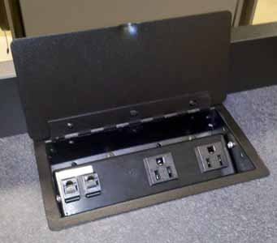
Sympodium Power Strip Module
The rest of the equipment is installed in the following order, VGA Switcher, Ethernet Switch, Interwrite Panel, speakers, DocCam and computer.
The VGA Switcher and Ethernet Switch can be attached to the inside of the Sympodium using two strips of Velcro each. The rubber feet should be removed from the Ethernet Switch to allow good adhesion.
It’s difficult to keep so much wiring tidy in the Sympodiums so the shortest cable lengths possible should be used for fixed equipment.
Wiring Diagrams
Power
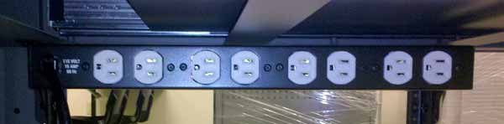

Medialink
Switcher
Power
Module
VGA
Switcher
Interwrite
Panel
Speakers
Ethernet
Switch
DocCam
Computer

Audio / Video
MediaLink Switcher
VGA Switcher
Interwrite
Panel
To DocCam
To Projector
To Speakers
To Computer
To Computer
To Laptop
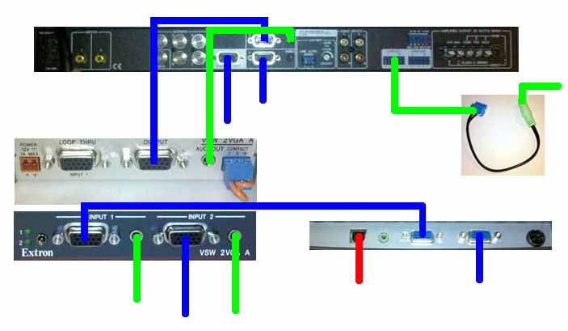

The space between the VGA DocCam and Projector connectors on the MediaLink switch is limited, so VGA cables with large ends cannot be used.
The symbols of the VGA sockets on the Interwrite Panel seem mixed up. The VGA cable from the computer should be plugged into the socket marked for the screen and the cable from Input 1 on the VGA Switcher should be plugged into the socket marked for the computer.

