Using the Sympodium DVD/VCR Player in H102
H102 is set up as a two-way classroom used to send audio and video signals to remote classrooms. For normal classroom use, the Sympodium will work the same as the other Sympodium’s at Ivy Tech EXCEPT for the DVD/VCR unit in the Sympodium. Using the DVD/VCR player involves an extra step that is not applicable to the other Sympodiums.
As in the other classrooms the Extron switcher unit inside the Sympodium should be switched to DVD/VCR.
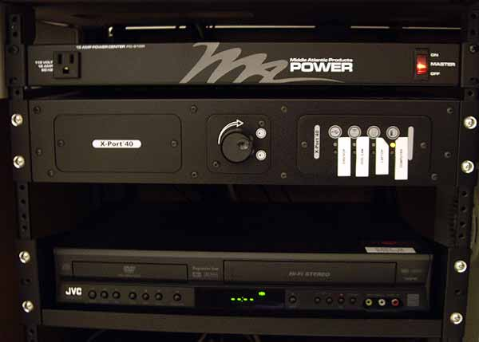
The EXtron DVD/VCR switch
The projector should be set to “Input 3” using the projector remote control
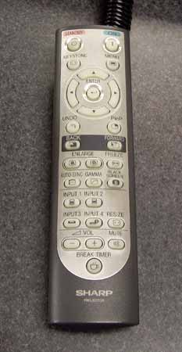
Projector Remote Control
The extra step in H102 involves setting the Audio/Video Mixer. To do this the unit has to be switched on and set to use the DVD/VCR. The power switch and switching buttons are highlighted in the image below.
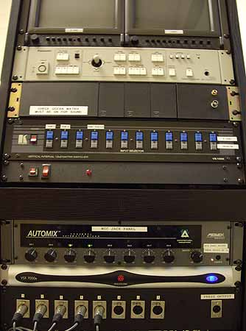
Audio / Video Mixer
Once the equipment has been set up s above the DVD/VCR video will now be projected. Please remember to reset the equipment once you have finished using the DVD/VCR unit.
Resetting the Equipment
For normal operation the Sympodium in H102 should be set up as the other Sympodiums. The Extron switch unit should be set to “Computer”, the projector should be set to “Input 1” using the remote controller and the Audio/Video mixer should be turned off.
Help & Information
For more help and information with this or any other instructional technology please contact the Distance Education department.

