Capturing a Computer Screen
It I sometimes very useful to capture what is on a computer screen to act as an illustration for a “how to” or sometimes to capture something that is not normally available to you.
Screenshots
PrtScn
Nearly all keyboards have a PrtScn or PrtScr button, usually combined with SysRq. As a historical note; SysRq was used to bypass any running program to regain control of the operating system and PrtScn was used to print a copy of a text screen directly to the printer.
PrtScn is now used to send an image of whatever is on the entire screen to the clipboard. If you have multiple monitors then the content of all screens are captured.
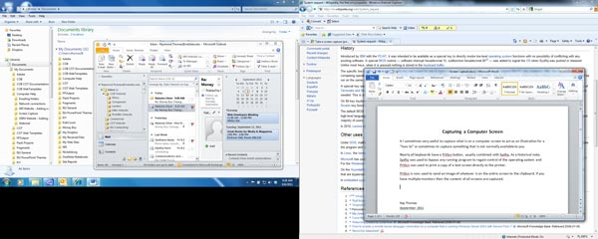
Two monitors captured using PrtScn

Sometimes it is more convenient to capture just the current item that is being worked on. If this is the case then pressing the Alt and PrtScn buttons together will do this.

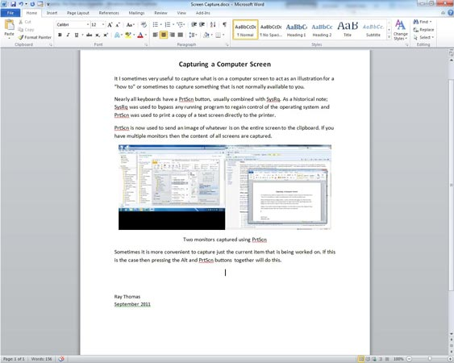
Using Alt + PrtScn

Once you have captured the screen using PrtScn or Alt + PrtScn to the clipboard it can now be pasted into any image editor. Simply use Ctrl + V to paste the contents of the clipboard or in most image editors then the Edit menu can be used. In some image editors, such as Paint, you can simply paste the image and a new canvas will be produced to hold the image. In other image editors, such as Photoshop, then a new canvas must be produced to hold the image. In Photoshop, once the image has been captured then File > New will automatically resize the canvas to the size of the clipboard image.
If for some reason your PrtScn key is working like the Home key in a browser window. (Home takes you to the top of the webpage and Alt + Home takes you to your browser home page.) Then if you are you using a laptop or a computer using a compact keyboard, or maybe one of the IR or RF keyboards try pressing the Fn key. Depending on the keyboard you may have to either hit it once to toggle the PrtScn key or press it at the same time as the PrtScn key.
Incidentally, pressing the Alt + Shift + PrtScn keys together will force the computer into a high contrast mode for the visually impaired.
Snipping Tool
Another method of making a screenshot is to use the Snipping Tool. This tool was found in various versions of Windows since 2002 but is now in all versions of Windows Vista and Windows 7. The tool can be found in Programs > Accessories.

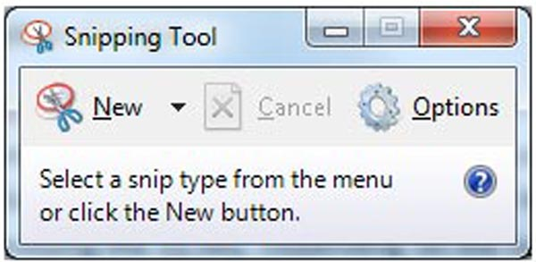
Snipping Tool Menu
Help for using the Snipping Tool can be found at http://windows.microsoft.com/en-US/windows-vista/Use-Snipping-Tool-to-capture-screen-shots

PSR (Problem Steps Recorder)
There is a little known tool in Windows 7 called the Problem Steps Recorder. Its main use is to record screenshots during problem solving and bug reporting to be sent to software developers. To open this tool go to Start and in the Search box type PSR. This utility will record a screenshot whenever the screen is click on.
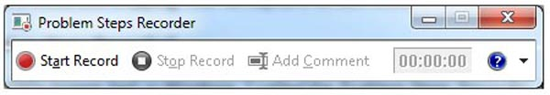
PSR (Problem Steps Recorder)
The program produces a single page that opens in an internet browser with all the screen captures on it. The screen captures can be saved individually from this.
For more help on the PSR see http://windows.microsoft.com/en-US/windows7/How-do-I-use-Problem-Steps-Recorder
Video Capture
Sometimes it is very convenient to capture what is happening on the screen as a video. This is how a lot of “how to’s” on places such as YouTube, such as http://www.youtube.com/watch?v=Oi84-dKcm2I are made.
One of the best video screen recorders is Camtasia - http://www.techsmith.com/camtasia/. This program costs around $300 but a free trial is available.
One of the most common free screen video recorders is Camstudio - http://camstudio.org/ The program is easy to use but there are some problems with it. It sometimes introduces banding, especially when trying to capture screens with color gradients and it sometimes will alter the screen colors.

Here are four good free video capture programs…
BB FlashBack Express - http://www.bbsoftware.co.uk/BBFlashBack_FreePlayer.aspx - good screen video capture program. Captures to AVI and SWF formats. The problem with this one is it puts a halo around the screen cursor which cannot be removed. It also needs to be registered, but that is free.
Expression Encoder - http://www.microsoft.com/download/en/details.aspx?id=24601 - An advanced audio/video-encoding and live-broadcasting application. A huge program but the video capture is great. Captures to WMV format. The free version is good enough for most things. The professional version costs around $200 from http://www.microsoft.com/expression/products/Purchase.aspx
Screen to Video - http://www.koyotesoft.com/indexEn.html - great screen video capture program. Can capture screens to AVI, SWF, FLA and WMV formats. My favorite free recorder.
Wink - http://www.debugmode.com/wink/ - A tutorial and presentation creation software. The screen capture is great. Captures to SWF format.
Capture Problems
Sometimes none of the above tools will capture screens. This is because some programs use a hardware overlay to display the screens. Instead of using the Windows software they use a video card to directly write to the screen hardware. In some instances the hardware overlay can be turned off by going to the Display Properties menu, clicking on the "Settings" tab, clicking, "Advanced", "Troubleshoot", and moving the Hardware Acceleration Slider to "None."
Capturing Web Resources
Sometimes it is very useful to capture resources from the internet for your own use, to play whenever you are offline. There are several utilities that can do this; one of the best is Orbit - http://www.orbitdownloader.com/

Ray Thomas
September 2011

