Some Webmail Help

New Email
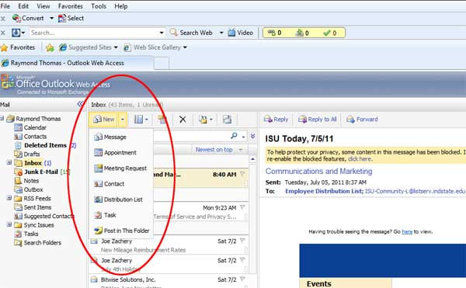

From the main webmail page either double click on “New” or single click on it and choose “Message from the drop down menu.

Address Book
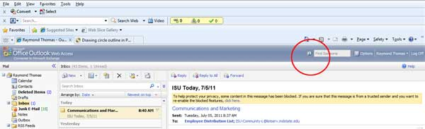
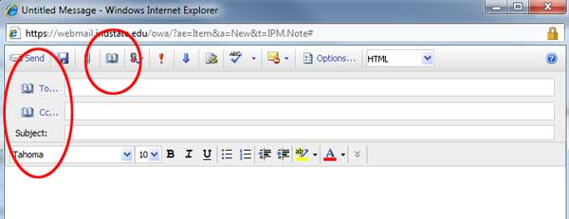

You can access the address book several ways. On the main webmail screen on the right hand top click on the little address book icon.
When you create a new email you can access the address book from the To and CC fields and also from the top menu.
Spell check
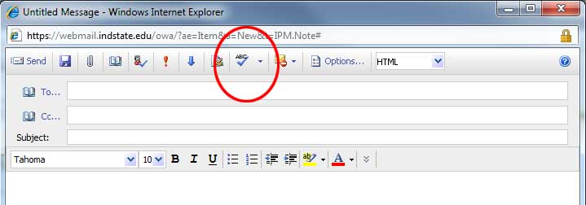
Unlike Outlook, Webmail does not automatically check your spelling. Once you have finished writing your email then click on the Spell Check icon in the top menu.

