The United Kingdom

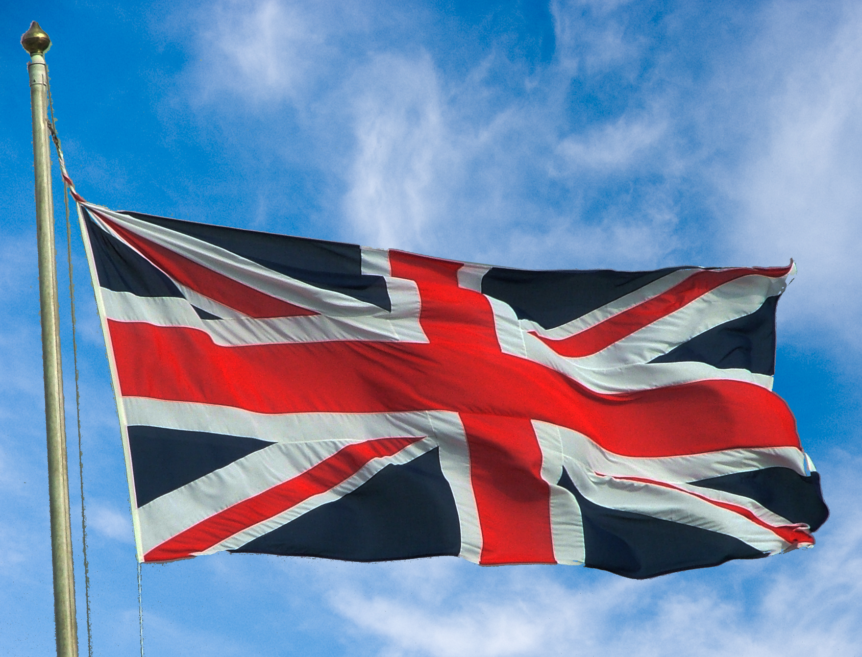

by
Ray Thomas
February 13th, 2011

The United Kingdom

When we first decided to get married my wife and I spent about a year trying to decide which country we were going to live in. One reason she didn’t want to live in Britain was that it was “like the Twilight Zone.” Almost the same as the United States but not quite.
What I want to do is try and explain who the British are and why we do some of the things we do.
One the first difficulties you have is knowing exactly what the United Kingdom is. The full name of the countries known as the United Kingdom is the United Kingdom of Great Britain and Northern Ireland.
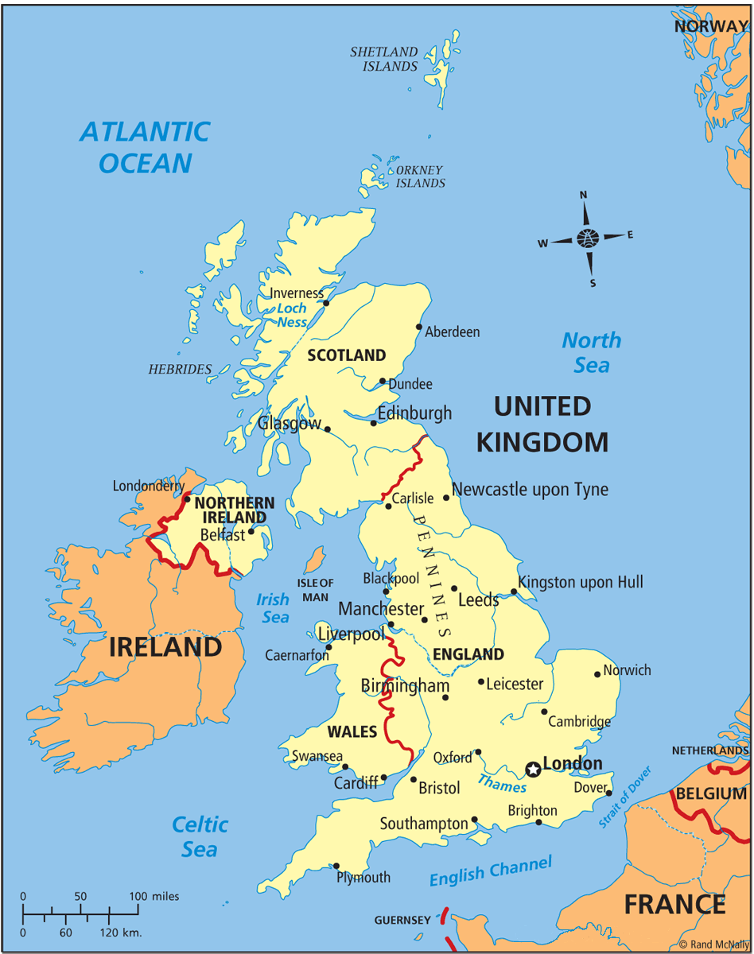
The four countries that make up the United Kingdom are England, Wales, Scotland and Northern Ireland and this is reflected in our flag which is known as the Union Flag or Union Jack.
Wales was annexed by England in 1282 so when the flag was formulated in 1606, Wales was already a Principality of England and was not included in the Union Jack.
King James I (who was also James VI of Scotland) ascended to the throne of England and Wales in 1603, styling himself King of Great Britain, although legislative union between Scotland and England did not take place until 1707.
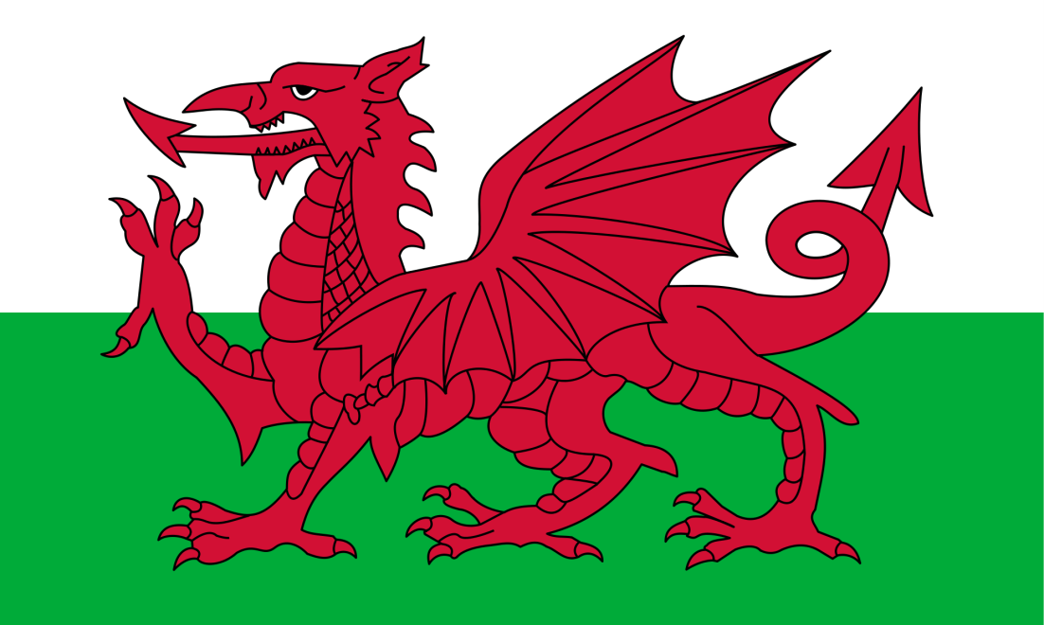
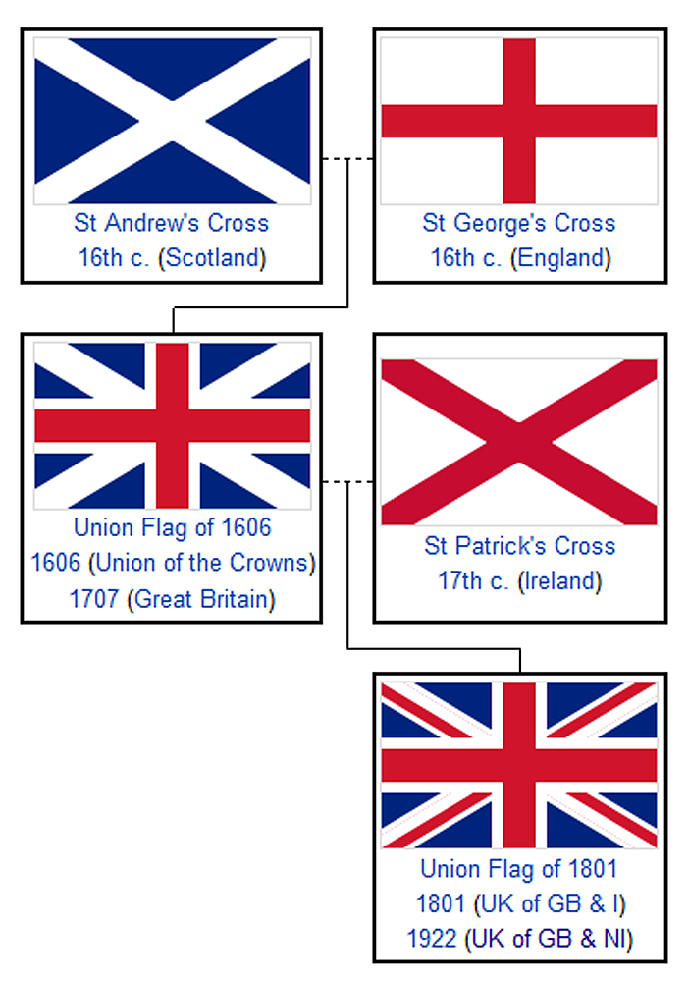
Great Britain thus comprises of the countries, England, Scotland and Wales. It was named Great Britain to distinguish it from Less, Lesser or Little Britain or Brittania Minor, now Brittany, in France, but which was once a British Duchy.
The United Kingdom came into being in 1801, following the Irish Union, although the greater part of Ireland gained independence in 1921 to form the Irish Republic or Eire.
The distinctions between the different countries that make up the United Kingdom are important. Although we’re all British we’re intensely proud of our separate countries and so calling all a Scot, or Scotsman, English will be considered an insult and you WILL be told that they are from Scotland. Another point about this, Scotch is a drink not a nationality and they don’t like being called that either.
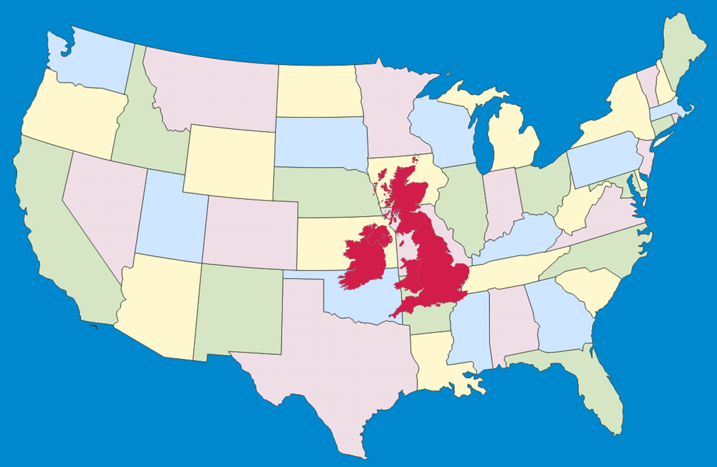
Looking at the relative size of the United Kingdom it’s hard to believe that the British Empire, the largest empire ever created, once covered a quarter of the globe. It was so large it was said that the sun never set on it.
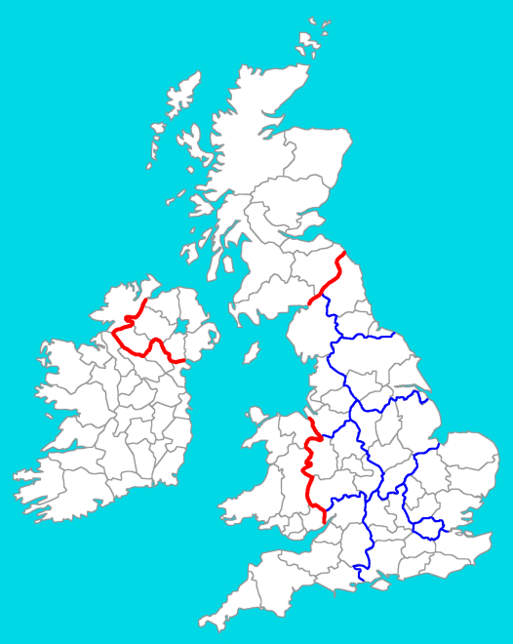
The UK, like the US, is split into smaller administrative districts called counties. The UK has 92 of them, 39 in England, 34 in Scotland, 13 in Wales and Northern Ireland has 6. England is also divided into 9 regions; these are for administrative purposes only and are the North East, North West, Yorkshire and the Humber, East Midlands, West Midlands, Eastern, Greater London, South East and the South West.
The regions have also been in existence for a long time and date from around the year 500. For some reason in the last four decades the government can’t leave the county and regional boundaries alone and they have been changed several times. The last change was to the administration of the regions and this was last done just in October 2010. The regions are administered by Regional Development Agencies which are responsible for industry, employment, training, agriculture, transport and the environment.
Although the regions have no real representation in the houses of Parliament because they cover roughly the same population numerically they do have representation in the European Parliament.

The Monarchy and Parliament
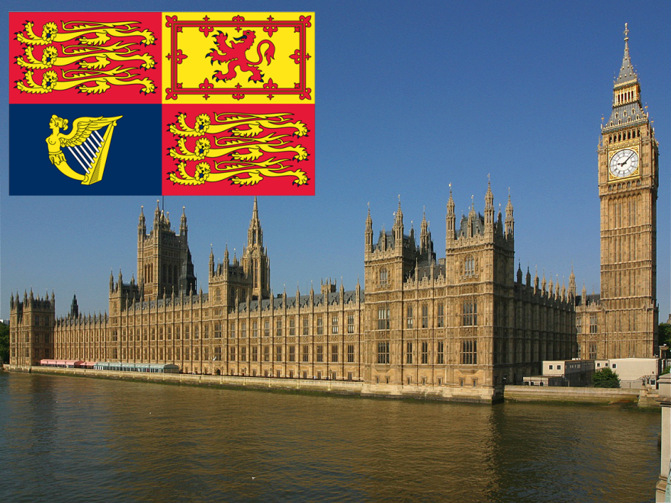
The monarchs of the United Kingdom rule by Royal Prerogative. That is, The Queen holds the ultimate, absolute authority over Parliament but at the same time Parliament has the authority to override Royal Prerogative. I know that sounds a bit strange but it’s worked for nearly 400 years and isn’t likely to change any time soon.
Between 1135 and 1688, Britain had 8 civil wars. Most of them concerned WHO was going to govern the land but the English Civil War of 1642 to 1651 determined HOW the British were to be governed.
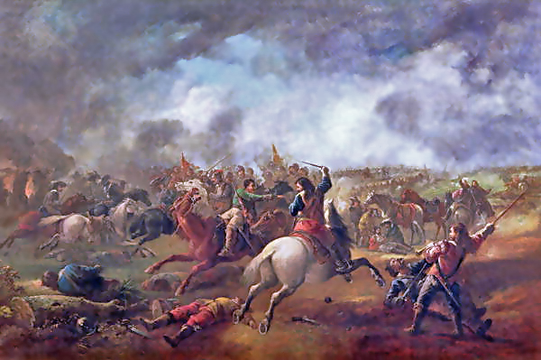
Up until 1642, Parliament was used as a means of raising taxes and simply advising the monarchy. It was convened and dissolved by the Monarchy at their command. What started the English Civil War were those three great causes of conflict – power, money and religion.
Britain had been Protestant since King Henry VIII had separated from Rome in 1533. The Thirty Years War, which started in 1618, was mainly a religious war between Protestants and Roman Catholics and Britain was fighting throughout Europe. The war was horrendously expensive and Parliament was already balking over raising taxes again to pay for it when King Charles I married a Roman Catholic, Henrietta Maria of France, in 1625, much to the horror of many in Protestant Britain. Arguments and mutterings of dissent were heard with growing hostility between the Royalists and Parliamentarians and eventually erupted into open conflict in 1642.
After several bloody battles King Charles was captured, tried for treason against the British nations and beheaded in 1649, but the war dragged on for another two years before the Parliamentarians overcame all resistance in 1651.
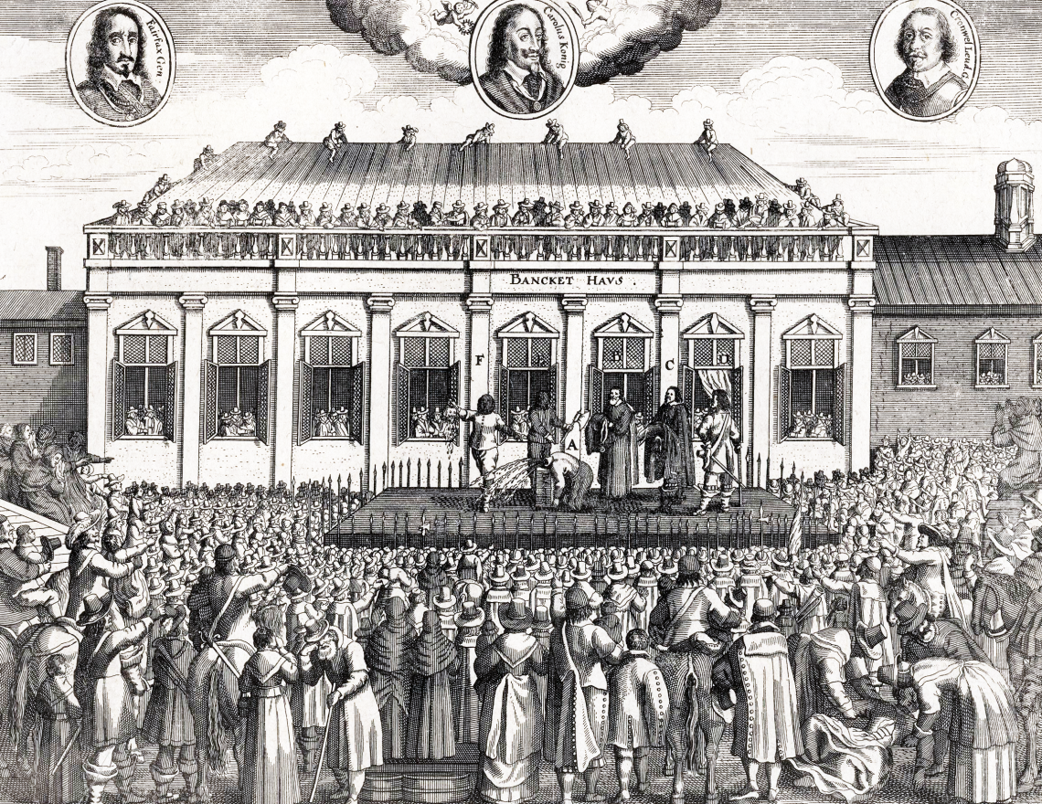
The civil war was brutal. In the nine years of fighting England had lost nearly 4% of the population to war, disease and famine. Scotland lost around 6% and the poor old Irish lost at least 30% of the population.
Ten years later, in 1661, the monarchy was restored but as a Constitutional Monarchy, not an absolute one.
The Royal Prerogative includes the powers to summon and dissolve Parliament, appoint and dismiss ministers, regulate the civil service, issue passports, declare war, make peace, direct the actions of the military, and negotiate and ratify treaties, alliances, and international agreements.
The British legislature consists of three components, the House of Commons which is made up of elected politicians, the House of Lords, which is made up of the senior bishops of the Church of England and the peerage and the Monarchy. Laws in the United Kingdom normally have to be passed by all three before entering the statutes, but the House of Lords can only delay a bill presented by the House of Commons for a year before it passes on for Royal Assent. As a point of interest, no Monarch has refused to give Royal Assent to an Act of Parliament for over 300 years – since 1708 to be exact.
There are only four countries in the world without a written constitution – New Zealand, Israel, San Marino and, of course, the United Kingdom. One reason we don’t have a written constitution is our law system evolved rather than being thrust upon us. Almost every country in the world has a written constitution that was formulated after revolution, invasion or independence, apart from the odd civil war; the United Kingdom hasn’t had any of those in over 1,000 years - not since King Harold was killed by getting an arrow in the eye at the Battle of Hastings in 1066. Instead of a written constitution we are governed by case law and custom.
Icons
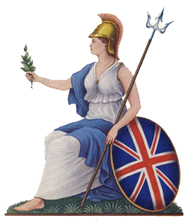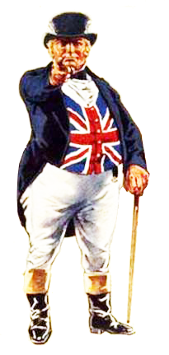
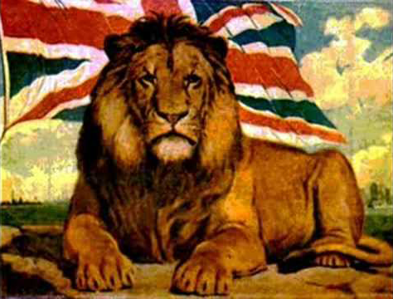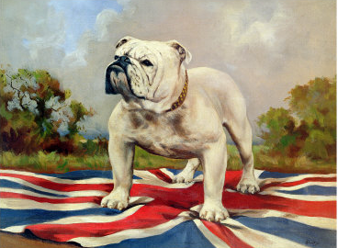
Just as the United States have Uncle Sam, who is the personification of the government then we too have our national icons. There’s Britannia which represents the monarchy and government and John Bull who represents the people. The lion represents strength and the bulldog which represents tenacity.
Age
You can’t be long in Britain, or any European country for that matter, without realizing how old the civilizations are. There’s evidence that the area around my home city of Bristol was settled around 60,000 years ago. There was a mint there by around the year 1000. The city was given a Royal Charter in 1373. A couple of years before the United States celebrated her bicentennial in 1976, Bristol celebrated 600 years of being a city.
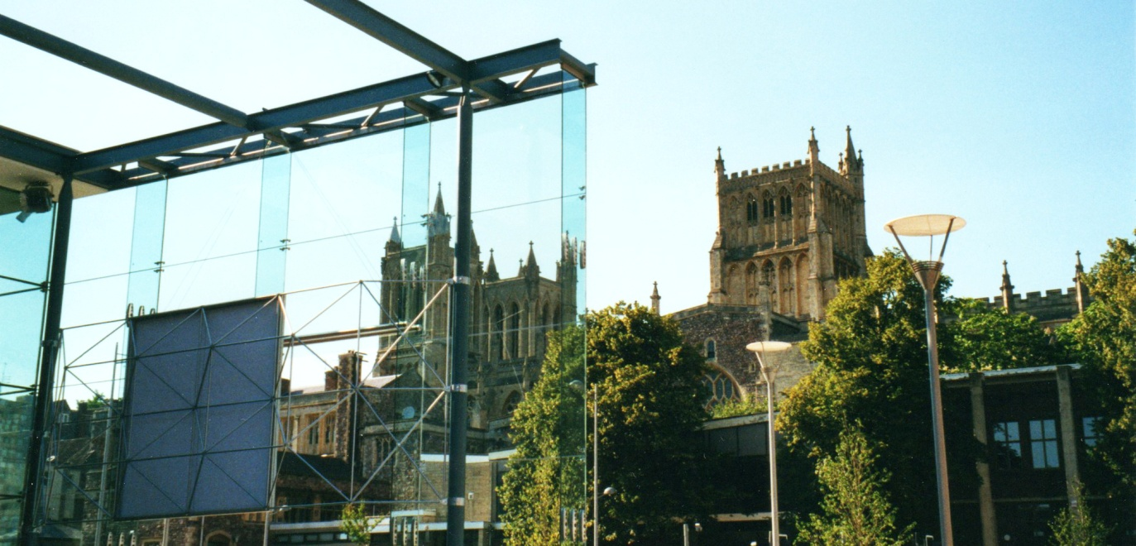
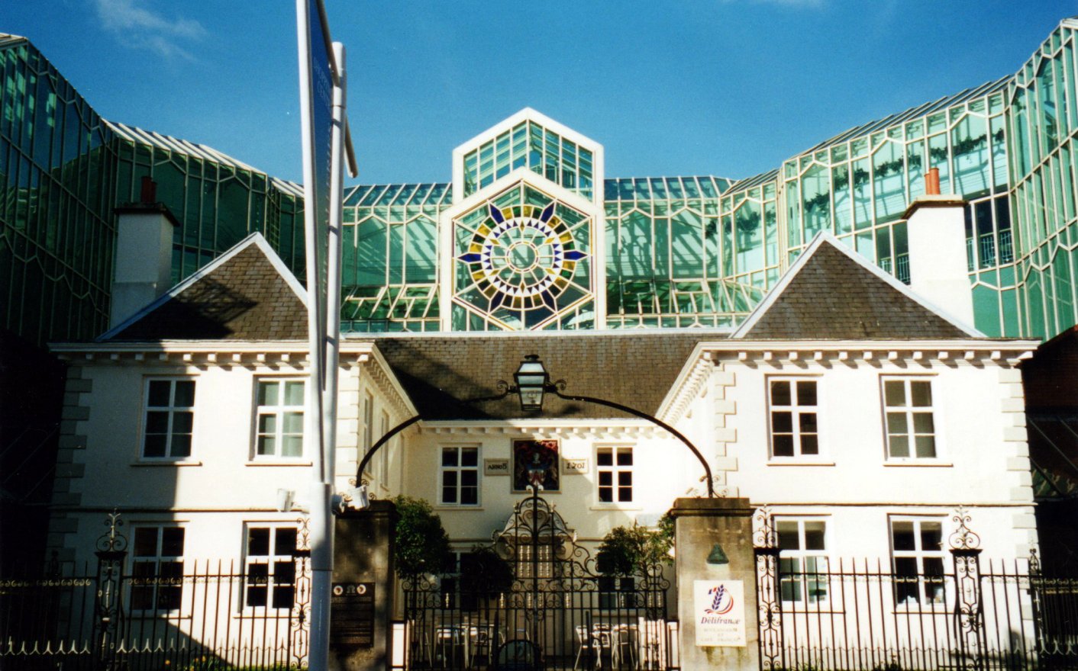
When you’re in Britain or any European city you’ll find a mixture of the old and new all around you. The photos show the At Bristol exhibition centre which opened in 1999 and the Cathedral which was built in 1149. The second photo shows The Galleries, a shopping center which was opened in 1991 and Merchant Tailors Almshouse which was built in 1701.
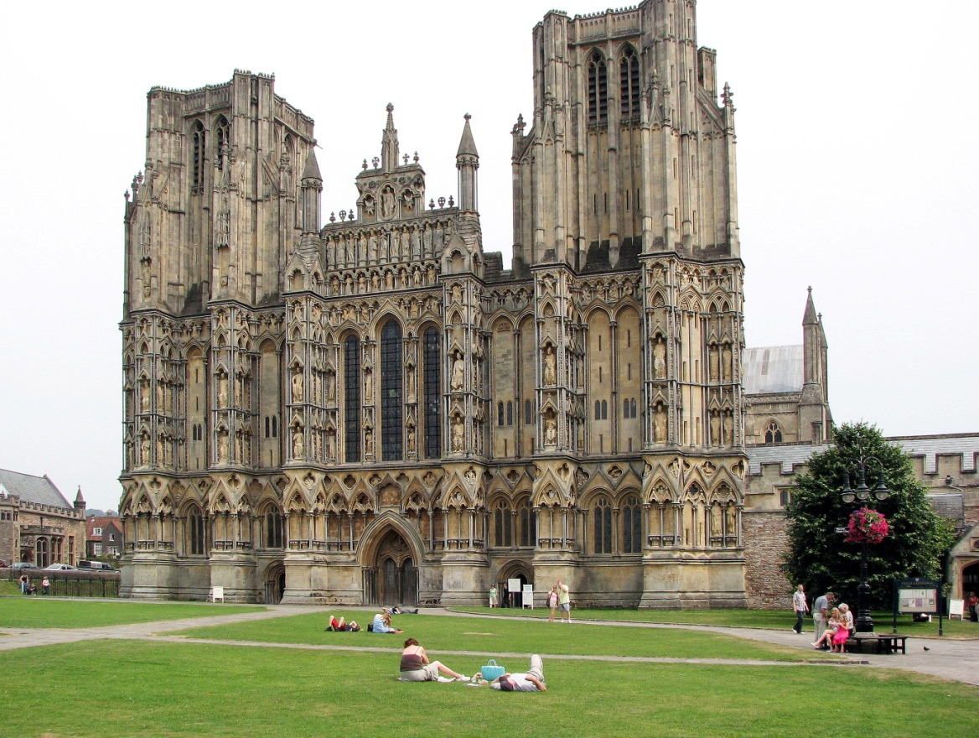
On one of her first visits to Britain I took my wife to Wells Cathedral. While we were wandering around, she asked how old the building was.
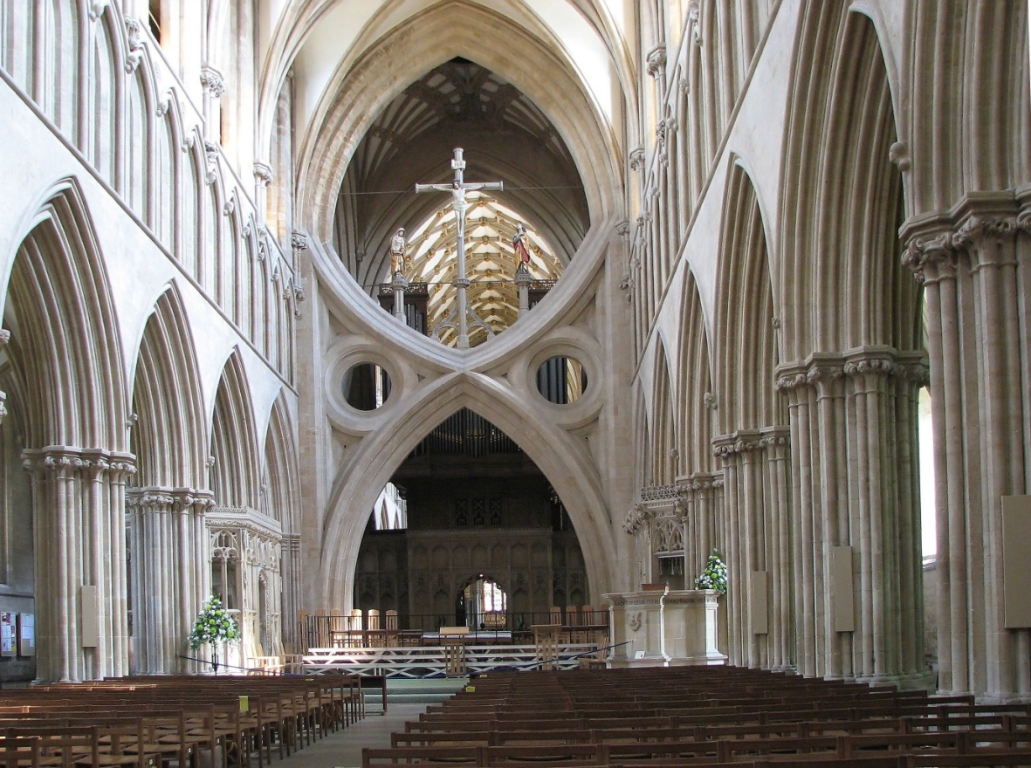
When these old cathedrals were built they buried members of the clergy in the walls and under the floor. I asked my wife to look down. She was stood on the grave of someone who had died in 909. The cleric buried there hadn’t seen the end of the first millennium, let alone the third. There has been a church on the site since 705.
Cheddar Gorge, birthplace of the world famous Cheddar cheese, is around 30 miles south of Bristol and in 1966 scientists examined the DNA of 6,000 and 10,000 year old skeletons found in the caves in the area.
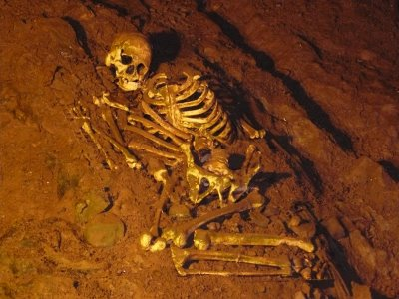
What they found was that people living within five miles of the gorge shared the same DNA with the DNA from the skeletons. What’s funny about it is that some people in the area not only know who their ancestors were 300 generations ago, but can go and visit them in the local museum.
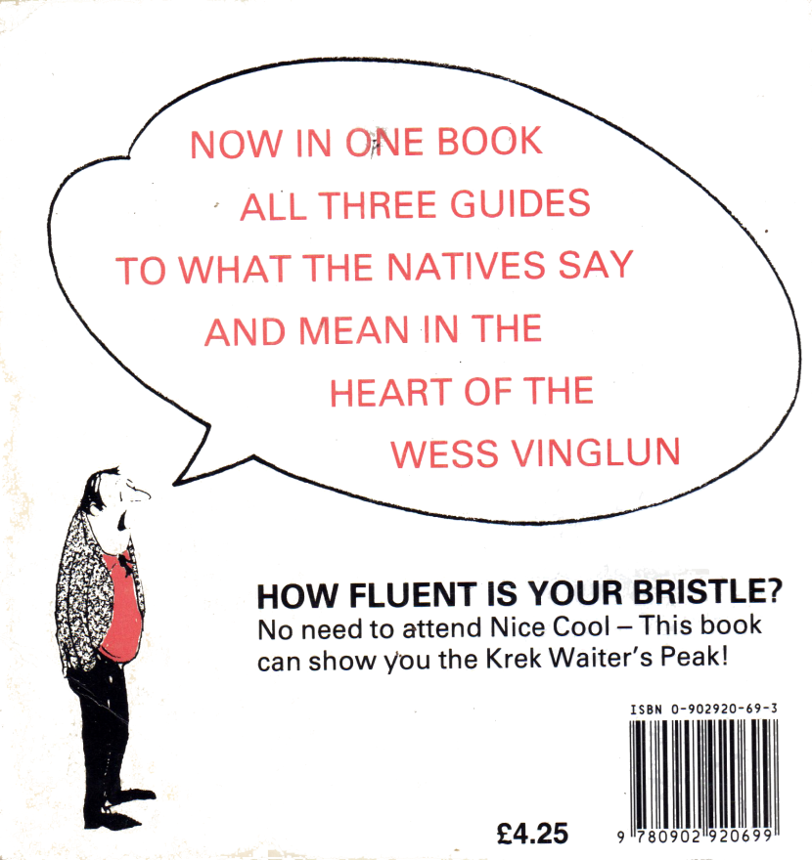
Accents
We all know that Europe is old, but what’s got that do with me? Actually, quite a lot. For hundreds of years travel was difficult. For most people the only transportation was their feet. This meant that most people never left the area they were born in. Even the very poor couldn’t move to a different area as the Poor Laws meant they couldn’t get assistance from any parish except the one they were born in. What this lack of movement meant was that strong local accents developed.
I’m from Bristol, and my accent is unique to south Bristol. Even people born in north of the city will have a different accent than mine. Not only do accents mean that words are pronounced differently but words are used that aren’t found in other areas.
For example, Bristolians use the word “gert” which isn’t found anywhere else in Britain. No-one seems to know where the word comes from but it’s been in use for many generations and means “very”. Go something described as “gert lush” is fantastic whilst something described as “gert little” is small.
My wife and I were sat in a pub one time and a group of people sat down near us and started chatting. When they had gone, she asked me “What country were those people from.” I thought it was hilarious; the people were from Liverpool – just 180 miles away.
In a business setting you’ll find the use of regional words, slang and even accents modified to more Standard English but in a social setting they are as strong as ever.

Food
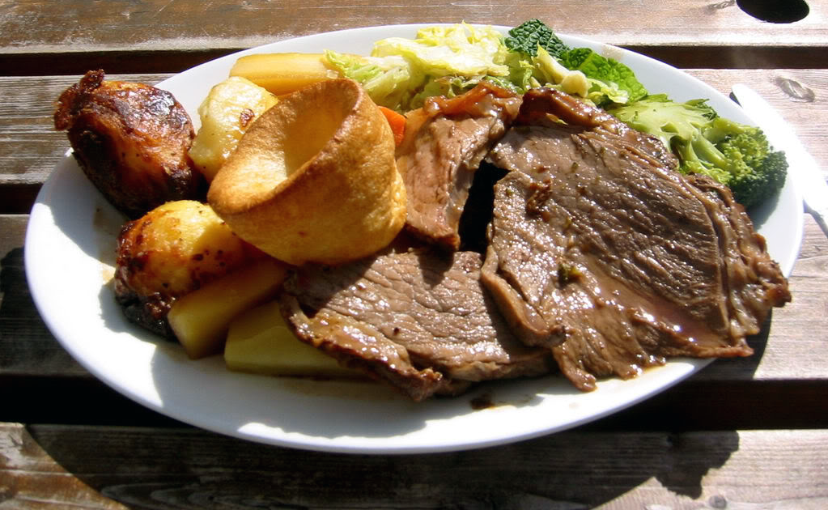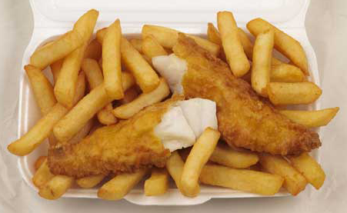

For some reason traditional British food has never been very highly regarded by the rest of the world; it’s had the reputation for being rather plain and boring. Not only that, but some British delicacies don’t sound too pleasant, but taste wonderful.
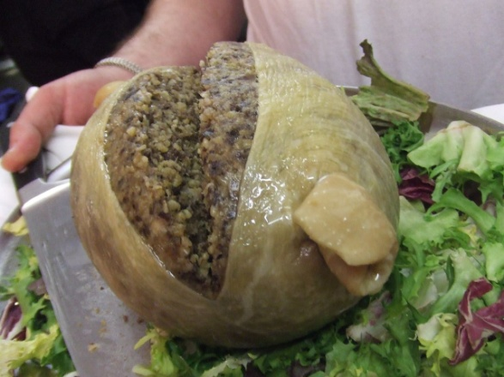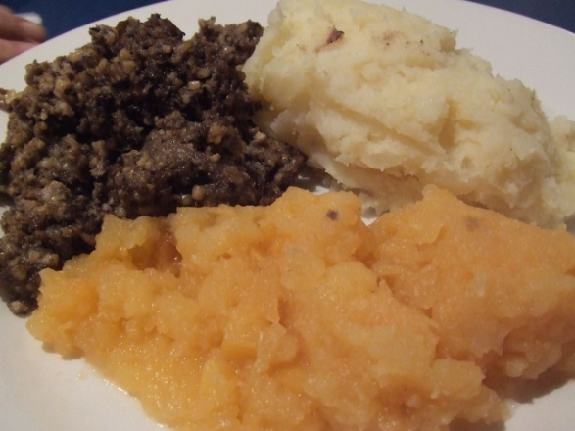
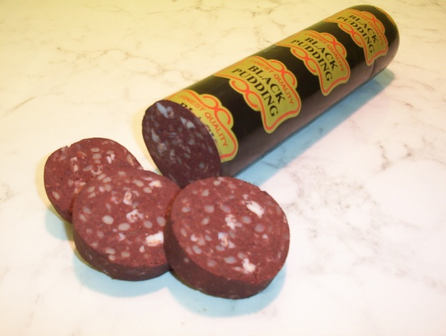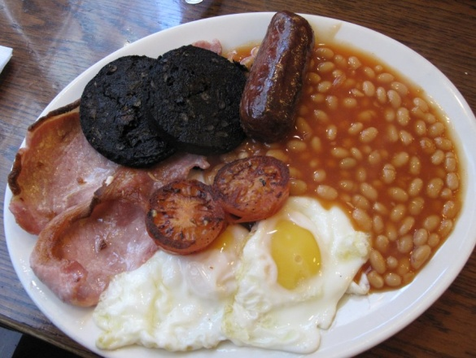

Take the Scottish Haggis, usually now only eaten to celebrate the birth of the poet Robbie Burns on January 25, 1759. The haggis is made from sheep’ heart, liver and lungs along with onion and oatmeal and cooked in a sheep’s stomach. It’s traditionally eaten with mashed potatoes and turnips. Another delicacy is black Pudding which is a sausage made from pig’s blood and fat. Personally, I don’t like it, but millions of people do.
The truth is we’ve a huge variety of food but thanks to the old Empire we enjoy food from all over the world. One of Britain’s favorite foods is curry, the popularity of which dates back to the days of Empire when it was brought back to the UK by soldiers serving in India.
Dinner Etiquette
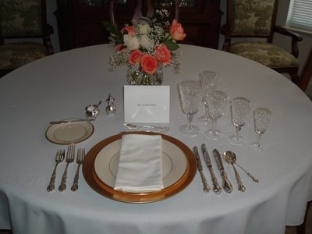
A formal dinner setting can look daunting, but don’t let is faze you. There may be a variety of glasses, the largest will be for water, the tall, skinny glass is a champagne flute, there may be glasses for both white and red wines and the smallest glass will be for sherry, which is usually drunk at the beginning of the meal.
The cutlery or silverware is used from the outside in, starting with either soup or some sort of cocktail such as shrimp. The utensils used, either a spoon or cocktail fork, will be on the outside right of your place setting. Once that has been finished with then the knives and forks from the outside in are salad, fish and finally your main course cutlery. The fork and spoon at the top of your place setting are for your dessert.
Formal table manners are mostly the same in both the United States and the United Kingdom. For example, eat your soup by spooning it away from you and sipping from the side of the spoon. Don’t put your elbows on the table, once used don’t put your cutlery back on the table, and don’t chew with your mouth open – no-one wants to see that!
Napkins should be placed on your lap, not tucked into your collar. If you have to leave the table during a meal the napkin should be placed on your seat and your knife and fork left at the 4 and 8 o’clock positions on your plate. If you leave the napkin on the table and your knife and fork placed together on your plate then it’s usually taken as a sign you have finished with that particular course and when you get back you may find whatever’s left of your meal has been taken away.
If you’ve got a communal butter dish then it’s acceptable to take a portion of it and put it on the edge of your side dish. The reason for this is so when you butter your bread or rolls you don’t put your crumbs back into the dish. If you’re having bread rolls it’s considered better to break off a piece of the roll, butter that then eat it rather than buttering the whole thing first.
If you need anything off of the table, like condiments or butter, it’s considered very rude to reach over someone else’s plate. Ask someone to pass them to you. If someone asks for salt and you’re closest to it, it’s polite to give them both the salt and pepper shakers.
When you eat you should always use the fork with the tines down. It is not a shovel so don’t use it tines up. Some food, like peas, are difficult to eat like this so what you do is squish them onto your fork with your knife.
One thing Americans do is cut up their meal then move the fork to the right hand and eat from that. Don’t do that in the UK because only children eat like that.
Don’t get all bent out of shape worrying about making a mistake when dining formally. If you’re unsure about things like what fork to use, just have a quick glance of what other people are doing. Remember, many British take etiquette very seriously but it’s not a competition to see who’s got the best table manners.
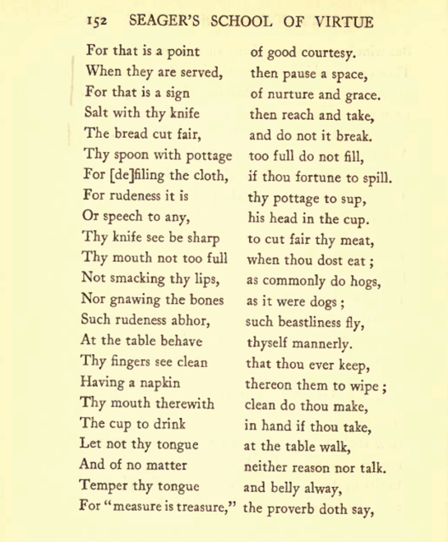
British table manners haven’t changed much in centuries. The following appeared in Francis Seager’s “School of Virtue” published in 1557.
In sitting down, to thy betters give place.
Suffer each man first served to be;
For that is a point of good courtesy,
When they are served, then pause a space,
For that is a sign of nurture and grace,
Salt with thy knife then reach and take,
The bread cut fair, and do not it break,
Thy spoon with pottage, too full do not fill,
For [de]filing the cloth, if thou fortune to spill,
For rudeness it is thy pottage to sup,
Or speech to any his head in the cup.
Thy knife see be sharp to cut fair thy meat,
Thy mouth not too full when thou dost eat;
Not smacking thy lips, as commonly do hogs,
Nor gnawing the bones as it were dogs;
Such rudeness abhor, such beastliness fly,
At the table behave thyself mannerly,
Thy fingers see clean that thou ever keep,
Having a napkin thereon them to wipe;
Thy mouth therewith clean do thou make,
The cup to drink in hand if thou take,
Let not thy tongue at the table walk,
And of no matter neither reason nor talk.
Temper thy tongue and belly alway,
For "measure is treasure," the proverb doth say,
And measure in all things is to be used.
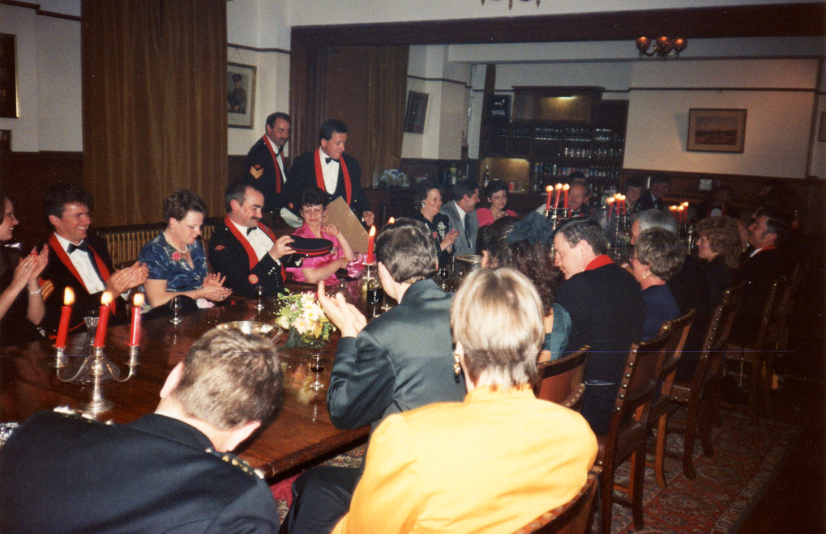
If you want a good, “proper” formal dinner then getting yourself invited to a guild or military mess dinner is a good idea. These things are full of tradition, many unchanged for hundreds of years.
For example, British sea officers are not obligated to stand during the loyal toast to the reigning sovereign. The custom is centuries old and dates from a dispensation given them when there simply wasn’t room between decks for people to stand properly.
In most regiments when passing the port decanters along the table they should be slid and only lifted when filling someone’s glass. In my old regiment, 266 Battery, 7 Parachute Regiment, Royal Horse Artillery, once the decanters were lifted from the table they were not allowed to be put down again until they are empty.
If you do go to one of these it’s best not to drink too much before dinner. Once you’re sat down you need to ask permission to leave the table for any reason and as the meals may have six or seven courses you could be there a long time. In the Royal Artillery you may only leave the table once “Ease Springs” has been called by the mess president.
Not only do the messes have official rules but there are unofficial ones as well. Two of the funniest I’ve seen are…
If challenged to dual then combatants must wait until after dessert has been finished and must not use automatic weapons nor use weapons greater than 9mm in caliber.
And
Should you drink yourself into a coma whilst dining, remember to fall backwards. Falling forward into your own plate carries the risk of suffocation and falling into neighbours plate, either to the left or the right, is simply bad manners.
Business Meetings
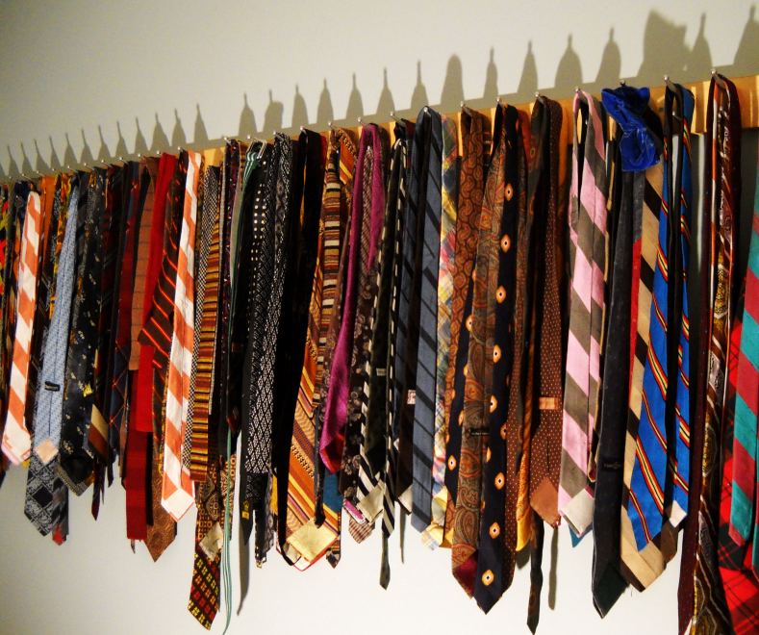
The British, generally speaking are conservative in business. When I moved to the U.S. it was the first time in my working life that I was not expected to wear a tie to work. Old fashioned? Definitely, but if you find it stuffy or uncomfortable then you’re wearing it wrong. Talking of which, unless it’s your own school or university tie stay away from striped ties. Every school, university, regiment and club in Britain has a tie, usually striped, and like wearing a class ring from a school you didn’t earn it from here it’s considered bad manners to wear the wrong tie Britain.
The British in business are a bit formal. Although it’s usually admissible to be “fashionably late” like about 10 or 15 minutes for an informal gathering, you should be punctual for any business meeting. As in the United States a handshake is normal form of greeting. The British also like a bit of personal space and standing within a couple of feet of someone is considered “in your face.”
The British are famous for “having a stiff upper lip” and may appear undemonstrative. The British usually understate when in conversation. So someone who says they are having “a bit of a problem” with something being discussed may have serious reservations about it. Business decisions are usually not rushed but carefully considered. The British tend to rely on facts and figures when making decisions not emotion.
There’s no need to exchange gifts when doing business in Britain but if you want to, a small, tasteful gift such as a “coffee table” book or paperweight is appreciated.
If you are invited out for a drink its customary to buy in rounds, that is, everyone in your party will take turns buying everyone else a drink. One website I visited said that “a work colleague will not invite out another for a drink until they have become firm friends or after 20 years – whichever comes first.
When making small talk keep away from politics and religion and anything personal. The British are generally more reserved about these topics than Americans, which is one reason we always talk about the weather – it’s a “safe” subject.
One last thing – remember that in Britain we drive on the left not the right!
This royal throne of kings, this sceptred isle,
This earth of majesty, this seat of Mars,
This other Eden, demi-paradise,
This fortress built by Nature for herself
Against infection and the hand of war,
This happy breed of men, this little world,
This precious stone set in the silver sea,
Which serves it in the office of a wall
Or as a moat defensive to a house,
Against the envy of less happier lands,--
This blessed plot, this earth, this realm, this England.
William Shakespeare (1564 - 1616), "King Richard II", Act 2 scene 1
Links
Accents
http://upload.wikimedia.org/wikipedia/en/3/34/Selected_languages_and_accents_of_the_british_isles2_rjl.jpg
http://upload.wikimedia.org/wikipedia/commons/1/1d/English_Dialects.jpg
http://www.bl.uk/learning/langlit/sounds/regional-voices/phonological-variation/

Food
http://www.dannychoo.com/post/en/25865/British+Food.html#comment-821949
http://blog.quitepeckish.com/category/british-treats/
Dining Etiquette
http://www.bbc.co.uk/dna/h2g2/A354782
http://www.learnenglish.de/culture/eatingculture.htm
http://allrecipes.com/cook/apple-strudel/blogentry.aspx?postid=178893
http://www.archive.org/details/thebabeesbook00furnuoft
http://books.google.com/books?id=PtMDAAAAMAAJ&pg=PA141&lpg=PA141&dq=seagers+school+of+virtue&source=bl&ots=uko6D6FEj0&sig=BXI10jJ1MyBeJXdvKvNw22BA39U&hl=en&ei=8FJPTZCHHcb_lgfMu5TXDw&sa=X&oi=book_result&ct=result&resnum=1&ved=0CBMQ6AEwAA#v=onepage&q&f=false
Business Etiquette
http://www.buzzle.com/articles/business-etiquette-in-the-uk.html
http://www.cyborlink.com/besite/united_kingdom.htm
http://www.kwintessential.co.uk/resources/global-etiquette/UK.html
http://www.venturenavigator.co.uk/content/556
Britannia
http://www.arthist.umn.edu/aict/Tennielweb/punch/610706.html
http://www.arthist.umn.edu/aict/Tennielweb/punch/611214.html
British Empire
http://www.originofnations.org/British_Empire/british_empire_resources_and_inf.htm

